Technical Design Specification

**OCBC Bank**

**Prepared by:**

**iZeno Pte. Ltd.**

Copyright © 2023. iZeno Pte. Ltd. All rights reserved.

Reproduction or disclosure in whole or in parts to parties other than the client is NOT permitted unless written consent is obtained.



**Document Control**

|  |  |  |  |
| --- | --- | --- | --- |
| Project Name: | OCBC - BOS DevOps Tool Migration | | |
| Project Manager: | Verlyn Goo | Document Version No: | 1.3 |
| Prepared By: | Tan Zhi Min | Document Version Date: | 27 Sep 2023 |

**Reviewed By**

|  |  |  |  |
| --- | --- | --- | --- |
| Name | Role/Department | Date | Signature |
|  |  |  |  |

**Version History**

|  |  |  |  |
| --- | --- | --- | --- |
| Ver. No. | Ver. Date | Revised By | Description |
| 1.0 | 15 Sep 2023 | iZeno | Initial version |
| 1.1 | 19 Sep 2023 | iZeno | Updated Section 5, 6, 8. Added Appendix |
| 1.2 | 21 Sep 2023 | iZeno | Added Section 4.1.2. Updated Section 5, 6 and Appendix |
| 1.3 | 27 Sep 2023 | iZeno | Remove Section 4.1.3 , omit version 7.8 details to be put in the appendix as an upgrade detail.  Add appendix to verify the conflicting item and the add on usage  Add procedure to do a post migration testing for final add on list for migration  Add procedure for add on migration |

**Table of Contents**

1. Introduction 5

1.1 Background 5

1.2 Objectives 5

1.3 Scope 5

2. Tools Introduction 7

2.1 Jira Software 7

2.2 Nexus Repository 8

2.3 BitBucket by Atlassian 9

2.4 Jenkins 10

3. Overview of Current OCBC Environment 11

3.1 Jira Software 11

3.1.1 Jira Add-ons in UAT 12

3.2 Nexus Repository 13

3.2.1 Repositories 13

3.2.2 Blob stores 14

3.2.3 Cleanup Policies 14

3.2.4 Roles 14

3.2.5 Users 14

4. Overview of Current BOS Environment 15

4.1 Jira Software 15

4.1.1 Initial Jira version 15

4.1.2 Upgraded Jira version 17

4.2 Nexus Repository 18

4.2.1 Repositories 19

4.2.2 Blob stores 19

4.2.3 Cleanup Policies 19

4.2.4 Roles 19

4.2.5 Users 19

4.3 Bitbucket 20

4.4 Jenkins 20

5. Jira Migration Process 21

5.1 Prerequisites 21

5.2 Migration Procedure 22

5.2.1 Pre-Migration Procedure 22

5.2.2 Migration Procedure 29

5.2.3 Post-Migration Procedure 38

5.3 Add-On Data Migration 53

5.3.1 ScriptRunner Add-On Data Migration 53

5.3.2 Zephyr Squad Add-On Data Migration 54

5.3.3 Time in Status Data Migration 54

5.3.4 JBehave for Jira Data Migration 55

5.3.5 Multiple Filters Chart Gadget 55

5.3.6 Easy Agile User Story Maps for Jira Data Migration 56

5.3.7 UpRaise for Employee Success Data Migration 56

5.4 Rollback procedure 57

6. Nexus Migration Process 59

6.1 Prerequisites 59

6.2 Migration Procedure 59

6.2.1 Pre-Migration Procedure 59

6.2.2 Migration Procedure 60

6.2.3 Post-migration Procedure 67

7. Bitbucket Reconfiguration 68

7.1 Prerequisites 68

7.2 Configuration Steps 68

8. Jenkins Reconfiguration 75

8.1 Prerequisites 75

8.2 Configuration Steps 75

9. Migration Runbook Schedule 81

10. Appendix 82

10.1 Nexus Python Script 82

10.1.1 List all the current Nexus Repository 82

10.1.2 List Nexus Asset for Maven Repository (get_maven_asset.py) 82

10.1.3 List Nexus Asset for Docker Repository (get_docker_assets.py) 82

10.1.4 List Nexus Asset for NPM Repository (get_npm_asset.py) 83

10.1.5 List Nexus Asset for Python Repository (get_python_asset.py) 83

10.1.6 List Nexus Asset for Raw Repository (get_raw_asset.py) 83

10.2 Jenkins Python Script 84

10.2.1 List files containing nexus url (file-list.py) 84

10.2.2 Jenkins file to run file-list.py 84

10.3 Bitbucket Python Script 84

10.3.1 List all the current repository 84

10.3.2 Clone All Repository 85

10.3.3 Check Nexus Url 86

10.3.4 Change Nexus Url and Create Pull Request 87

10.3.5 Complete Script Code 87

10.4 Jira Version Upgrade 88

# 

# 

# 

# 1. Introduction

This document is used to document the technical design and requirements related to migration and merger of selected DevOps Tool from Bank of Singapore (BOS) environment into OCBC Bank (OCBC) environment. This should be used in conjunction with the scope documented in the Statement of Work (SOW).

This document also serves as a guide to development and testing throughout the project.

## 1.1 Background

Bank of Singapore was acquired by OCBC Bank in 2009. Each bank has their own DevOps framework and instances to meet individual business requirements. In order to foster collaboration and enhance the productivity from the business operations, it is important to have a joint single DevOps model for Bank of Singapore and OCBC Bank.

## 1.2 Objectives

The scope of this project is aiming to achieve the following primary objectives:

* Migrate BOS Jira to OCBC Jira
* Migrate BOS Nexus to OCBC Nexus
* Reconfigure Nexus URL in BOS Bitbucket
* Reconfigure Nexus URL in BOS Jenkins
* Warranty Support (minimal one month)

## 1.3 Scope

The scope of work for this project is as follows:

* Analysis and Design
  + Assess the requirements and prerequisites
  + Document the Design and assumptions
  + Conduct Technical Design Workshops
* Small-scale Implementation
  + Test-run and debug Python scripts
  + Perform Jira Migration in UAT at a small scale (~10 projects)
  + Perform Nexus Migration in UAT at a small scale (~ 5 repositories)
* Full-scale Implementation
  + Run Python scripts in UAT
  + Perform full-scale Jira Migration in UAT
  + Perform full-scale Nexus Migration in UAT
* User Acceptance Test
  + Bitbucket and Jenkins changes
  + Nexus Repositories
  + Jira Software Projects
* Production Implementation and Project Transition
  + Run Python scripts in Production
  + Perform full-scale Jira Migration in Production
  + Perform full-scale Nexus Migration in Production
* Post Implementation Transition
  + Fulfillment of Warranty period (minimal one month)

# 

# 2. Tools Introduction

## 2.1 Jira Software

Jira Software is a software development tool used by agile teams – with customizable requirement types, workflows, permissions, and notifications. It provides virtual scrum and kanban boards for teams to collaboratively and visually manage backlogs, track the progress of work, and use real-time reports. IT teams can use Jira Software to organize large change management projects and problem management initiatives, or with even routine maintenance tasks. This is especially helpful for teams who organize their work in sprints or want to visualize their tasks to be done with scrum and kanban boards.

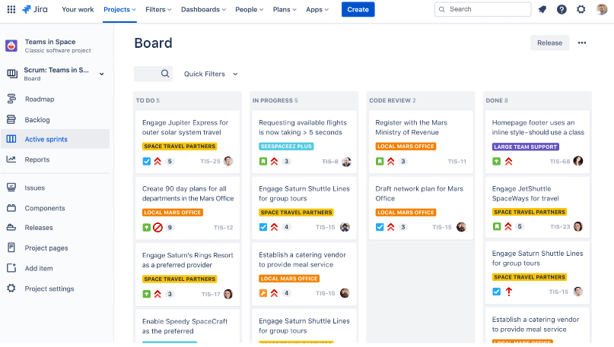

Each project can have its own configurable Workflows, Issue types, Screens, Custom fields and Priorities. This enables Project Administrators to customize the project according to the project requirements and business scenarios.

## 

## 2.2 Nexus Repository

Nexus by Sonatype is a repository manager that organises, stores and distributes artifacts needed for software development. It provides developers the capability to control access to, and deployment of, every artefact in an organisation from a single location. IT teams can use Sonatype Nexus repository as a central platform for storing build artifacts, which will help to optimize build performance and storage costs. This is beneficial for large organizations as they can improve efficiency across teams.

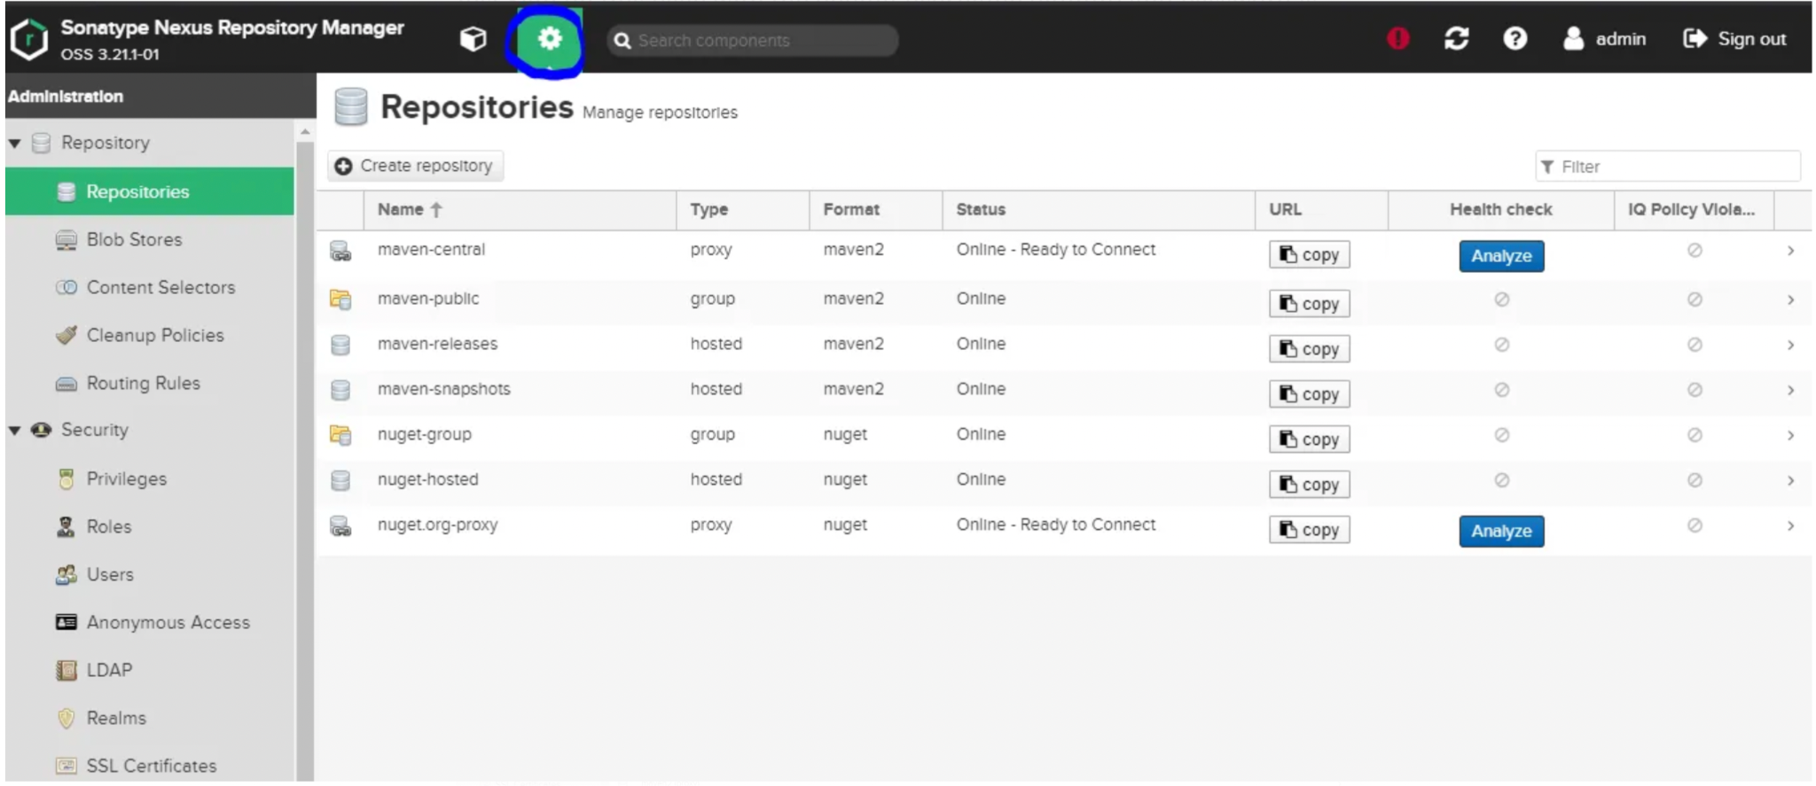

The binary assets that users download via proxy repositories, or publish to hosted repositories, are stored in the blob store attached to those repositories.

Cleanup policies can be used to remove content from the repositories, at a configurable frequency. Once created, a cleanup policy must be associated with a repository.

## 2.3 BitBucket by Atlassian

Bitbucket by Atlassian is a Git-based source code repository and CI/CD tool that is optimised for teams using Jira. With the built-in Jira UI, teams can manage their Jira issues in Bitbucket and keep track of code changes, thereby improving visibility and transparency of the build process. Using Bitbucket Pipelines, developers can easily setup and configure CI/CD with language specific templates, as well as build automated workflows. This helps reduce context-switching and allows teams to store and manage their entire development workflow in a single place, enabling continuous delivery.

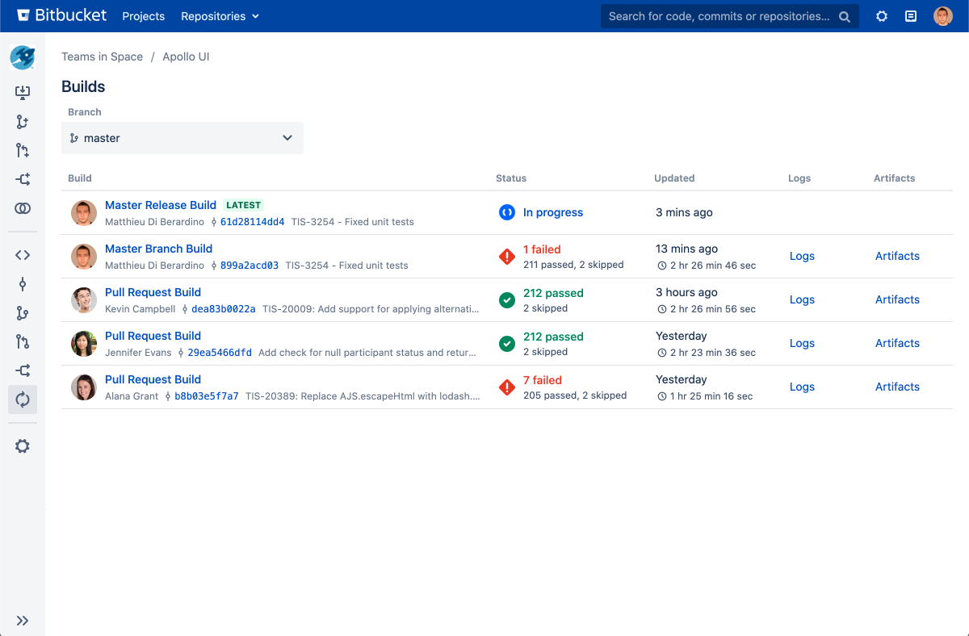

## 

## 2.4 Jenkins

Jenkins is a Java-based open-source automation platform and can be used as a CI/CD solution. It helps automate parts of the software development process related to building, testing and deploying. Developers can leverage on the feature of Jenkins’ automatic job management to automatically create, update and delete jobs based on the repositories it identified in the software configuration management. By writing the definition of a Jenkins Pipeline into a Jenkinsfile and in turn committing it to a project’s source code repository, this automatically creates a Pipeline build process for all branches and pull requests, which can be used by all members of the project.

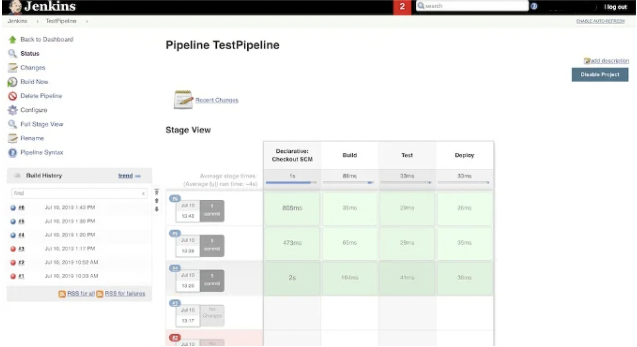

# 3. Overview of Current OCBC Environment

## 3.1 Jira Software

There are two available environments: UAT and Production.

* UAT environment - Jira version 9.6.0. (Developer license, Data Center)
* Production environment - Jira version 9.6.0

|  |  |  |
| --- | --- | --- |
| Composition | UAT Jira | Prod Jira |
| Server Info | Operating System: Linux 3.10.0-1160.95.1.el7.x86_64  Database type: postgres72  Database version: 14.7.0  Database driver: PostgreSQL JDBC Driver 42.2.25  Total Memory: 4096 MB  Available Memory: 932 MB (23% Free) |  |
| Database Statistics | Total Projects: 1183  Archived Projects: 152  Total Issues: 2057703  Archived Issues: 200799  Custom Fields: 1328  Issue Types: 249  Attachments: 1194264  Screen Schemes: 2816  Users: 15436  Groups: 12950  Workflows: 995  Priorities: 9 |  |

### 3.1.1 Jira Add-ons in UAT

The list of enabled Jira Add-ons is listed in the table below.

|  |  |
| --- | --- |
| Add-on | Description |
| Project Configurator | Version: 3.9.17  License: Evaluation, Unlimited-user commercial license, Data Center, expires 21/Sep/23  License Status: Valid |
| Adaptavist ScriptRunner for Jira | Version: 8.2.1  License: 10000-user developer license, Data Center, expires 31/Mar/24  License Status: Valid |
| Jira Command Line Interface (CLI) | Version: 10.6.0  License: 10000-user developer license, Data Center, expires 31/Mar/24  License status: Valid |
| Jira Toolkit Plugin | Version: 1.0.0 |
| Manage Inactive Users for Jira | Version: 1.4.9  License: 10000-user developer license, Data Center, expires 31/Mar/24  License status: Valid |
| Microsoft Teams for Jira Server | Version: 2023.03.114 |
| Time In Status | Version: 4.30.0.750  License: 10000-user developer license, Data Center, expires 31/Mar/25  License status: Valid |
| Zephyr Squad | Version: 9.2.2.92209740  License: 10000-user developer license, Data Center, expires 31/Mar/24  License status: Valid |

## 

## 3.2 Nexus Repository

There are two available environments: UAT and Production.

* UAT environment - Nexus version 3.46.0-01, with Pro license.
* Production environment - Nexus version 3.46.0-01, with Pro license.

|  |  |
| --- | --- |
| Composition | UAT Nexus |
| Configuration | installDirectory  workingDirectory  temporaryDirectory |
| Status | <Insert screenshot> |

|  |  |
| --- | --- |
| Composition | Prod Nexus |
| Configuration | installDirectory  workingDirectory  temporaryDirectory |
| Status | <Insert screenshot> |

### 

### 3.2.1 Repositories

The repositories present in UAT is captured below:

<Insert Screenshot of UAT>

The repositories present in Production is captured below:

<Insert Screenshot of Production>

### 3.2.2 Blob stores

The blob stores present in UAT is captured below:

<Insert Screenshot of UAT>

The blob stores present in Production is captured below:

<Insert Screenshot of Production>

### 3.2.3 Cleanup Policies

The cleanup policies present in UAT is captured below:

<Insert Screenshot of UAT>

The cleanup policies present in Production is captured below:

<Insert Screenshot of Production>

### 3.2.4 Roles

The roles present in UAT is captured below:

<Insert Screenshot of UAT>

The roles present in Production is captured below:

<Insert Screenshot of Production>

### 3.2.5 Users

The users present in UAT is captured below:

<Insert Screenshot of UAT>

The users present in Production is captured below:

<Insert Screenshot of Production>

# 4. Overview of Current BOS Environment

## 4.1 Jira Software

There is only one environment - Production environment.

### 4.1.1 Initial Jira version

The initial Jira version, before the upgrade, was 7.8.0 (server).

|  |  |
| --- | --- |
| Composition | Jira v7.8.0 instance |
| Server Info | Operating System: Windows Server 2012 R2 6.3  Database type: mssql  Database version: 12.00.6444  Database driver: Microsoft JDBC Driver 6.2 for SQL server 6.2.1.0  Total Memory: 4069 MB  Used Memory: 3516 MB  Available Memory: 553 MB (14% Free) |
| Database Statistics | Total Projects: 183  Total Issues: 132192  Custom Fields: 357  Issue Types: 65  Attachments: 154617  Screen Schemes: 167  Users: 115769  Groups: 27734  Workflows:86  Priorities: 10 |

|  |  |
| --- | --- |
| Add-ons | Description |
| Adaptavist ScriptRunner for Jira | Version: 5.2.1  License: 2000-user commercial license, Standard, expires 14/Feb/24  License status: Valid |
| Easy Agile User Story Maps for Jira | Version: 4.0.8  License: 2000-user commercial license, Standard, expires 16/Jul/23  License status: Valid |
| JBehave for Jira | Version: 5.0.4  License: 2000-user commercial license, Standard, expires 14/Feb/24  License status: Valid |
| Multiple Filters Chart Gadget | Version: 4.7.2  License: 2000-user commercial license, Standard, expires 14/Feb/24  License: Valid |
| Time In Status | Version: 4.3.6.626  License: 2000-user commercial license, Standard, expires 14/Feb/24  License status: Valid |
| UpRaise for Employee Success | Version: 4.0.0.0  License: 2000-user commercial license, Standard, expires 14/Feb/24  License status: Valid |
| ZAPI | Version: 2.7.1.27107788 Part of Zephyr (API Integration) |
| Zephyr for Jira | Version: 4.0.2.40207614  License: 2000-user commercial license, Standard, expires 14/Feb/24  License status: Valid |

### 4.1.2 Upgraded Jira version

The current Jira version, after the upgrade, is 8.5.0 (server).

|  |  |
| --- | --- |
| Composition | Jira v8.5.0 instance |
| Server Info | Operating System: Windows Server 2012 R2 6.3  Database type: mssql  Database version: 12.00.6444  Database driver: Microsoft JDBC Driver 7.2 for SQL server 7.2.1.0  Total Memory: 2007 MB  Used Memory: 1584 MB  Available Memory: 423 MB (21% Free) |
| Database Statistics | Total Projects: 184  Total Issues: 135809  Custom Fields: 357  Issue Types: 65  Attachments: 157447  Screen Schemes: 161  Users: 115755  Groups: 27734  Workflows:87  Priorities: 10 |

The list of enabled Jira Add-ons is listed in the table below.

|  |  |
| --- | --- |
| Add-ons | Description |
| Adaptavist ScriptRunner for Jira | Version: 6.38.0  License: 2000-user commercial license, Standard, expires 14/Feb/24  License status: Valid |
| Easy Agile User Story Maps for Jira | Version: 4.0.8  License: 2000-user commercial license, Standard, expires 16/Jul/23  License status: Valid |
| JBehave for Jira | Version: 5.0.4  License: 2000-user commercial license, Standard, expires 14/Feb/24  License status: Valid |
| Multiple Filters Chart Gadget | Version: 5.15.0  License: 2000-user commercial license, Standard, expires 14/Feb/24  License: Valid |
| Time In Status | Version: 4.31.2.754  License: 2000-user commercial license, Standard, expires 14/Feb/24  License status: Valid |
| UpRaise for Employee Success | Version: 4.0.0.0  License: 2000-user commercial license, Standard, expires 14/Feb/24  License status: Valid |
| ZAPI | Version: 2.7.1.27107788 |
| Zephyr Squad | Version: 8.3.0.83009793  License: 2000-user commercial license, Standard, expires 14/Feb/24  License status: Valid |

## 4.2 Nexus Repository

There is only one environment - Production environment. The current Nexus version is 3.38.1-01. The license edition has been upgraded from OSS to PRO.

|  |  |
| --- | --- |
| Composition | Prod Nexus |
| Configuration | installDirectory: J:\CI\nexus\nexus-3.16.2-01  workingDirectory: J:\CI\nexus\sonatype-work\nexus3  temporaryDirectory: J:\CI\nexus\sonatype-work\nexus3\tmp |
| Status | <Insert screenshot> |

### 4.2.1 Repositories

The repositories present is captured below:

<Insert Screenshot of Production>

### 4.2.2 Blob stores

The blob stores present is captured below:

<Insert Screenshot of Production>

### 4.2.3 Cleanup Policies

The cleanup policies present is captured below:

<Insert Screenshot of Production>

### 4.2.4 Roles

The roles present is captured below:

<Insert Screenshot of Production>

### 4.2.5 Users

The users present is captured below:

<Insert Screenshot of Production>

## 4.3 Bitbucket

There is only one environment - Production environment. The current Bitbucket version is v8.9.3.

Currently, the dashboard view for Production is shown below.

<Insert Screenshot>

## 4.4 Jenkins

There is only one environment - Production environment. The current Jenkins version is v2.176.4

Currently, the dashboard view for Production is shown below.

<Insert Screenshot>

# 

# 5. Jira Migration Process

Objective is to migrate Jira instance data from the BOS environment into the OCBC environment. Doing so enables:

* Better planning of Roadmaps strategically across multiple teams and projects.
* Optimisation of data management, and cleanup of old projects, unused workflows, unused custom fields.
* High level visibility and traceability of projects across the Bank environment.

## 5.1 Prerequisites

To get started, the following prerequisites need to be met:

* BOS to be on Jira v8.5.0
* Ensure OCBC Jira have the BOS Jira Add-ons with the compatible version.
* Jira System Admin access to both BOS and OCBC.
* Data transferred from BOS Production Server to OCBC Production Server.

## 5.2 Migration Procedure

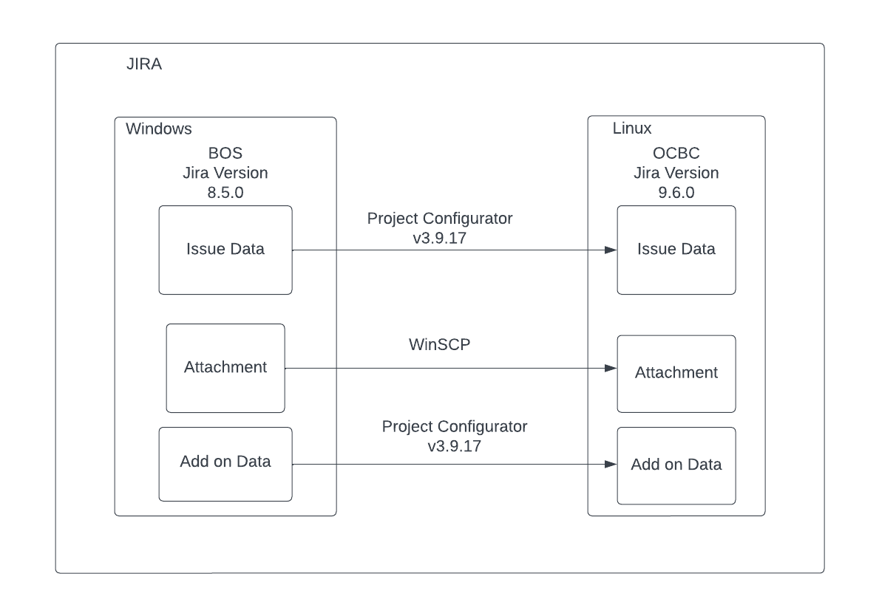

### 5.2.1 Pre-Migration Procedure

Pre-migration procedure will revolve around preparing the instances, and all the necessary data before the actual Go-Live Migration Day. Pre-migration procedure will include:

* Install Project Configurator in OCBC instance and BOS instance;
* Add-on installation in the OCBC instance;
* Resolve conflict for configuration based on test result
* Blast Email All BOS Users to not use Jira BOS in the production migration and to confirm it is their risk to migrate after that production migration hour.

Procedure as following :

1. **Install Project Configurator v3.9.17 in BOS instance and OCBC instance**

You will need to:

* Browse the add-on website.

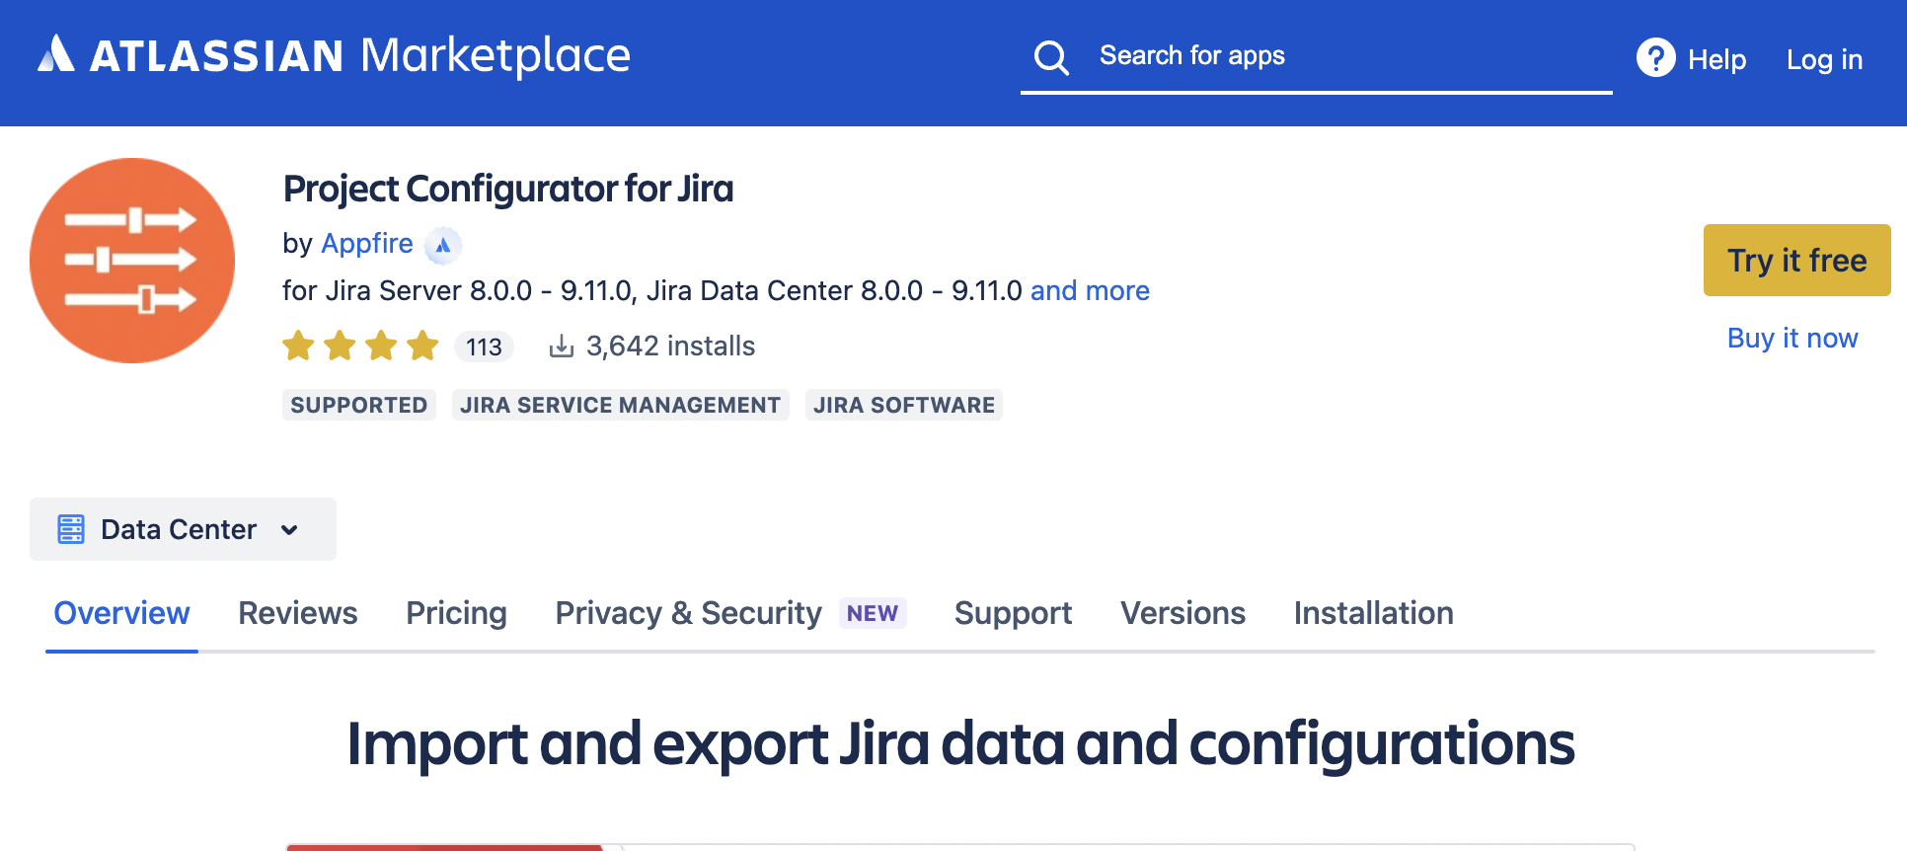

* Download the version 3.9.17 (Apps are normally distributed as JAR or OBR files, which are the only types of files accepted by the Jira file upload mechanism)
* Log into BOS Jira as **System Administrator.**
* Click the Admin dropdown and choose **Manage Apps.**

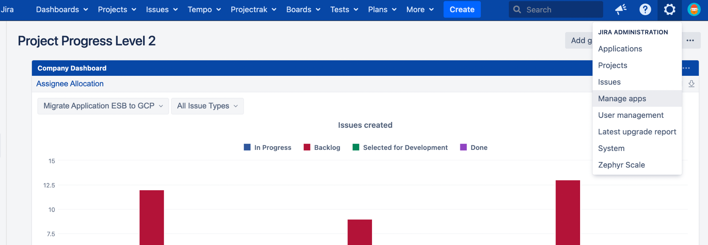

* On the left-hand panel, click **Manage apps.**

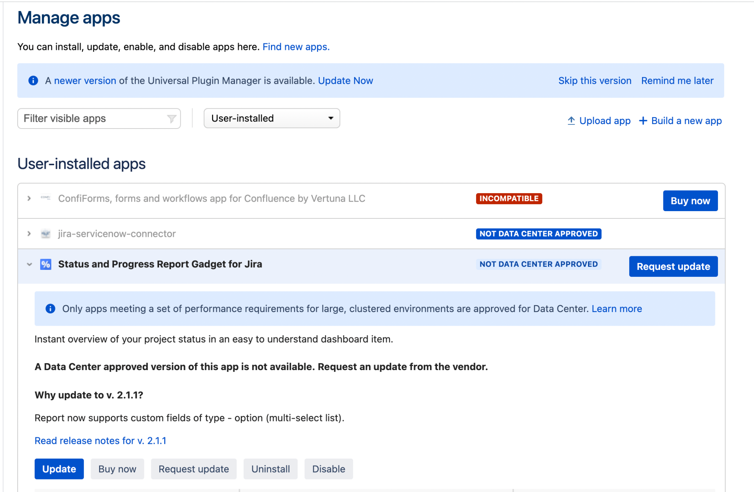

* From the top navigation bar, choose **Upload app**

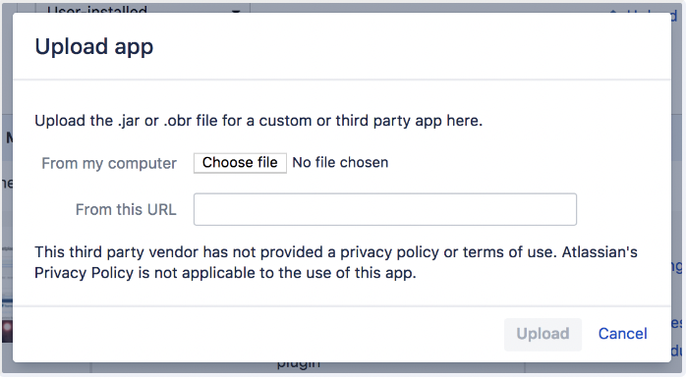

* Select the app file to upload
* Click **Upload**
* Once installation is complete, you may need to enter a license before you can use the app.
* Log into OCBC Jira as **System Administrator** and follow the same steps above to install the project configurator in the OCBC instance.

1. **Install Jira add-ons used by BOS instance in OCBC instance**

In Section 4.1.2, the table lists down the Jira add-ons enabled in BOS instance, including the add-on version and license status. Note that only add-ons that exist in target OCBC instance will be migrated. Other add-ons data, functions, and modules will not be migrated and stays in the BOS instance. The following are the Jira add-ons that will be migrated:

|  |  |  |
| --- | --- | --- |
| Add-ons | Target Description | Version Consideration |
| Adaptavist ScriptRunner for Jira | Version: 8.21.0 | Utilize version 8.2.1 that already exist in the OCBC instance |
| Easy Agile User Story Maps for Jira | Version: 9.2.0 | Version that is compatible with OCBC JSW 9.6 version and current BOS version |
| JBehave for Jira | Version: 5.1.0 | Version that is compatible with OCBC JSW 9.6 version and current BOS version |
| Multiple Filters Chart Gadget | Version: 5.15.0 | Install same version with current BOS version as it is compatible with JSW 9.6 |
| Time In Status | Version: 4.30.0.750 | Utilize Version 4.30.0.750 that already exist in OCBC instance |
| UpRaise for Employee Success | Version: 9.10 | Version that is compatible with OCBC JSW 9.6 version |
| ZAPI | Version: 2.7.1.27107788 | Migrated with Zephyr Squad |
| Zephyr Squad | Version: 9.2.2.92209740 | Utilize version 9.2.2.92209740 that already exist in the OCBC instance |

1. **Resolve conflict for configuration based on test result**

Based on the test result, several things need to be reconfigured before proceeding to import the BOS export file to the OCBC instance. Those things are as following:

1. Rename Custom Field (in BOS instance) that has the same name on OCBC production instance

* Log into BOS Jira as **System Administrator.**
* From the Admin console, navigate to the **Issues** page
* On the left hand panel, click **Custom Fields** under **Fields.**

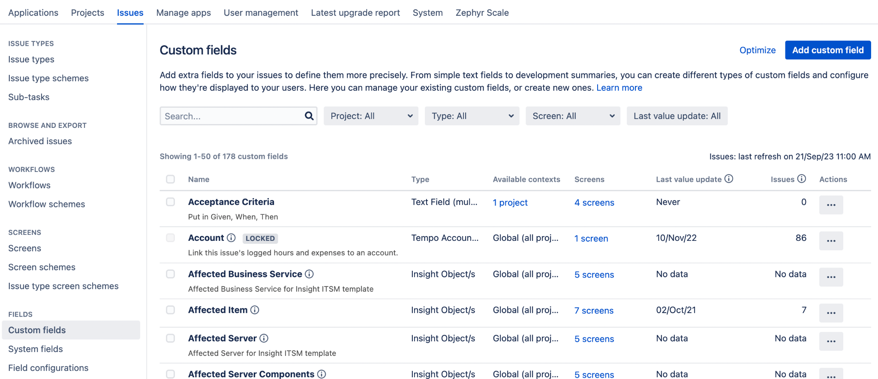

* Find the Custom Field you want to edit and select **the three dots under Actions,** then click **Edit.**

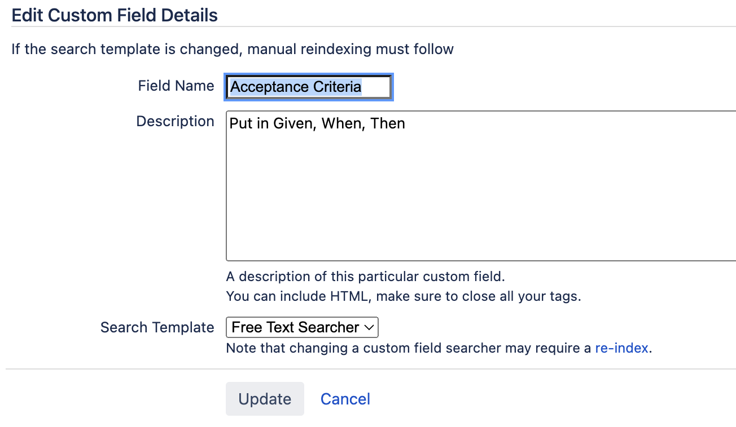

* Modify the **Field name** then click Update.

1. Rename Workflow Scheme in BOS instance, if there’s any scheme with the same name on the OCBC Production Instance

* Log into BOS Jira as **System Administrator.**
* From the Admin console, navigate to the **Issues** page
* On the left hand panel, click **Workflow schemes** under **Workflows.**
* Find the Workflow scheme you want to edit and select it.

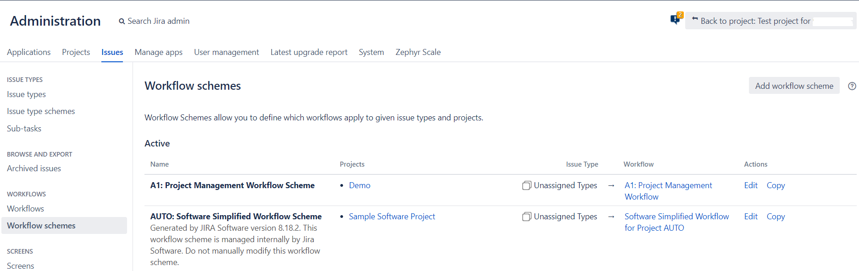

* Click **Edit** and modify the relevant fields.

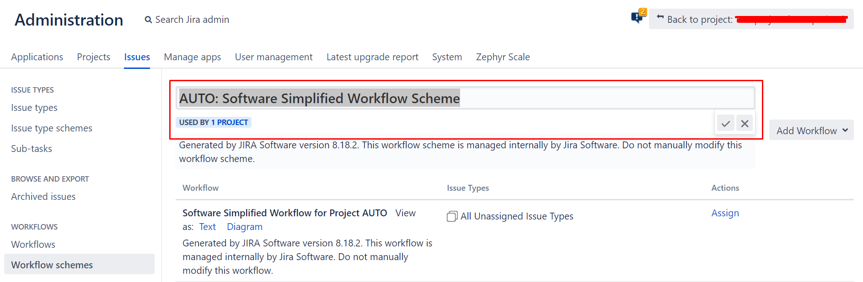

1. Rename Screen Scheme in BOS instance, if there’s any scheme with the same name on the OCBC Production Instance

* Log into BOS Jira as **System Administrator.**
* From the Admin console, navigate to the **Issues** page
* On the left hand panel, click **Screen schemes** under **Screens.**
* Find the Screen scheme you want to edit and select it.

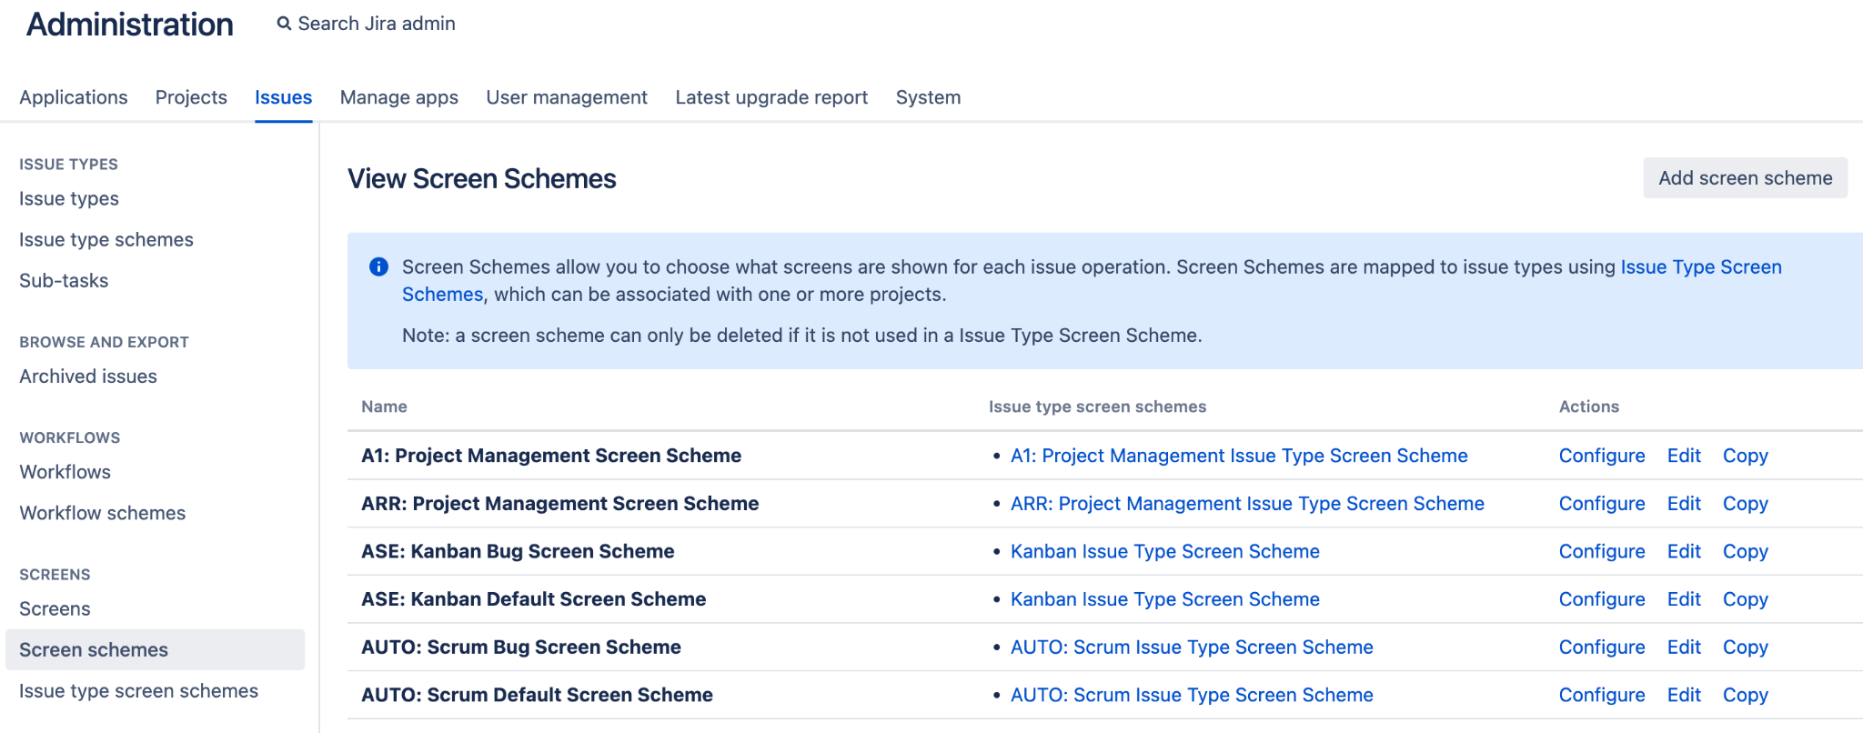

* Click **Edit** and modify the relevant fields.

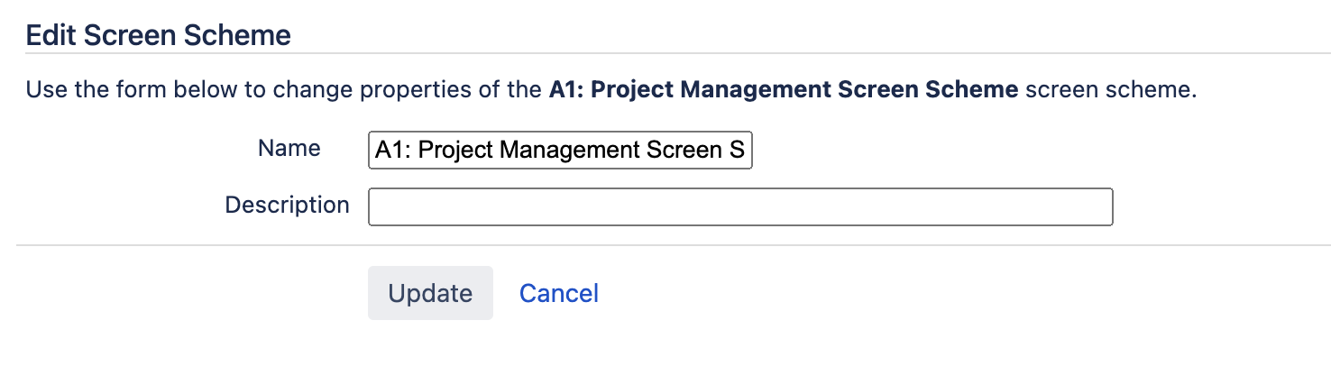

1. Rename Issue Type Scheme in BOS instance, if there is any scheme with the same name on the OCBC Production Instance.

* Log into BOS Jira as **System Administrator.**
* From the Admin console, navigate to the **Issues** page
* On the left hand panel, click **Issue type schemes** under **Issue Types.**
* Find the Issue type scheme you want to edit and select it.

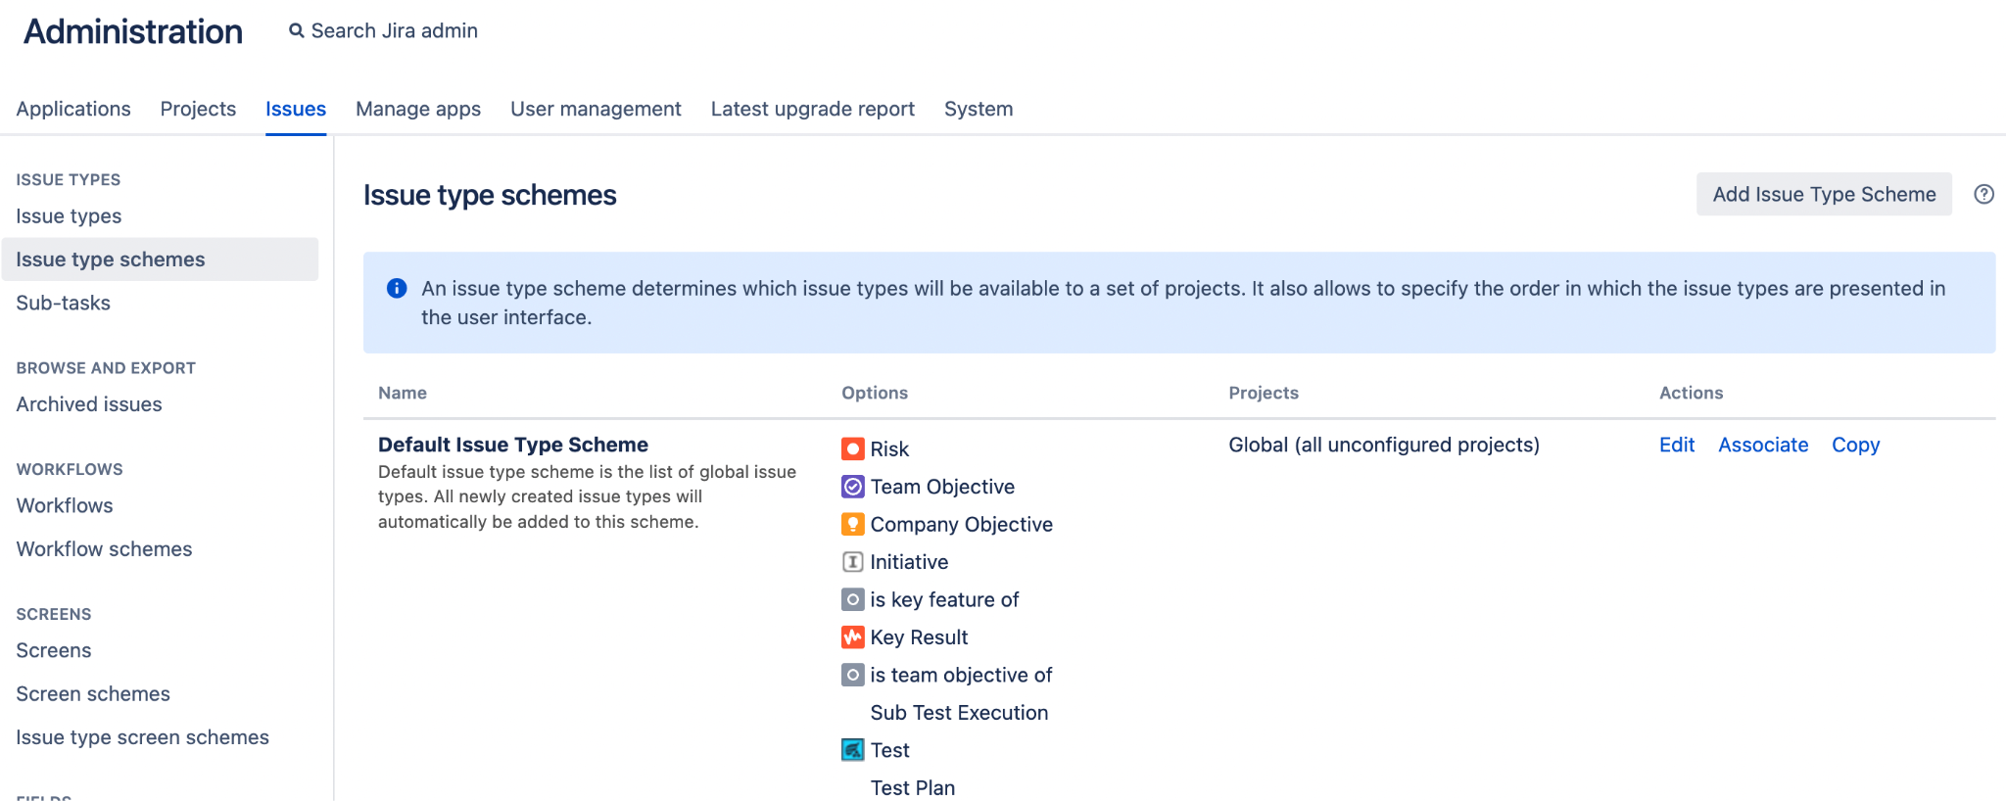

* Click **Edit** and modify the relevant fields.

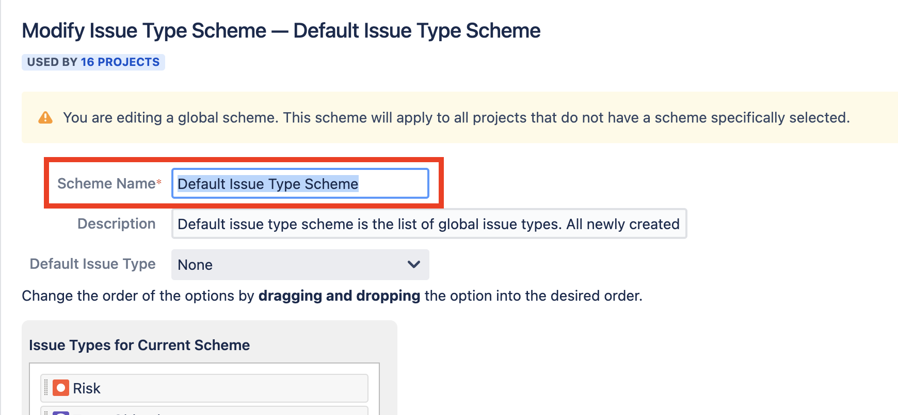

1. Rename Priority Scheme in BOS instance, if there is any scheme with the same name on the OCBC Production Instance.

* Log into BOS Jira as **System Administrator.**
* From the Admin console, navigate to the **Issues** page
* On the left hand panel, click **Priority schemes** under **Priorities.**
* Find the Priority scheme you want to edit and select it.

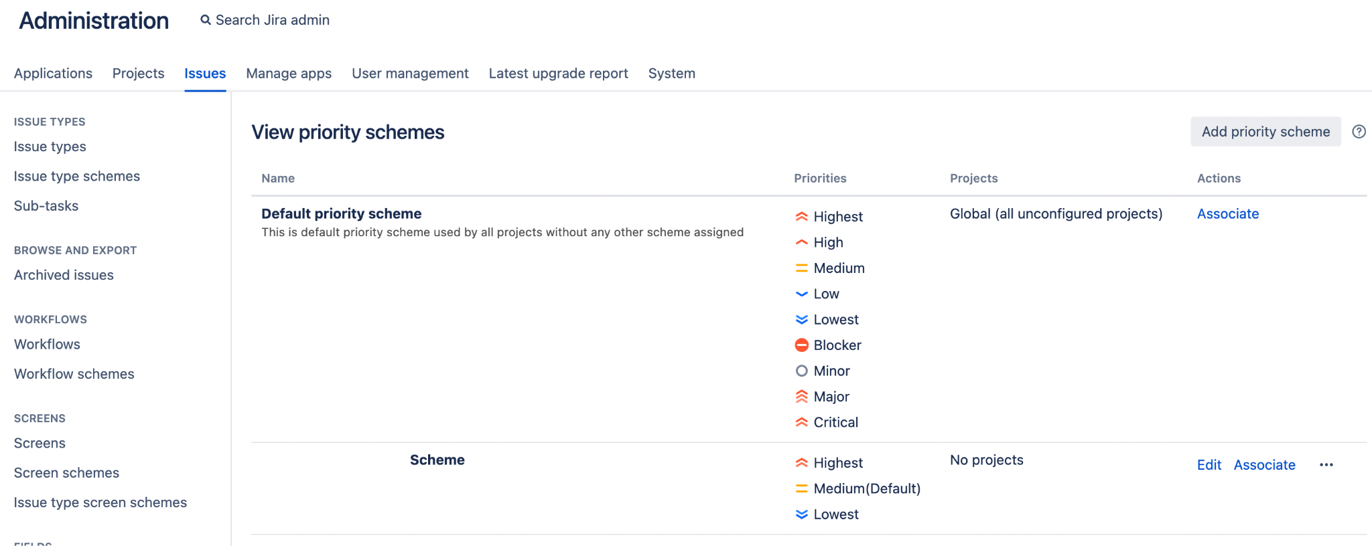

* Click **Edit** and modify the relevant fields.

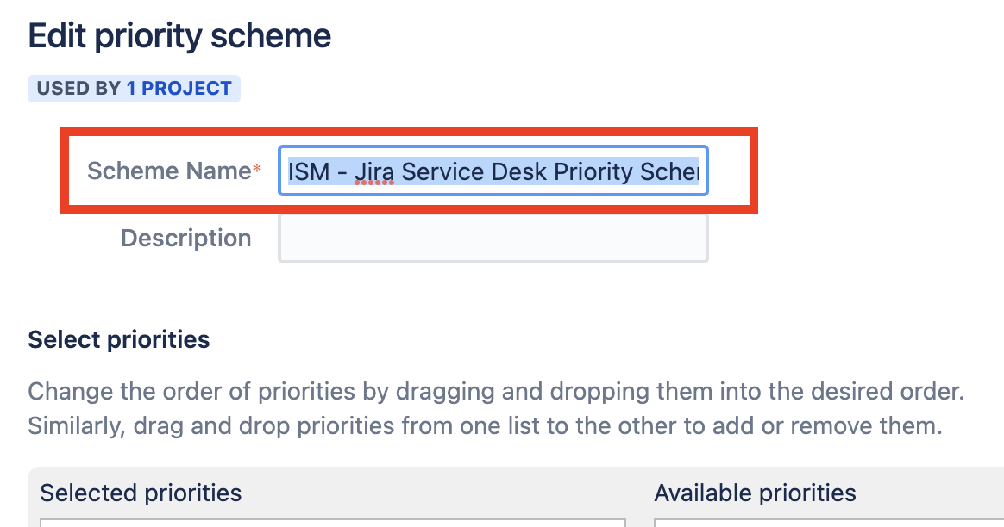

### 5.2.2 Migration Procedure

1. Take snapshot of data for OCBC instance

Before starting the migration process, OCBC will need to take database backup and VM Snapshot

1. Turn Off OCBC Jira Service
2. Backup OCBC Database Data
3. Create the OCBC Virtual Machine Snapshot
4. Turn On the OCBC Jira Service
5. Capture Database statistic from the system info before starting the project configurator info procedure.
6. Export BOS Jira project data and Add-on data using Project Configurator

You will need to

* Log into BOS Jira as **System Administrator.**
* From the Admin console, navigate to the **Manage apps** page.
* On the left hand panel, click **Export projects,** under **Project Configurator** section.

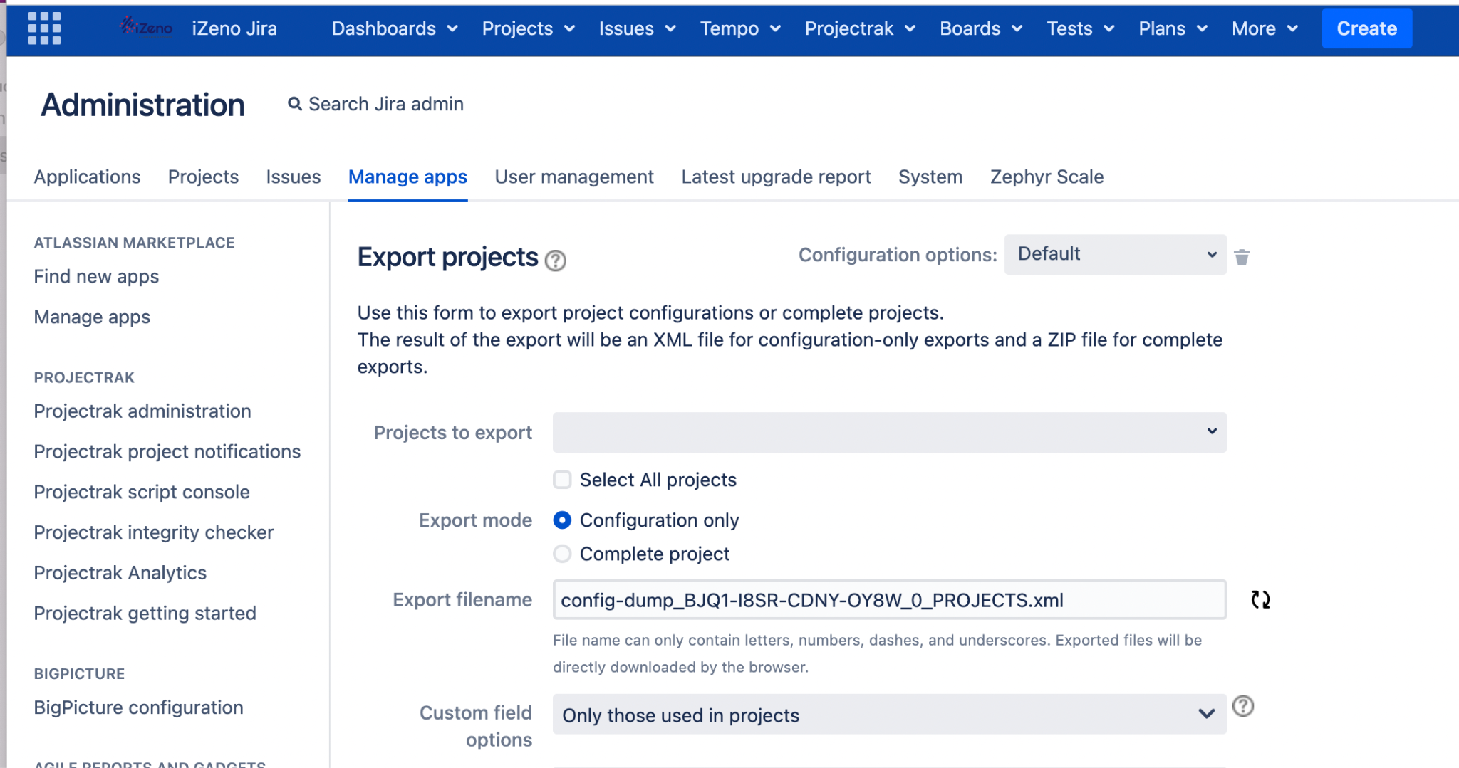

* Select one or more projects from the **Projects to export** drop-down list. Or tick the **Select All projects** checkbox to export all of the projects.
* Under Export mode, select **Complete project** to export all project data.
* Attachment migration mode we set to manual so the export process will be faster.
* with manual mode copy the project attachment folder to the OCBC attachment folder.

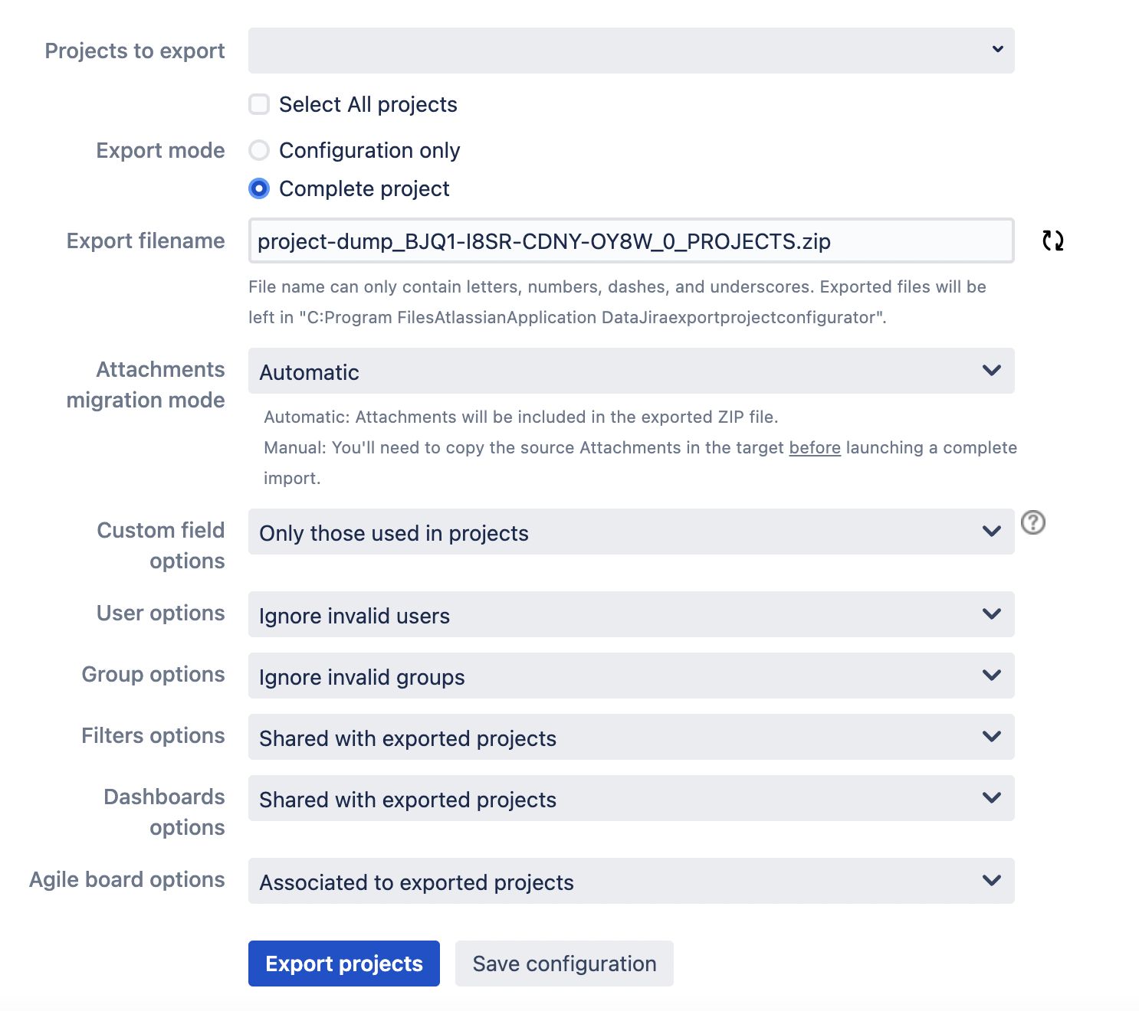

* System will generate a default **Export filename**, but you can change it. Note that the file name must be unique.
* Select the type of **Attachments migration mode**. This is only available if you select the **Complete project Export Mode**.
* The **Custom field option** allows you to select whether to export all custom fields or only those that are used by the exported projects (default).
* The **User options** drop-down list allows you to select how to handle user data during the export. Default is set to ignore invalid users.
* The **Group options** drop-down list allows you to select how to handle group data during the export. Default is set to ignore invalid groups.
* The **Filters options** drop-down list allows you to control how to handle the export of filters. Default is set to filters shared with exported projects.
* The **Dashboards options** drop-down list allows you to control how to handle the export of dashboards. Default is set to dashboards shared with exported projects. Note that if you choose to export some or all dashboards, but none of the filters, those filters that are used by the selected dashboards will be exported also, so that the exported configuration is complete.
* The **Agile board options** drop-down list allows you to select which boards to export. Default is set to boards associated with exported projects.
* Before running the export, click **Save configuration,** if you wish to use the custom export configuration in subsequent export tasks.

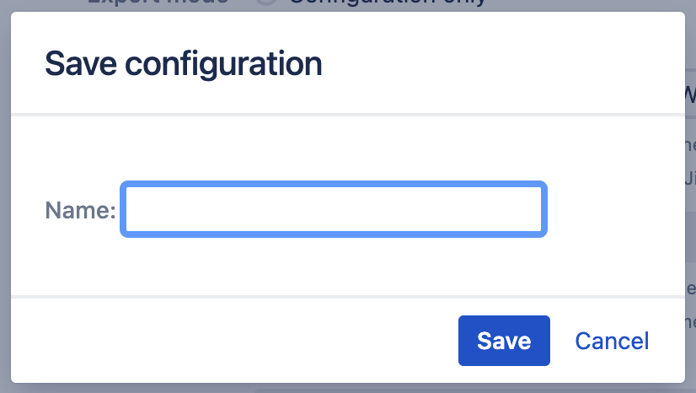

* Click **Export projects** to start the export.

1. Copy the exported BOS Jira project data and Add-on data to OCBC Jira

When exporting complete projects, the created .zip file is stored in the *JIRA_HOME/export/projectconfigurator*folder. Alternatively, you can click **Download exported file** to download the file to your local computer. The export summary is displayed on a successful export, where the full path for the created .zip file is shown.

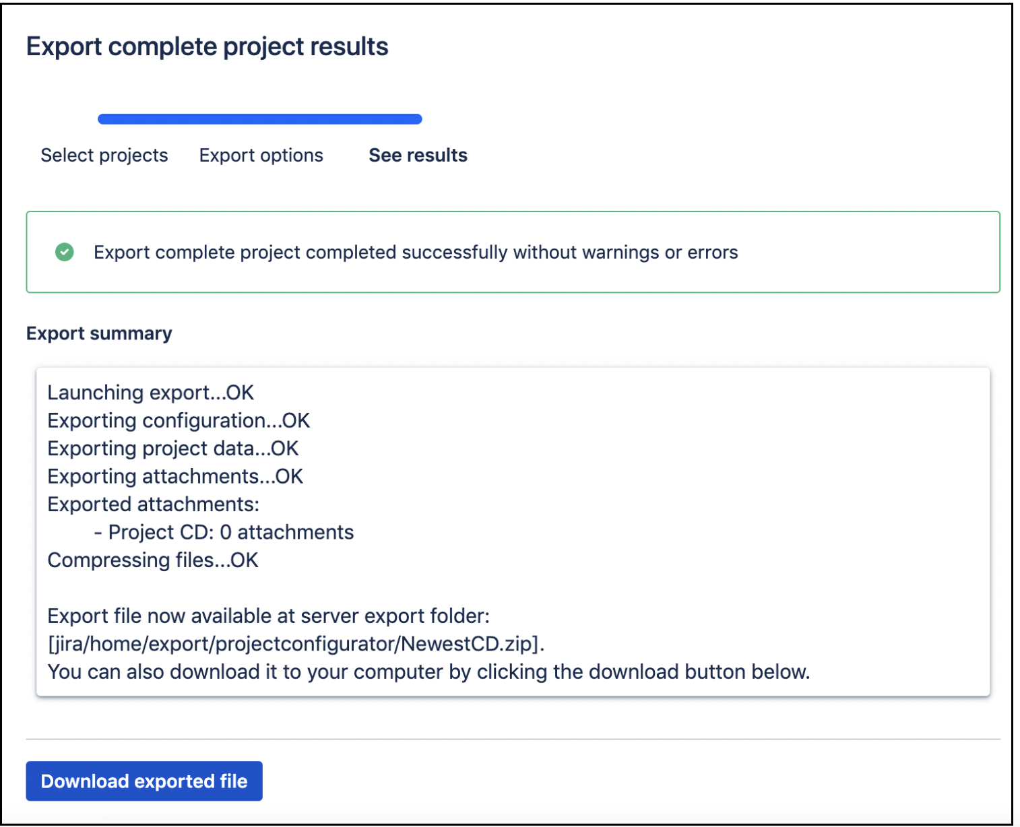

When importing complete projects data, you can choose between two options: Browse upload (default) or Server upload. For Server upload, you will need to manually copy the .zip file from the source instance to a folder in the target instance.

* In the target Jira instance, go to *<Jira-home-directory>/import*, and create a directory called *projectconfigurator*.
* Copy the exported .zip archive to the created *projectconfigurator* directory.

To transfer all the exported data files to OCBC server, you can use WinSCP.

* Ensure you use a local computer that has **system administration access** to BOS server and OCBC server.
* Ensure you have WinSCP installed on your local computer.
* Have the following information ready:
  + **Host name/IP address** of the OCBC server
  + **Protocol** supported by the OCBC server
  + **Username and password** of the service account to use
* Start WinSCP and the Login Dialog will appear.

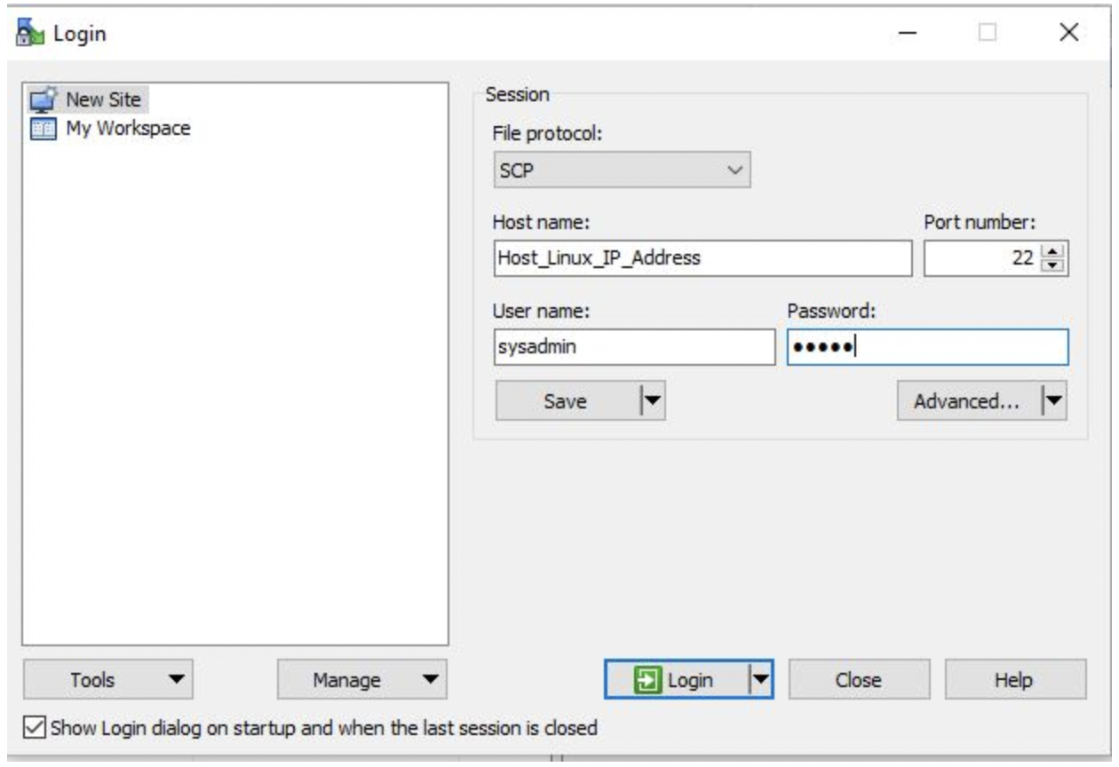

* Choose the protocol supported by OCBC server in the **File protocol** field.
* Enter **IP address or DNS name** of the target OCBC server in the **Host name** field.
* Enter **22** in the **Port number** field.
* Enter **user name and password t**o authenticate access to OCBC server.
* Click **Login** button
* Verify that you are authenticated to the OCBC server. Upon success, the IP address or DNS name of the OCBC server will appear at the top of the window.

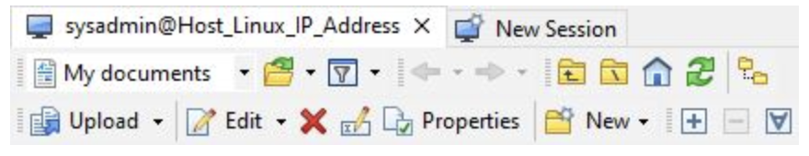

* On the left window pane, select the files you want to migrate.
* You can drag and drop the files from the left window pane to the target OCBC server pane on the right. The files will start transfer.

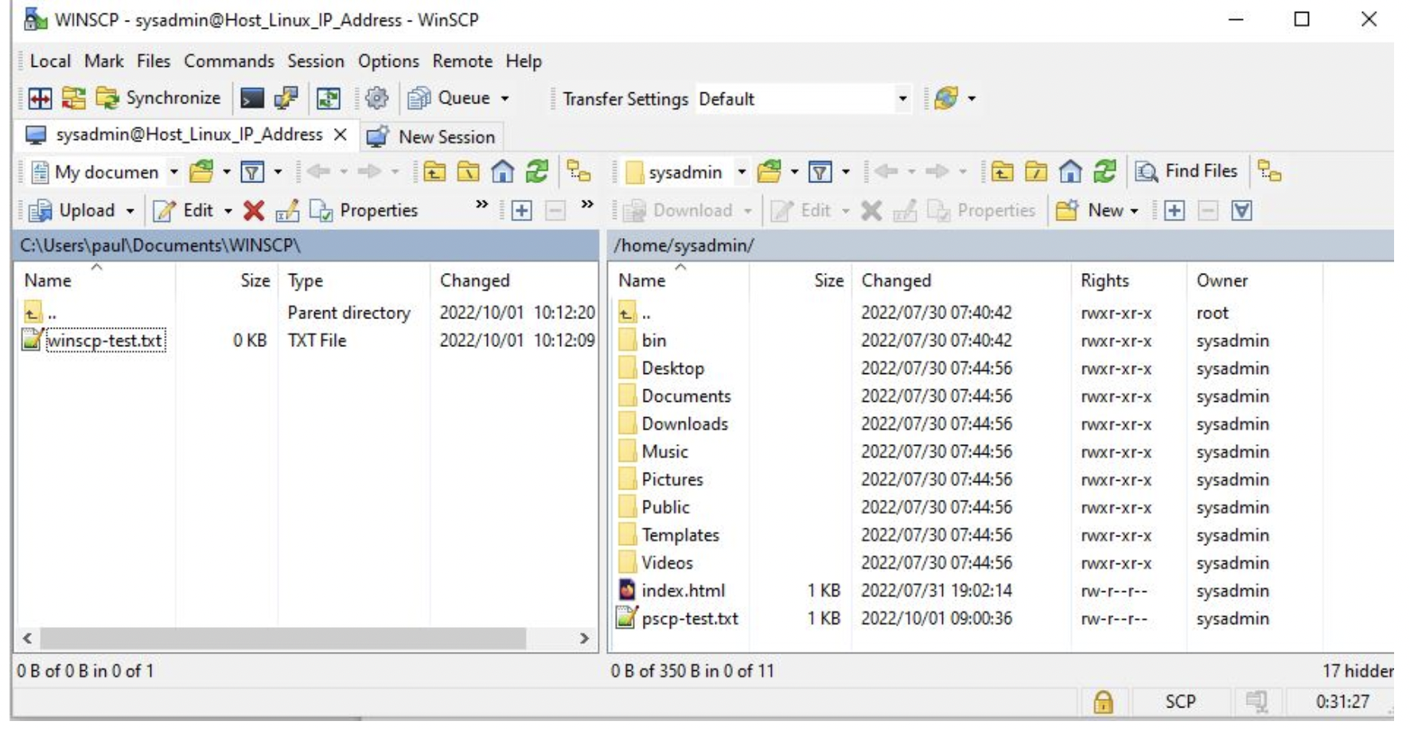

* Once complete, you will be able to see the files on the right panel.

1. Import the exported BOS Jira project data and Adds-on data using Project Configurator

You will need to

* Log into OCBC Jira as **System Administrator.**
* From the Admin console, navigate to the Manage **apps** page.
* On the left hand panel, click **Import projects,** under **Project Configurator** section.

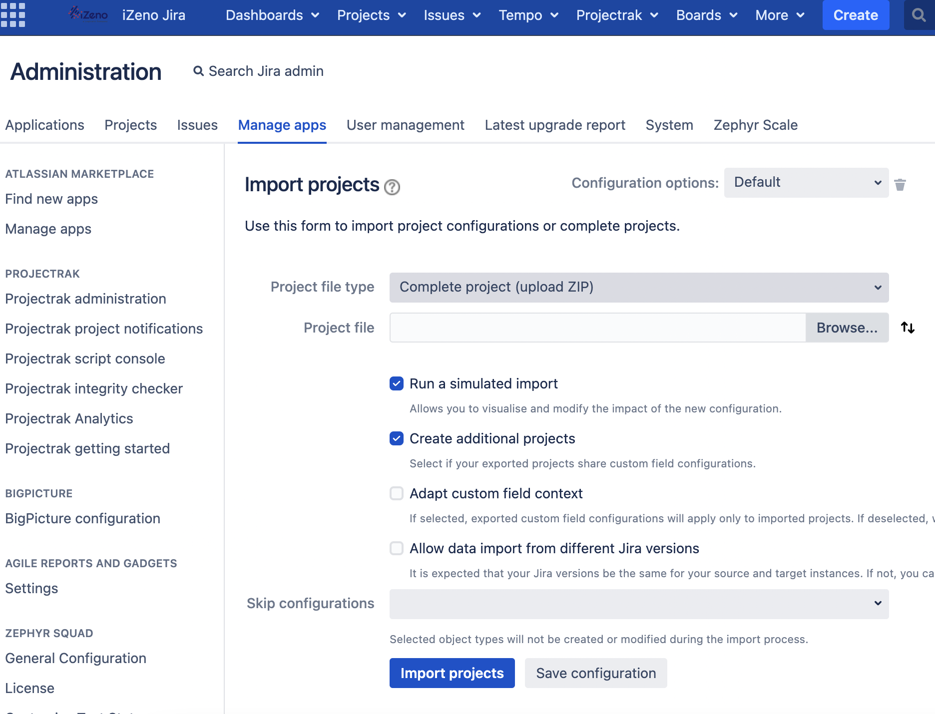

* Select to import **complete project .zip files**.
* If you choose to import complete projects, you can select between two modes - Browser upload (default) or Server upload.

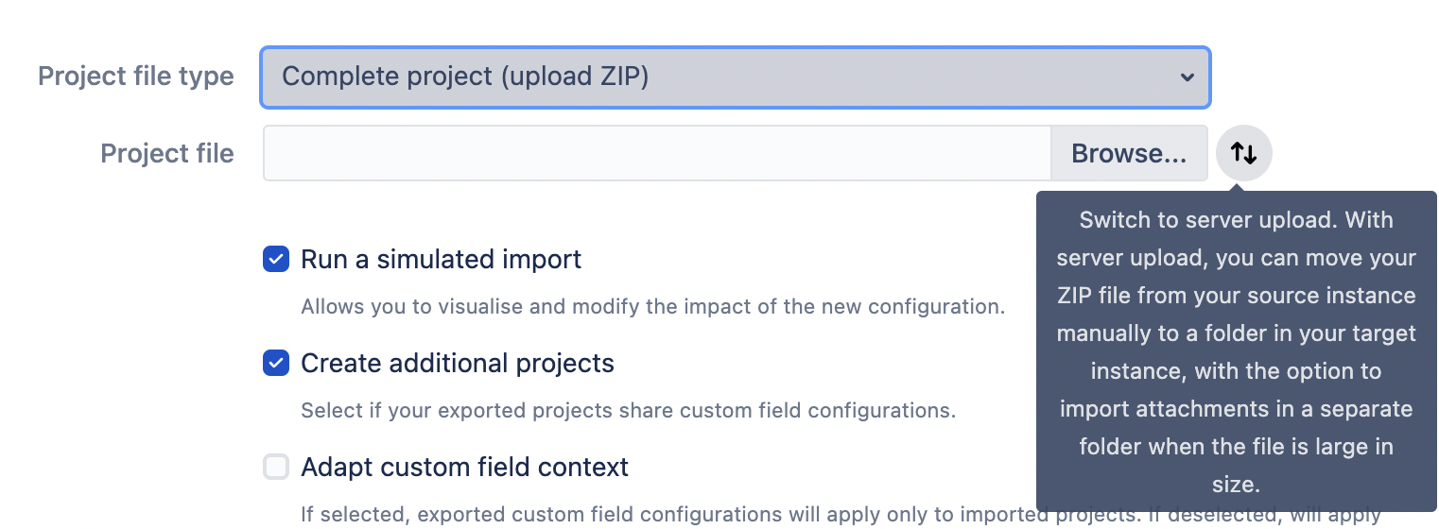

* For Server upload mode, you have an option to include the Attachments path, if you choose to move the Attachments file manually during the export process.

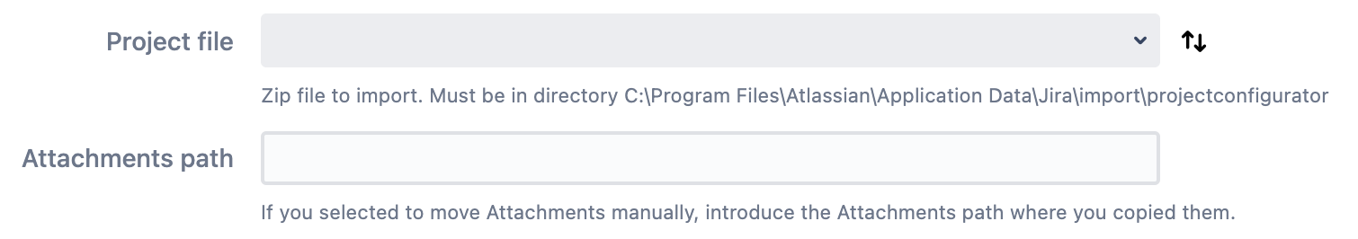

* The **Run a simulated import** option is default selected. This option allows you to run a simulation before the actual import is done.
* The **Create additional projects** option is default selected. This option will automatically create projects in the target instance when required by the custom field configurations context.
* The **Adapt custom field context** option is not selected by default. This option limits the custom field configurations to only those imported projects.
* The **Publish workflow drafts** option is only available to Configuration only import, and is selected by default.

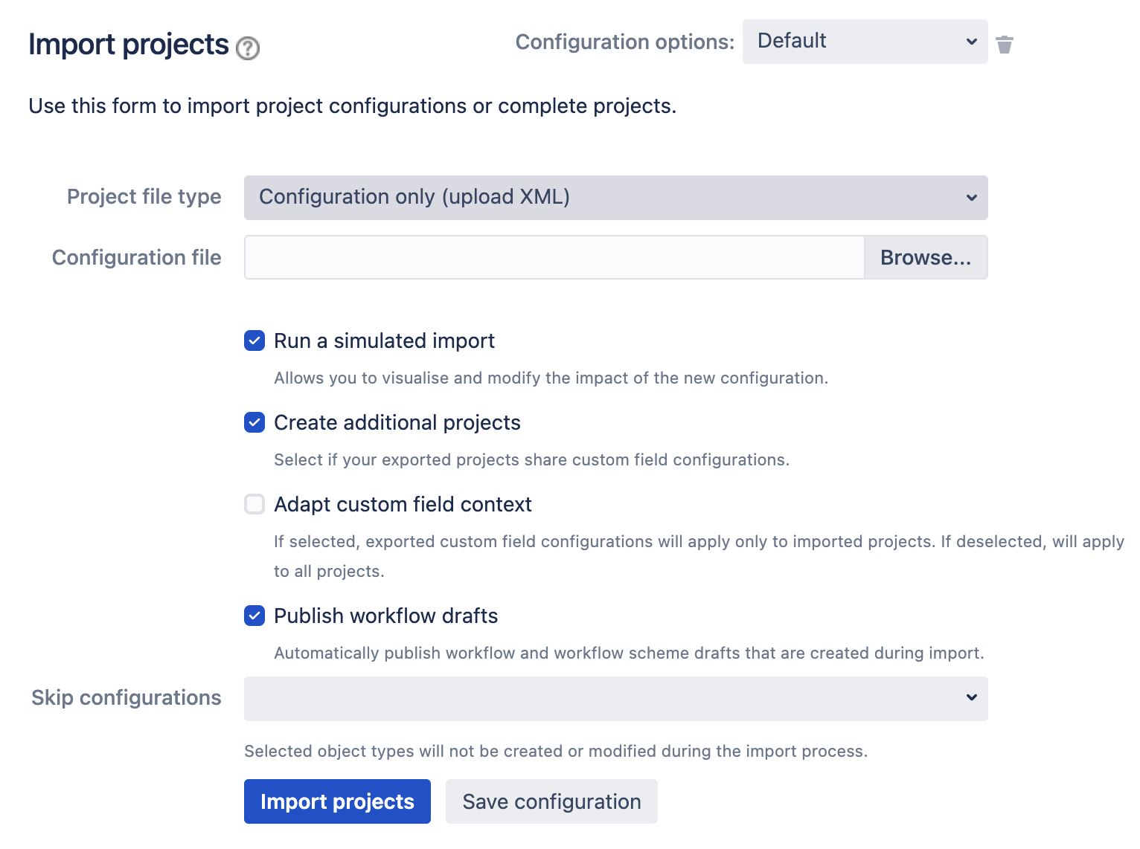

* The **Allow data import from different Jira versions** option is only available to Complete projects import, and is not selected by default. It is recommended that the target instance has the most recent Jira version.
* The **Skip configurations** option allows you to list object types you wish to ignore during the import.
* Before running the import, click **Save configuration,** if you wish to use the custom import configuration in subsequent import tasks.
* Click **Import projects** to start the import.
* Once completed, the import summary is displayed.

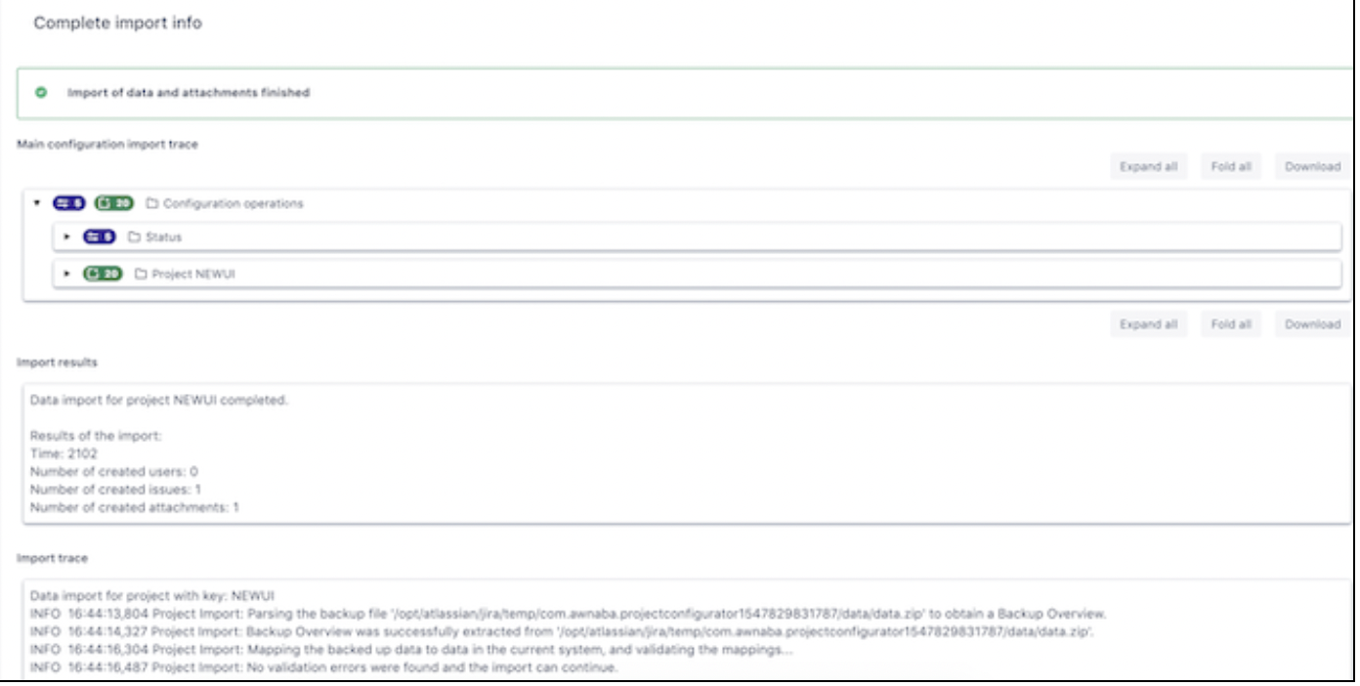

You can view the chosen configuration details under the *Main Configuration Import Trace* section. The *Import Results* section shows the statistical results of the data import for each imported project. The *Import Trace* section displays the sequence of actions performed during the import process.

### 5.2.3 Post-Migration Procedure

1. Re-Index OCBC Instance

You will need to

* Log into OCBC Jira as System Administrator.
* From the Admin console, click on **System.**
* On the left-hand panel, click **Indexing** under **Advanced** section.

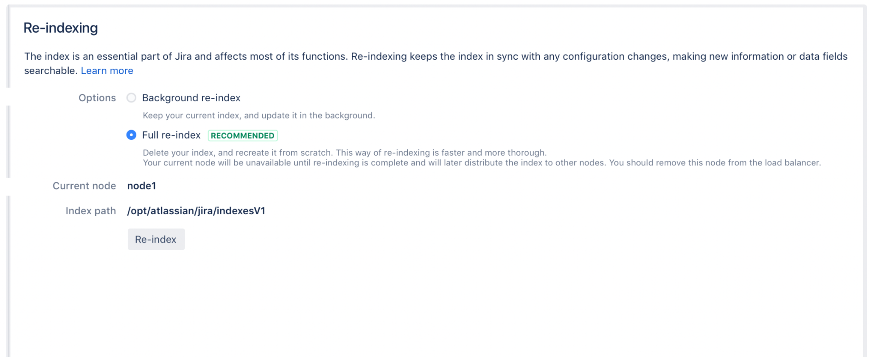

* Choose the option of **Full re-index**.
* Current node is where the re-index will be performed.
* Index path is the directory where the index is stored. To change the index path, you must be logged in as System Administrator with global permission.
* After the re-indexing is complete, let the Jira User do Business as usual in the OCBC Instance.

1. **Validate the delta statistical count of the BOS Jira data migrated**

You will need to

* Log into OCBC Jira as **System Administrator.**
* From the Admin console, click on **System.**
* On the left-hand panel, click **System Info.**

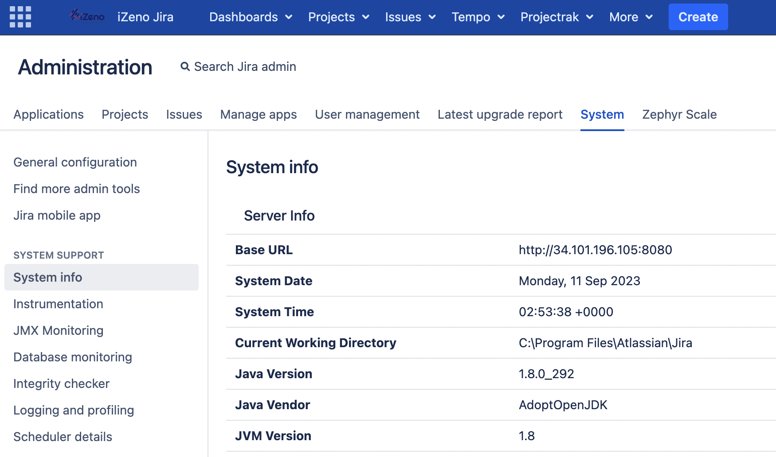

* Locate the **Database Statistics** section and compare the data count before and after the import.
  + Total count of Projects
  + Total count of Issues
  + Total count of Attachments
  + Total count of Custom Fields
  + Total count of Workflows

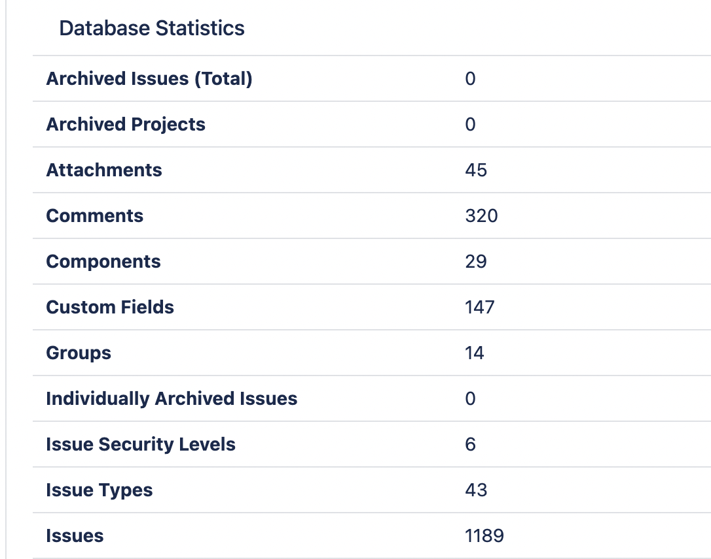

1. **Validate the functions of Jira**
2. Health Check

Check the health status of Jira instance

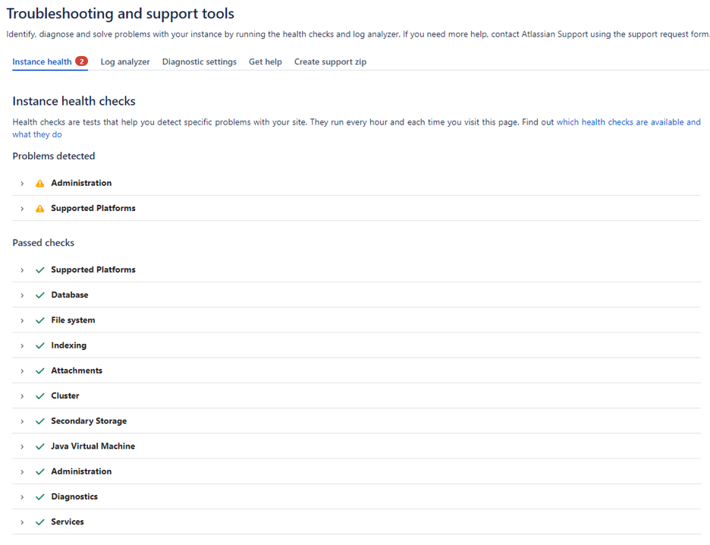

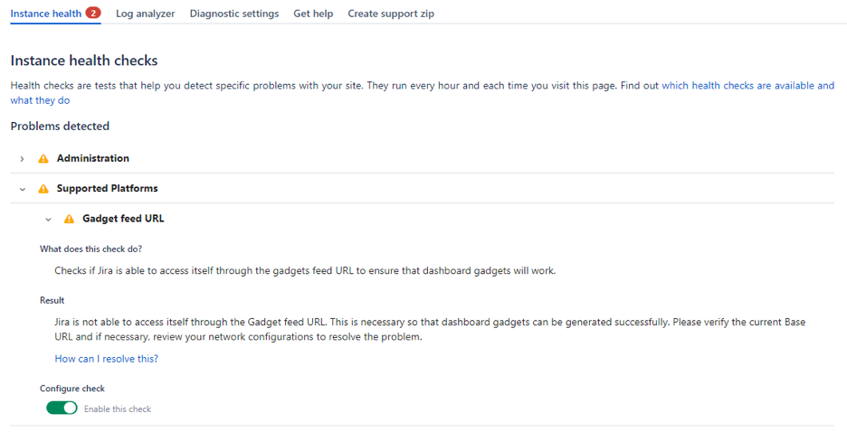

1. Create an issue

Test basic issue functionality.

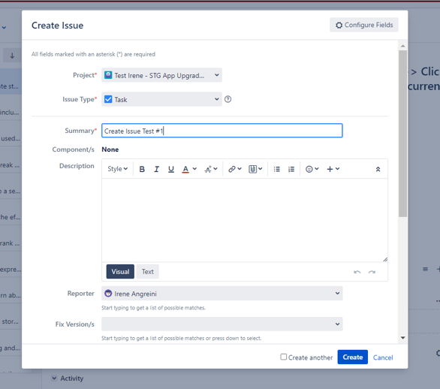

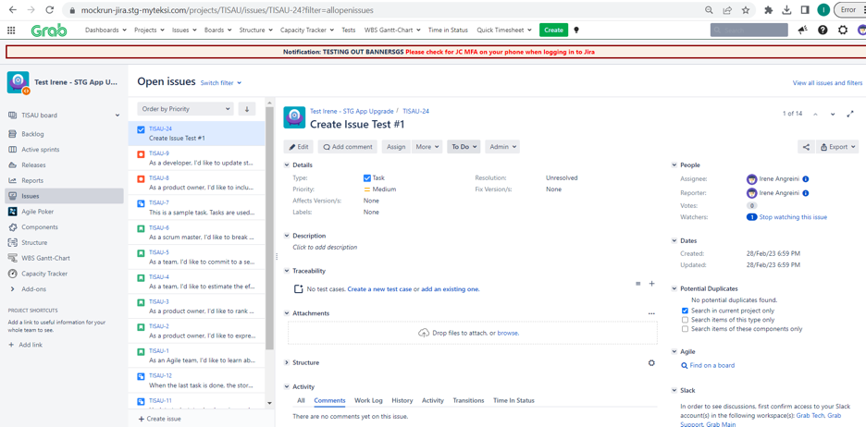

1. Edit an issue

Test basic issue functionality.

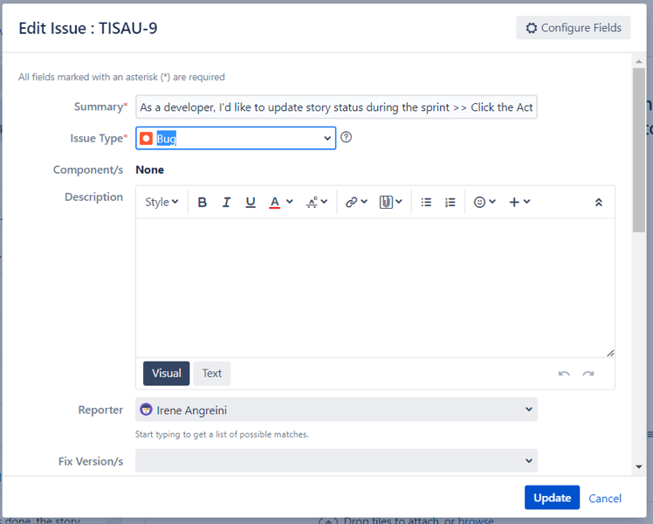

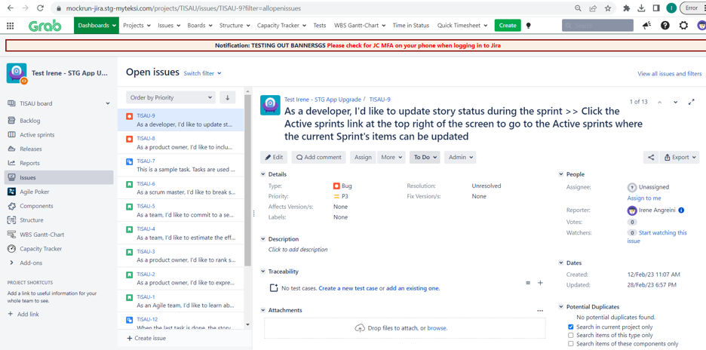

1. Delete an issue

Test basic issue functionality.

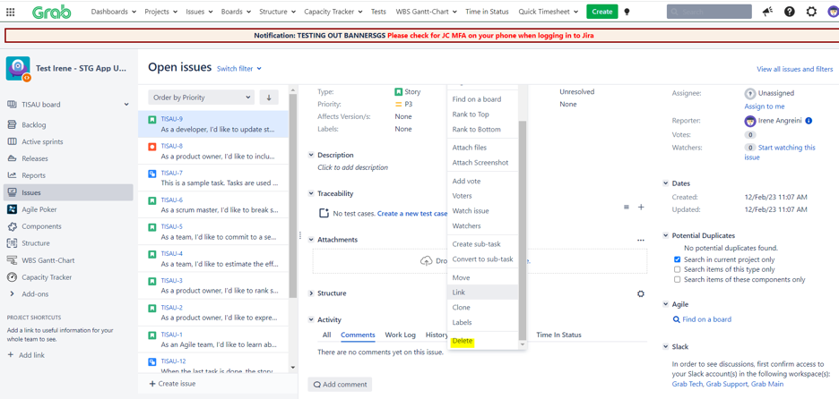

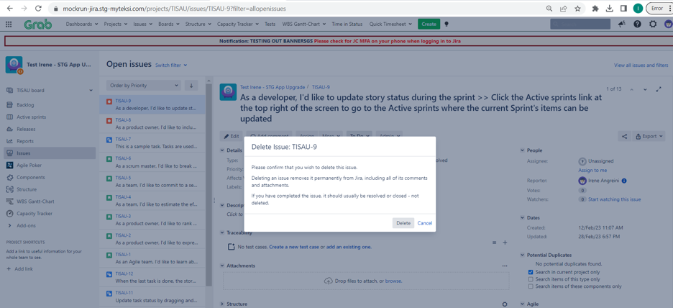

1. Layout Manager

Check the display whether working as expected

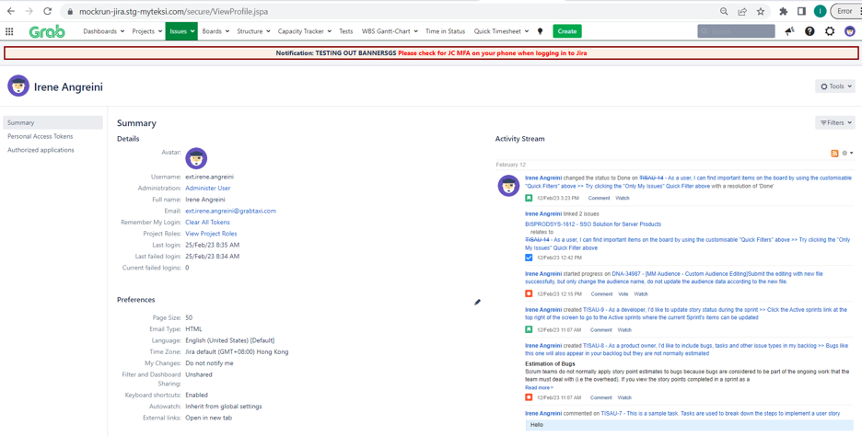

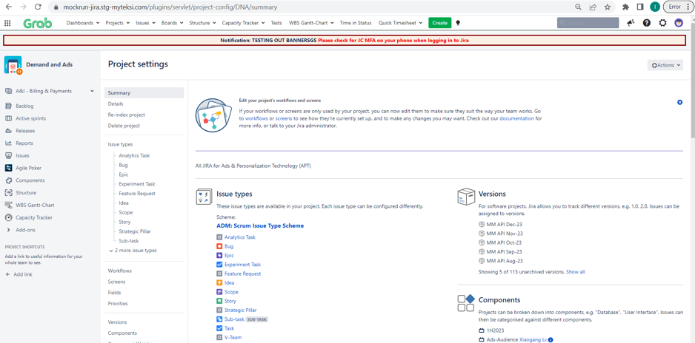

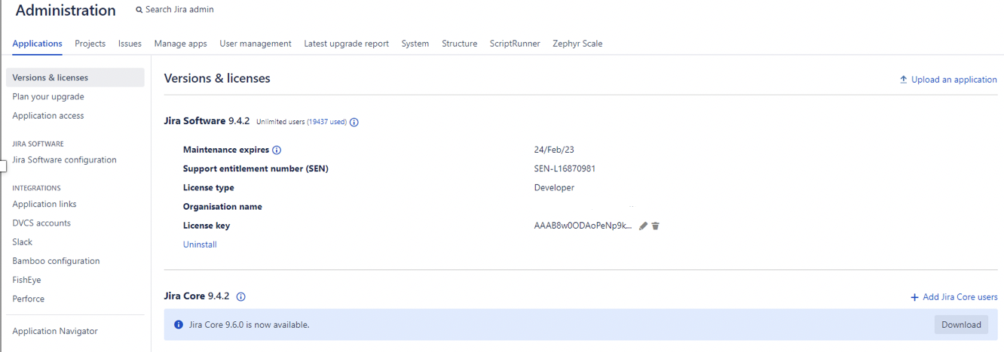

1. Permissions

Test the user actions is aligned with permission configuration

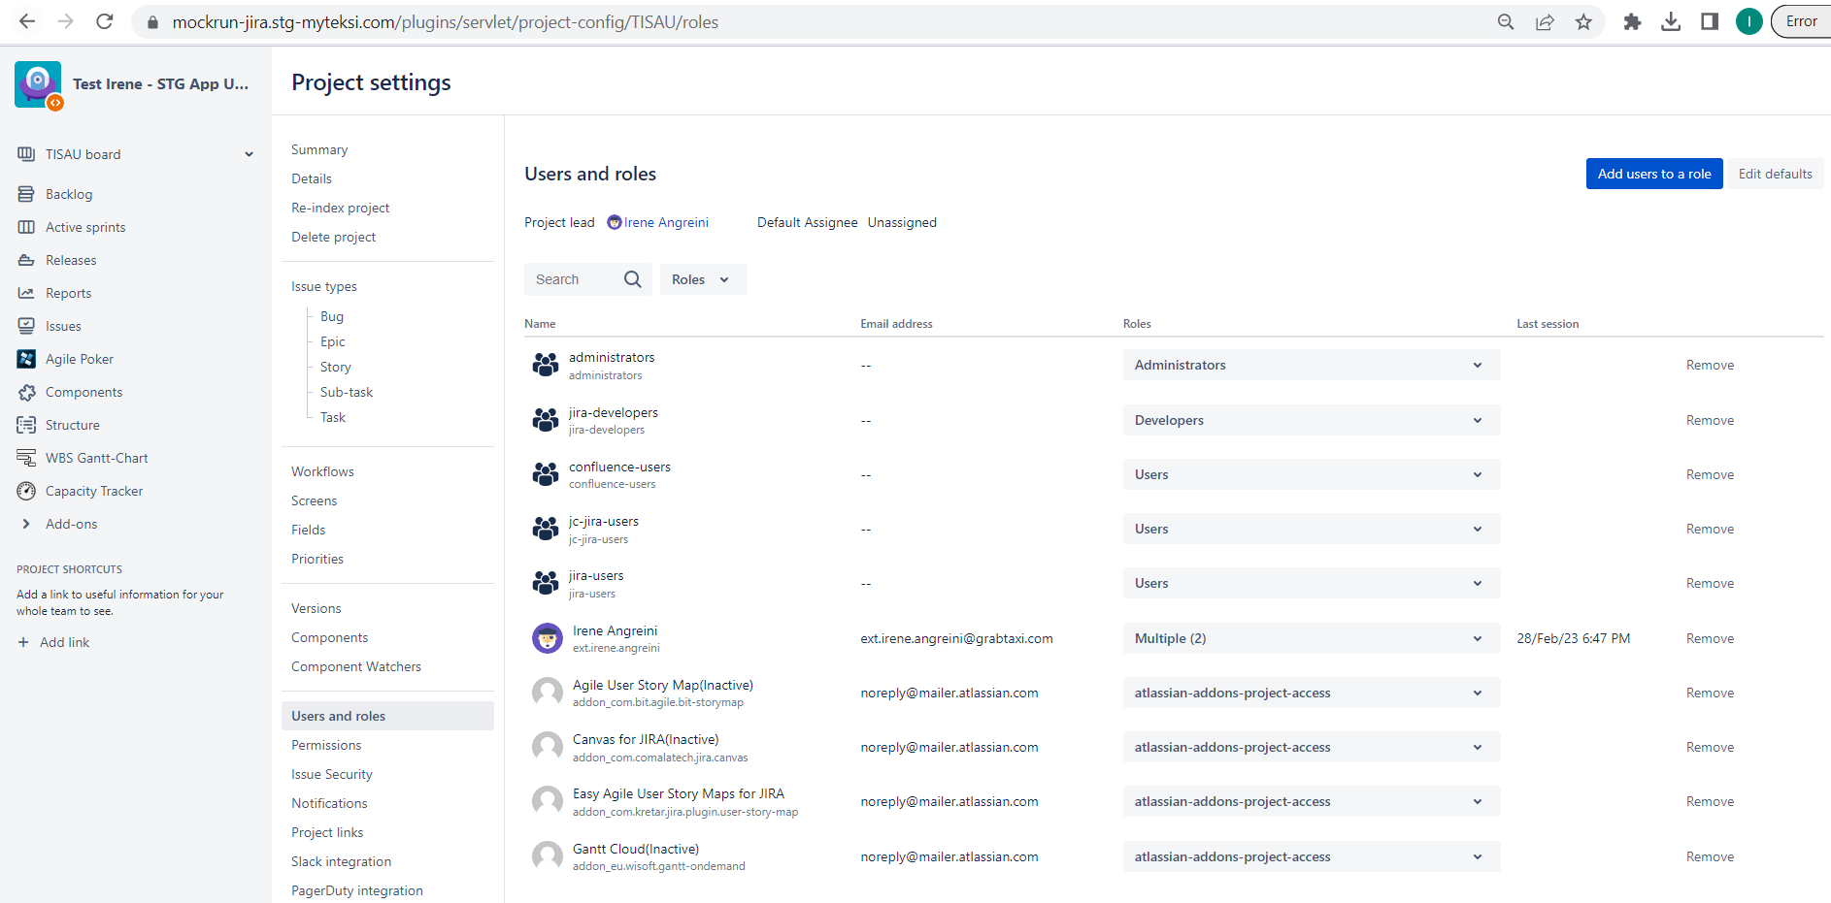

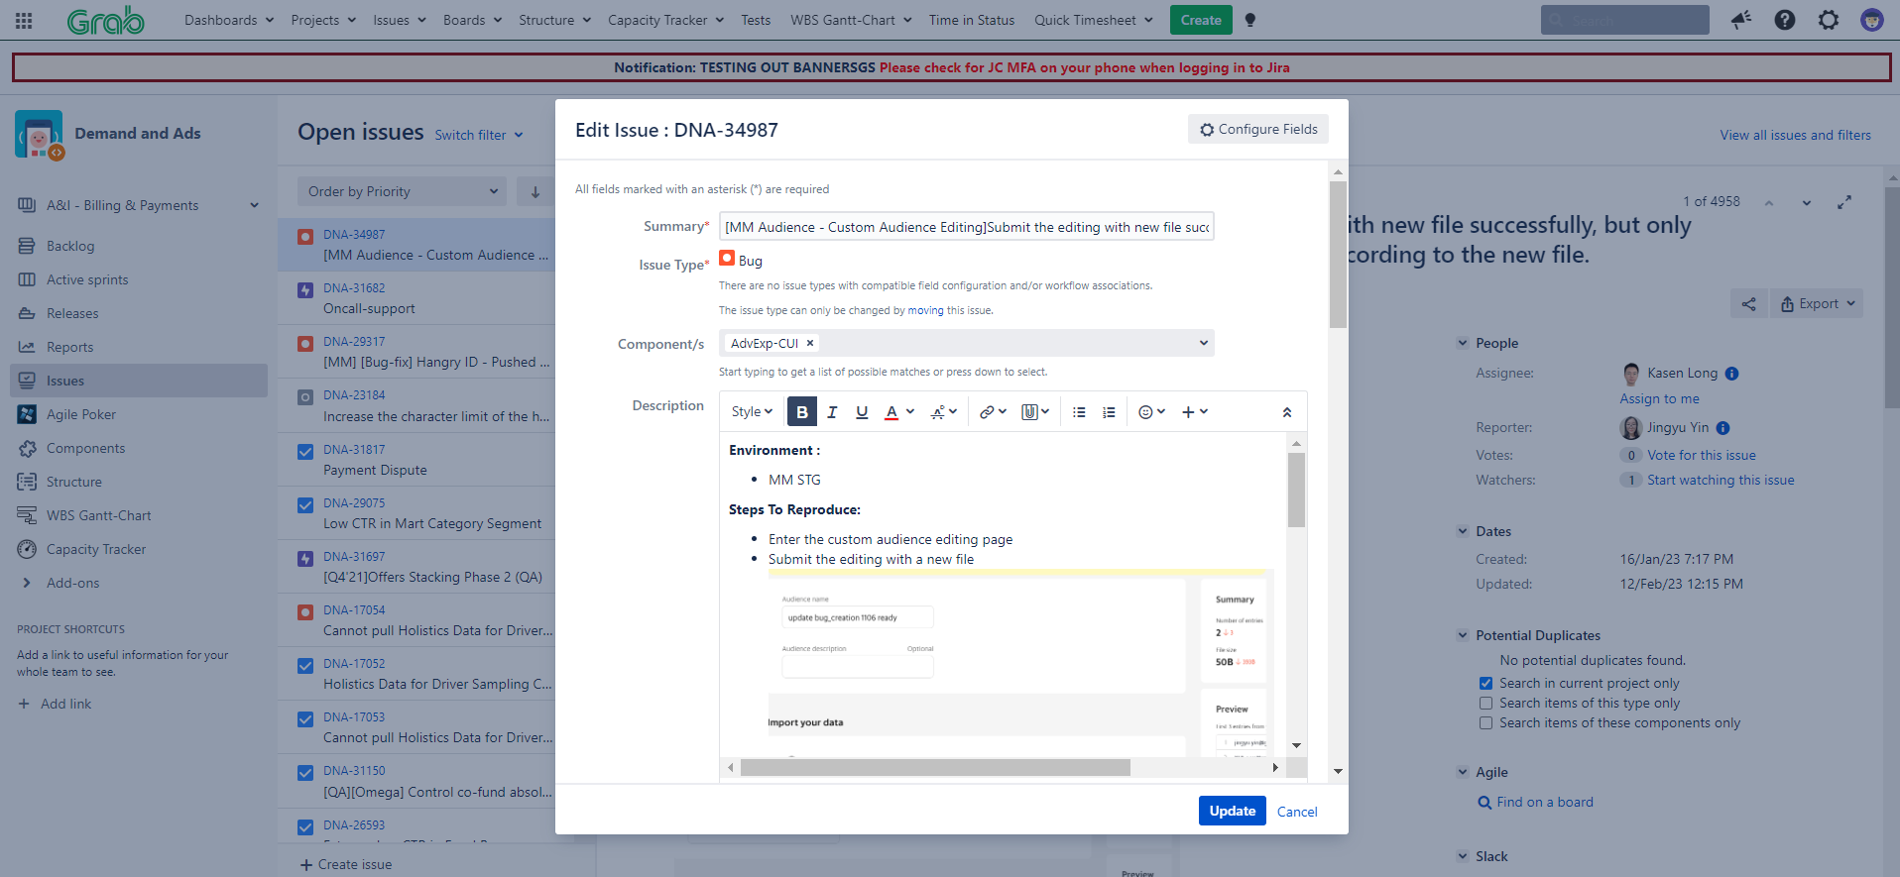

(g) Search functionality

Test whether the search functionality is working.

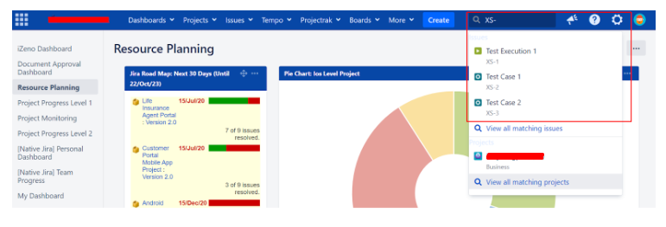

(h) Dashboard

Check that the native dashboard and dashboard with add on gadget are displayed as expected. 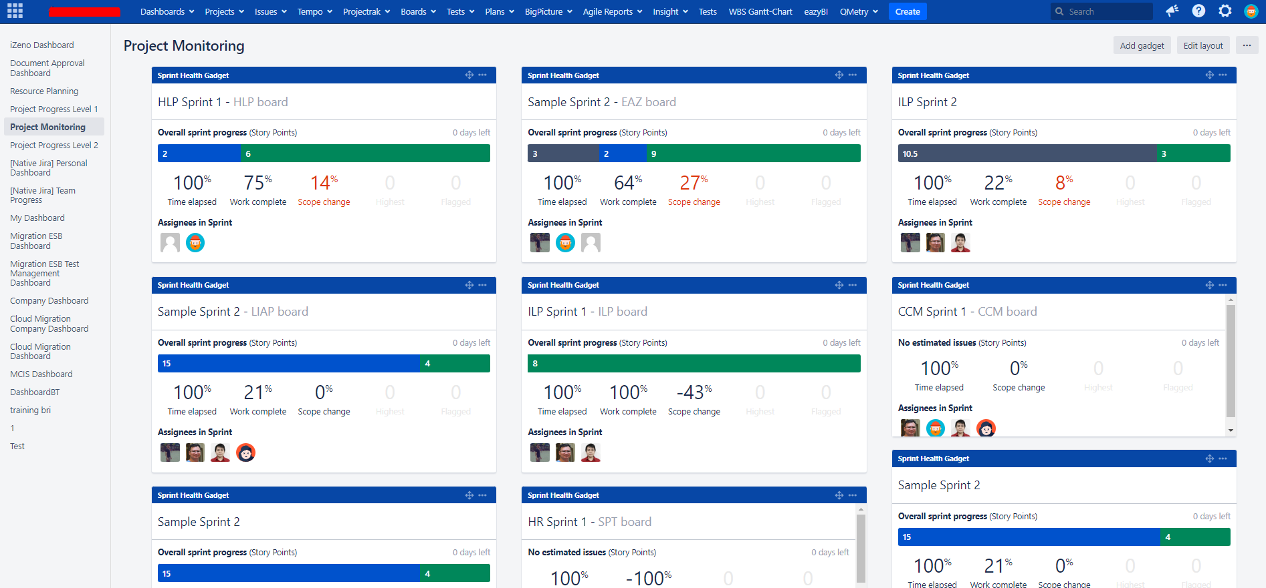

1. **Validate the function of Jira add-ons \***

You will need to

* Log into OCBC Jira as **System Administrator.**
* Test the functionality of each of the Jira add-ons as below.

1. Adaptavist ScriptRunner for Jira

* Select **ScriptRunner** from the Administration console.

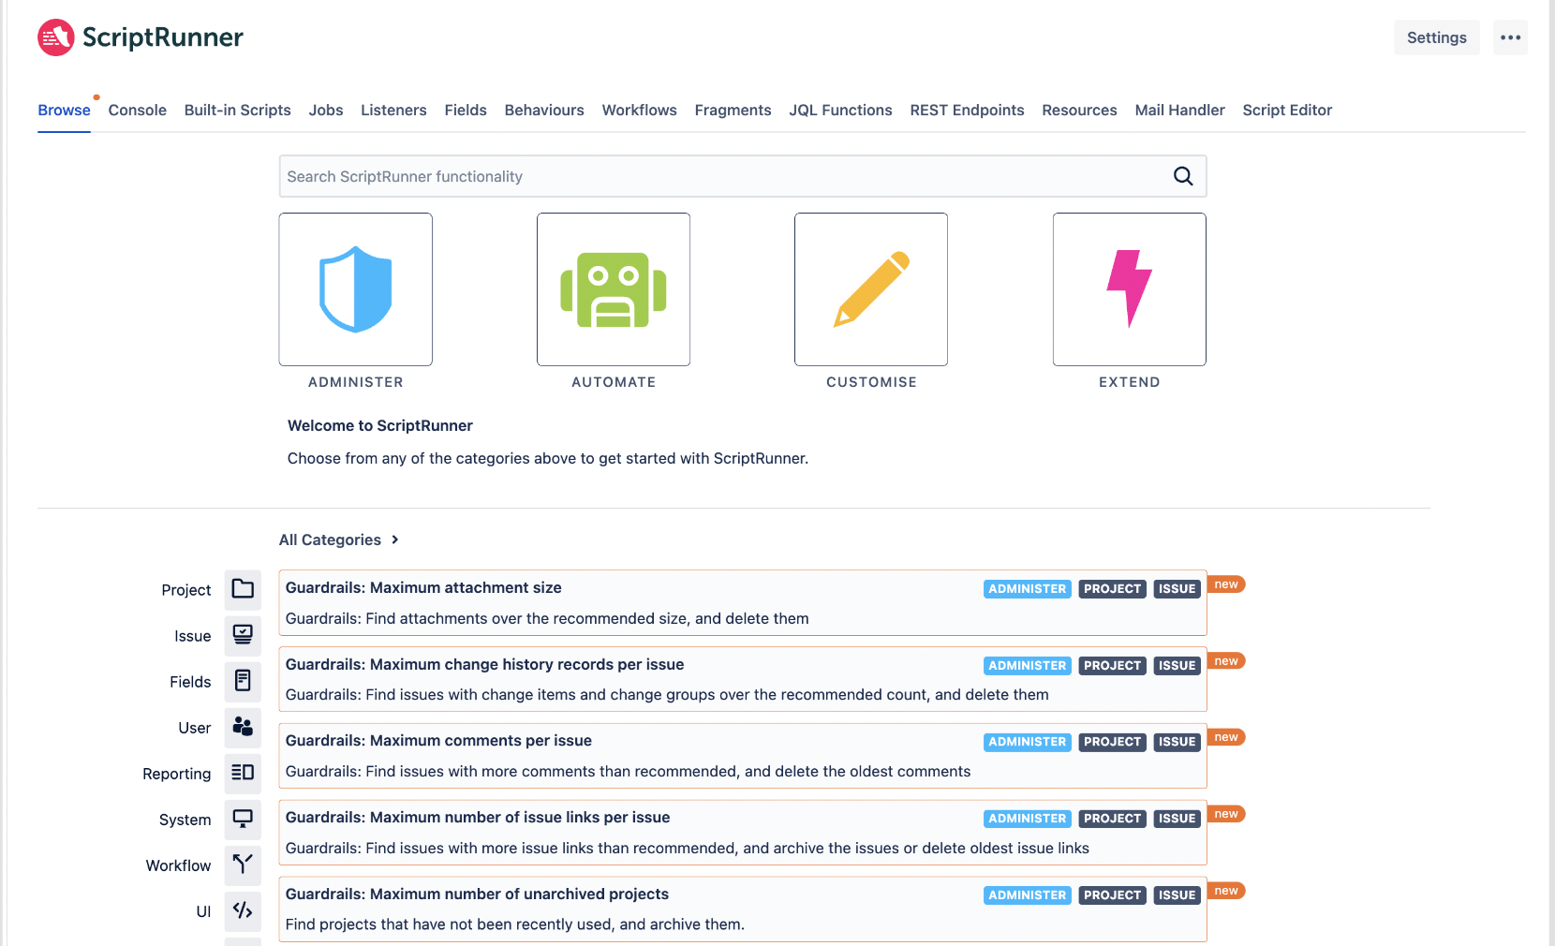

* Use the **search** bar to search for scripts by name or goal. You can select **categories** and **filters** to further narrow down the search results
* Inthe **Console** tab, you can copy/paste or upload your script to test the script functionality.

1. Multiple Filter Charts for Jira

* Select the dashboard you wish to add the gadget in



* Click on **Add gadget.**
* Search for **Multiple Filters** and add the desired gadget

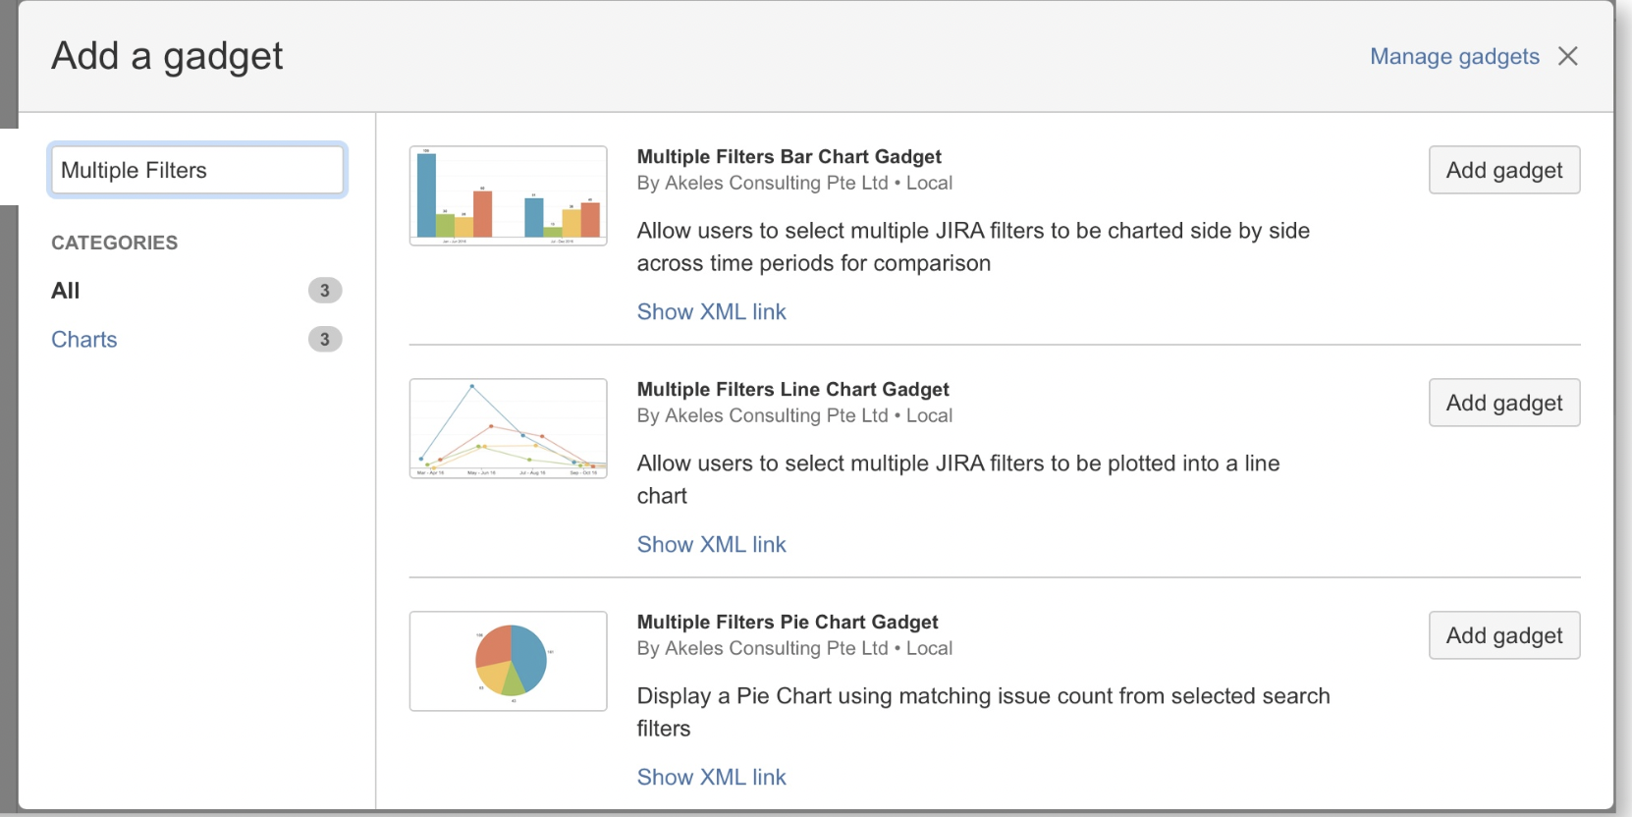

* Configure the gadget by selecting the options on the next screen and view the displayed output.

1. Time In Status

* Select **Time In Status** from the top menu navigation.

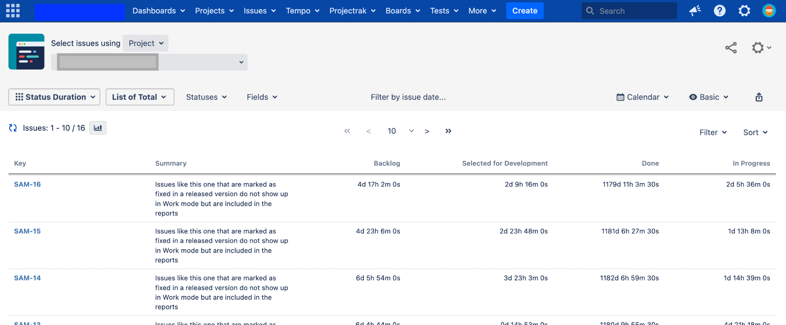

* You can change the below options to show a different report view
  + Filter Type
  + Columns By
  + Statuses
  + Fields
  + Date Range
  + Calendar

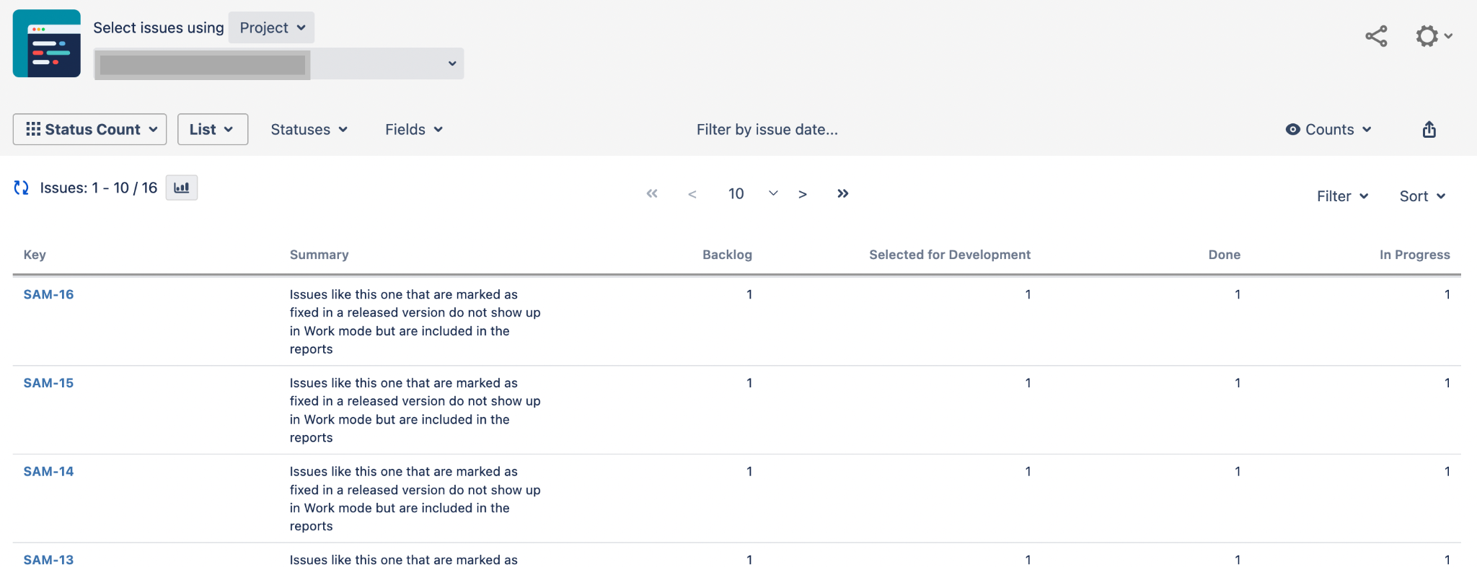

1. Easy Agile User Story Map

* Select one of the project and click on **User Story Map** from the project menu sidebar.

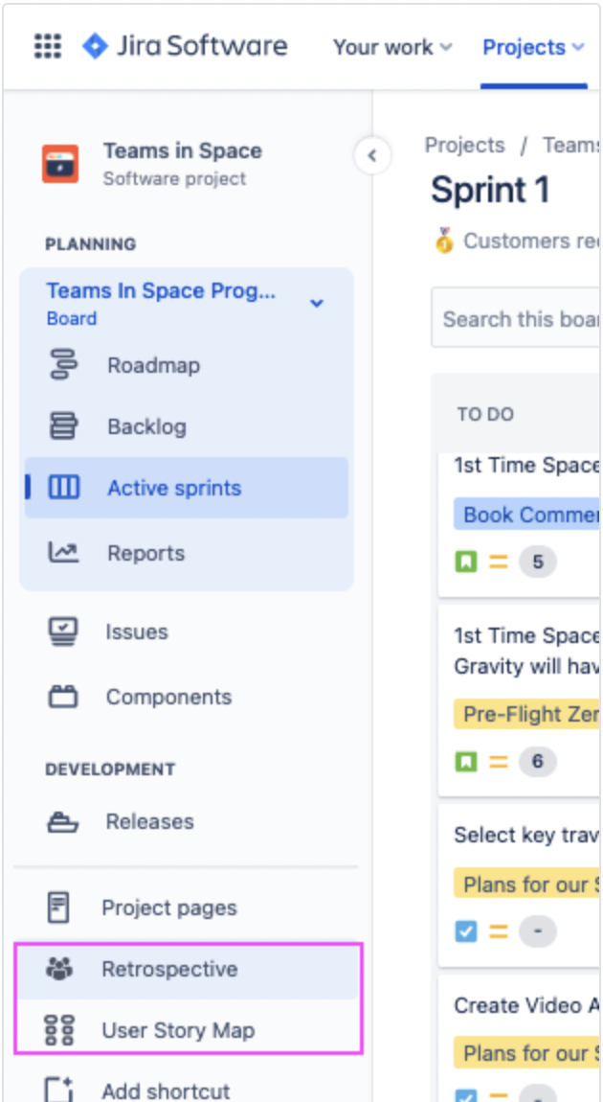

* The screen will show the Epics lining the top of the Story Map, with their linked issues below in the respective Sprint swimlane.

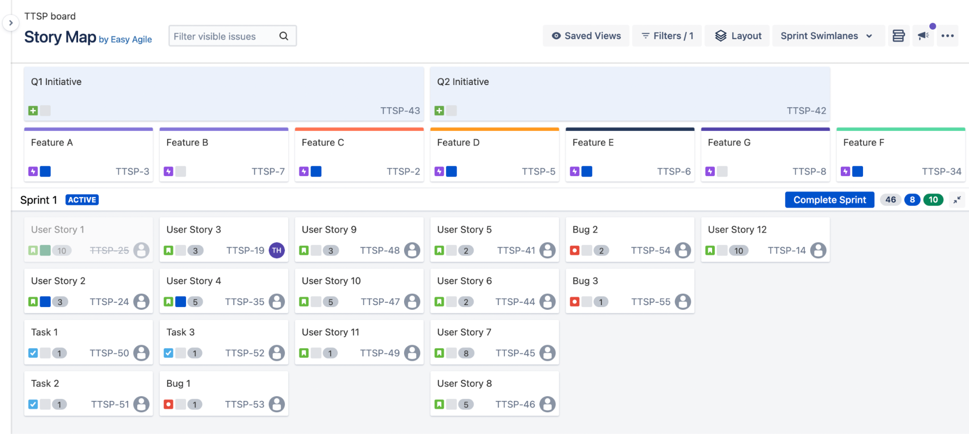

1. JBehave for Jira

* Select the project you wish to have JBehave add-on enabled for.
* Under the project’s administration page, navigate to the JBehave configuration page and enable it.
* Once enabled, navigate to one of the issue in this project and click on **Add User Story** to start adding JBehave stories.

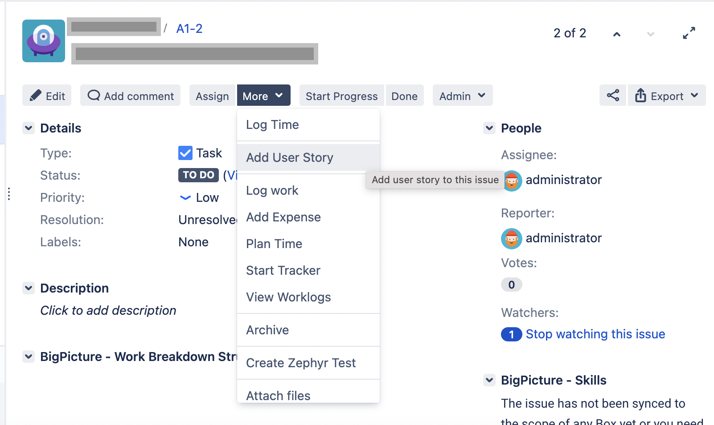

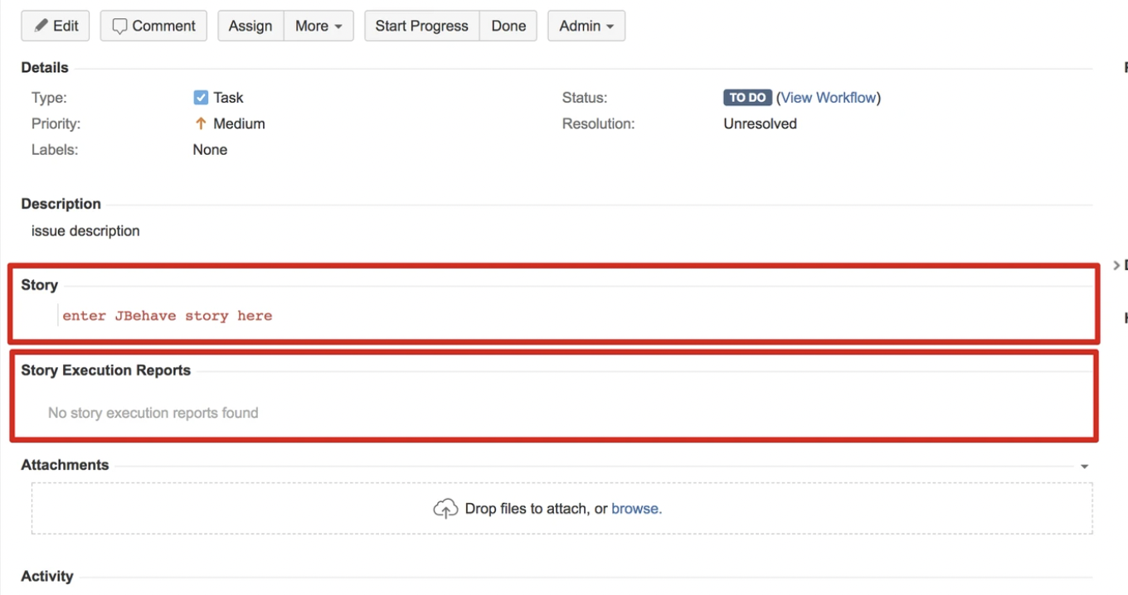

1. Upraise for Employee Success

* Select **Upraise > Dashboard** from the top menu navigation.
* You can view or edit existing dashboards; or click on **Create dashboard** to create your own.

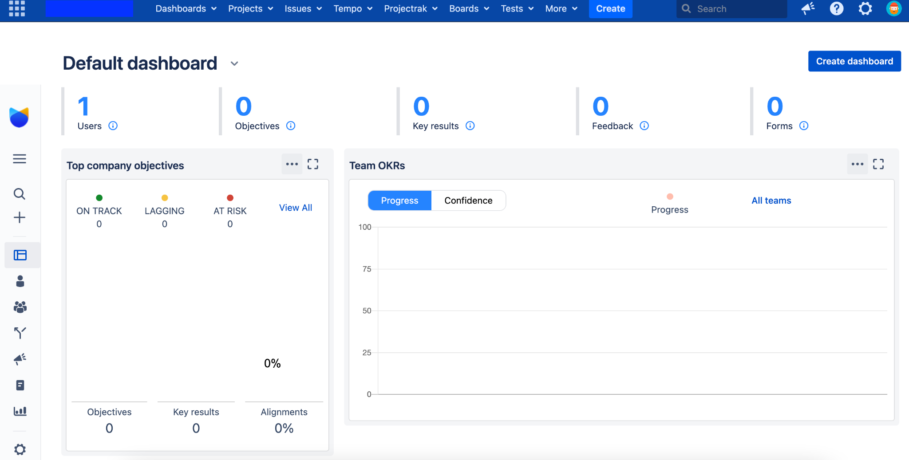

* In the **Forms** page, you can view the forms you are involved in, as well as create form template for use.

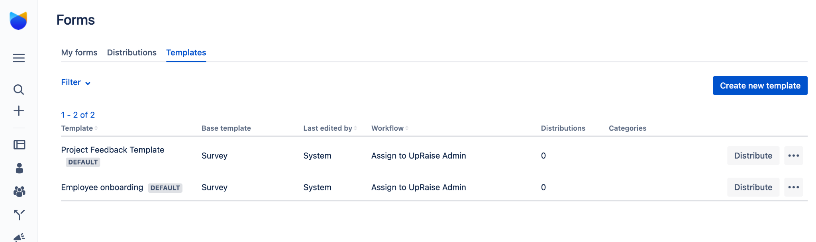

1. Zephyr for Jira

* Select **Tests > Test Summary** from the top menu navigation

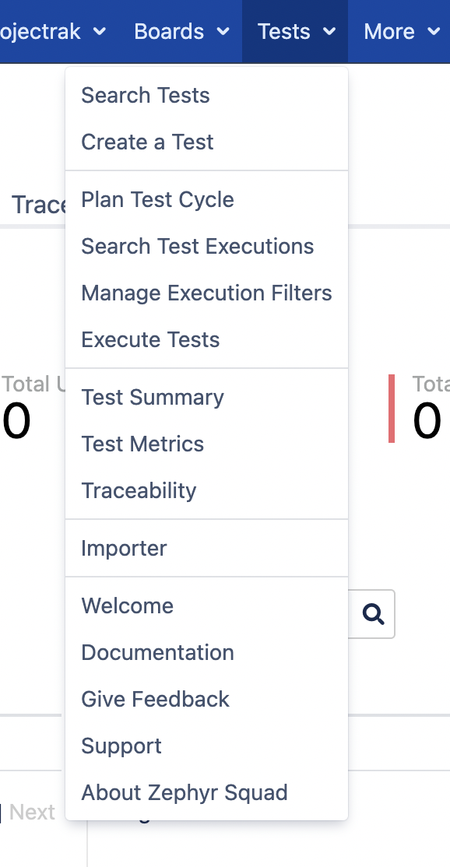

* The Test Summary will show the view of the all the tests that belong to a particular project

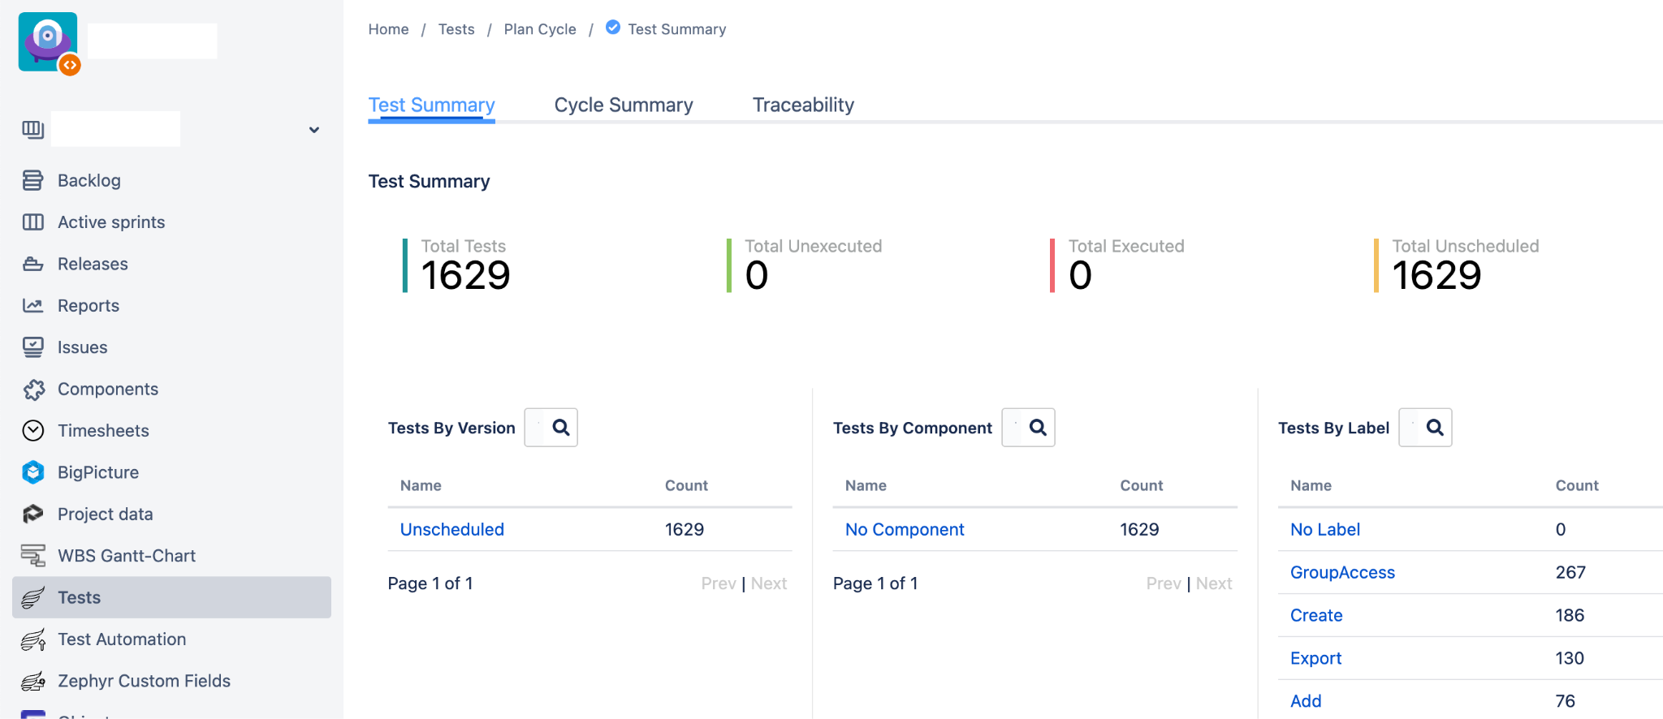

* Click on **Create a Test** to create a test for the project. A test can be created similarly to any issue type in Jira.

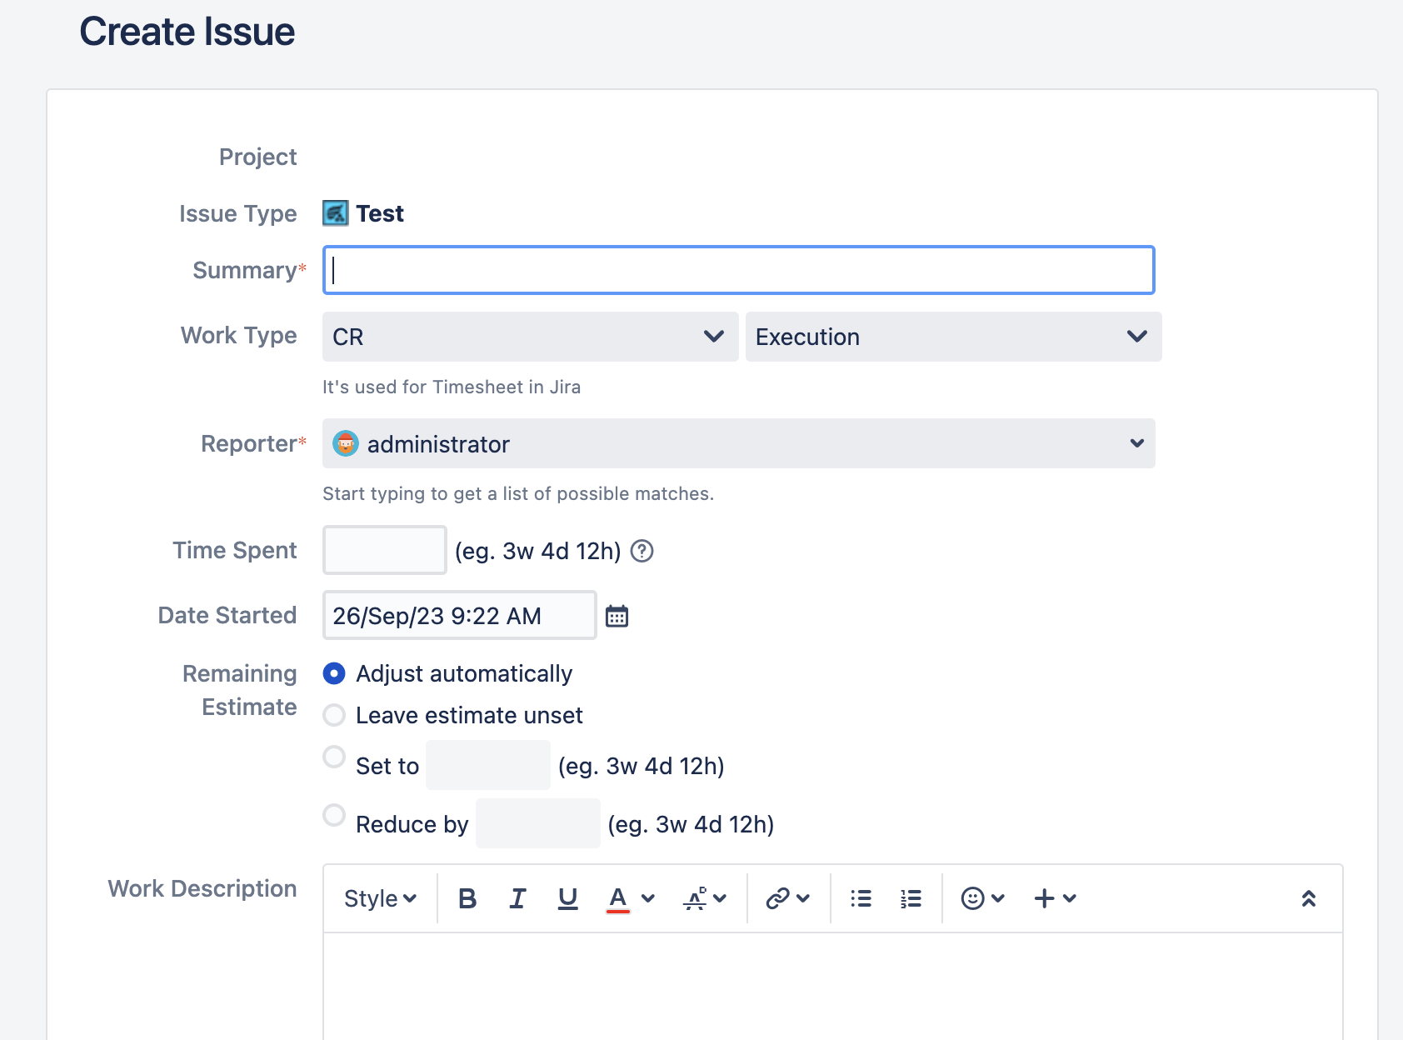

## 5.3 Add-On Data Migration

|  |  |  |
| --- | --- | --- |
| Add-ons | Description | Method of Migration |
| Adaptavist ScriptRunner for Jira | Can be Migrated Using Project Configurator. Script functionality verification will be part of Post Migration Activity. But no package / class has been deprecated with the upgrade. | Project Configurator |
| Easy Agile User Story Maps for Jira | Easy Agile User Story Map Data using the Jira Board ID and which after migrate the project configurator create a same board with new ID | Recreate - Manual |
| JBehave for Jira | Migrated using Project Configurator | Project Configurator |
| Multiple Filters Chart Gadget | Migrated using Project Configurator | Project Configurator |
| Time In Status | Able to migrate because the data using jira issue history which Project Configurator can migrate | Project Configurator |
| UpRaise for Employee Success | There is no export import method, and the data can’t be migrated using Project Configurator. Data will be recreated manually. | Recreate - Manual |
| Zephyr for Jira | Using Zephyr Squad native export and import, populate additional data (test execution) with script to migrate | Project Configurator for the issues data  Script Migration for Test Execution, Folder, and Cycle Assignment |

### 5.3.1 ScriptRunner Add-On Data Migration

Adaptavist ScriptRunner for Jira is a collection of powerful but easy-to-use workflow functions, JQL functions, listeners, and services, enabling the automation of a wide range of tasks in Jira and other tools in the Atlassian ecosystem. Project Configurator currently supports ScriptRunner Behaviours, Workflows, Resources, Script Fields, REST Endpoints, Jobs, Fragments, and Listeners.

The prerequisite for Scriptrunner to be able to migrate with Project Configurator is ProjectConfigurator version 3.6 or newer and ScriptRunner version 6.22 or newer with details [here](https://appfire.atlassian.net/wiki/spaces/PC/pages/197952617/Integration+with+ScriptRunner+for+Jira). The instances are able to meet these prerequisites. With that prerequisite, the migration can cover ScriptRunner for Jira (Behaviours, Workflows, Resources, Script Fields, REST Endpoints, JObs, Fragments, and Listeners).

### 5.3.2 Zephyr Squad Add-On Data Migration

Zephyr Squad is a Jira Add-on that brings test management capabilities specifically built to cater the needs of QA/Tester team use cases. With the addition of Zephyr Squad, tests can be created and viewed in any Jira project, linked to other issues, executed immediately or as part of a test cycle and detailed test metrics can be tracked via customized gadgets.

The main data migrations using Project Configurator are not able to cover Zephyr Squad Data Migration and especially data merge considering target instances already have Zephyr Squad data. To migrate and merge the data, a combination of Zephyr Specific Export and Import with some manual API Data migration will be used. To be more exact, test cases will be migrated using the export import method, while test executions, test cycles, and attachments will be recreated manually using REST API.

### 5.3.3 Time in Status Data Migration

Time in Status prepares the report using the Jira Issue History and using the project configurator we can migrate the issue history. The process of the migration will be the same as the project configurator data migration.

To check the data report succeed, we can go to the Time in Status and can check the duration the issue is in the status.

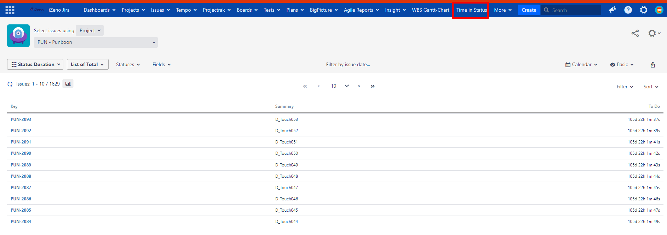

### 5.3.4 JBehave for Jira Data Migration

JBehave data can be migrated using Project Configurator. The process to migrate is the same step when using the project configurator. The migrated data is the User Story Field.

To check the data have been migrated We need to run the SQL query:

|  |
| --- |
| SELECT count(*) FROM "AO_EEBD71_JBEHAVE_STORY" group by "PROJECT_KEY" having "PROJECT_KEY" = <Project_Key>; |

This will return the total issue in the project we migrate that has Jbehave for Jira.

### 5.3.5 Multiple Filters Chart Gadget

Multiple Filters Chart Gadget can be migrated using Project Configurator. The process to migrate is the same step when using the project configurator. The migrated data are the Filters and Gadgets.

The respective dashboard needs to be shared to the project so it can be included when migrated.

To check if the data has been migrated, we need to run this query in the Jira database: This query will return all the dashboards that use Multiple Filters Chart Gadget.

|  |
| --- |
| SELECT pp.pagename, pc.gadget_xml, count(pc.gadget_xml)  FROM portalpage pp  JOIN portletconfiguration pc ON pp.id = pc.portalpage  WHERE pc.gadget_xml LIKE '%MultipleChartsGadget%'  GROUP BY pp.pagename, pc.gadget_xml; |

### 5.3.6 Easy Agile User Story Maps for Jira Data Migration

Can not be migrated using project configurator because the add on using board id as a reference and after the migration the board ID will be different so can not reference back.. The only option is to recreate the board manually in the project. By default the epic issue will always top the hierarchy.

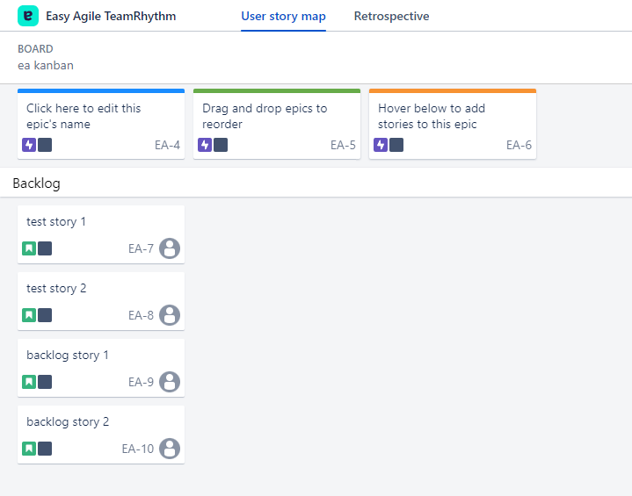

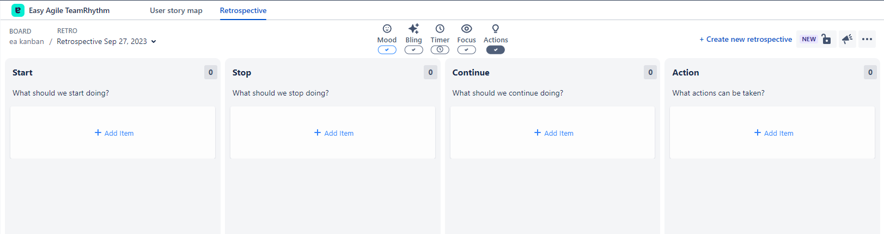

### 5.3.7 UpRaise for Employee Success Data Migration

There is no default migration pathway to merge. Migration will be done by manually recreating the dashboard and the form that has been used in BOS.

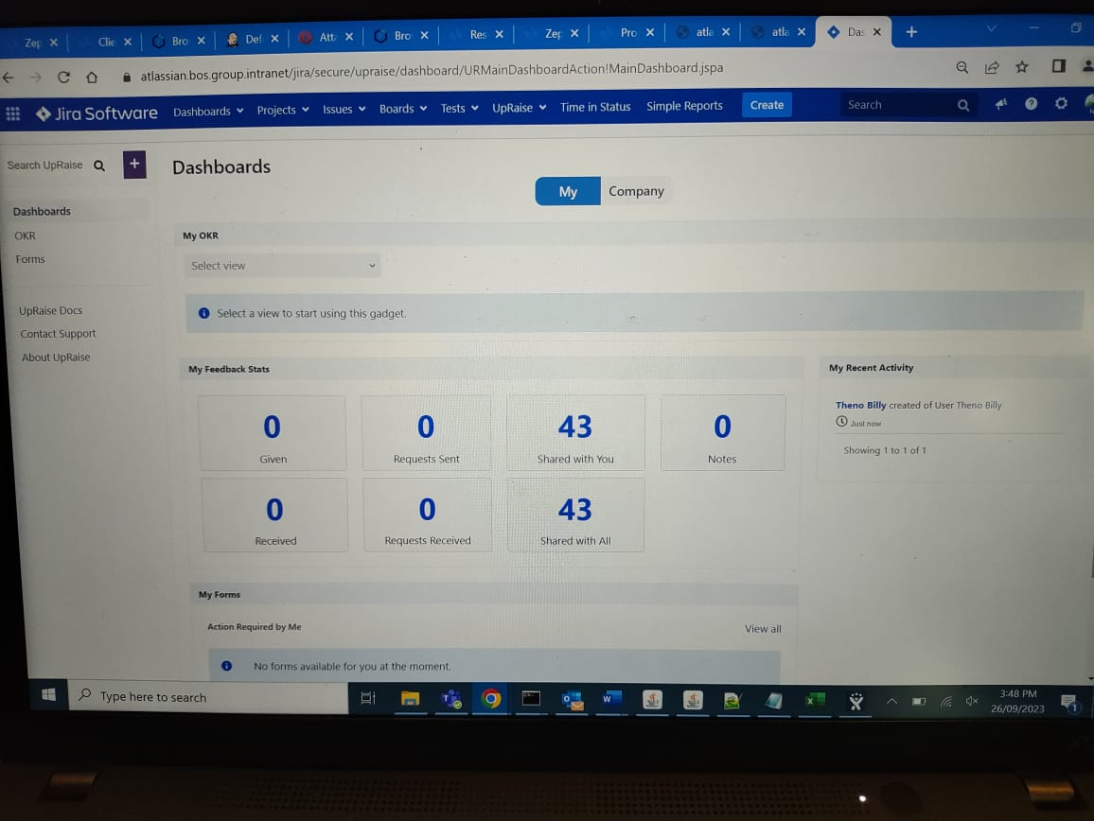

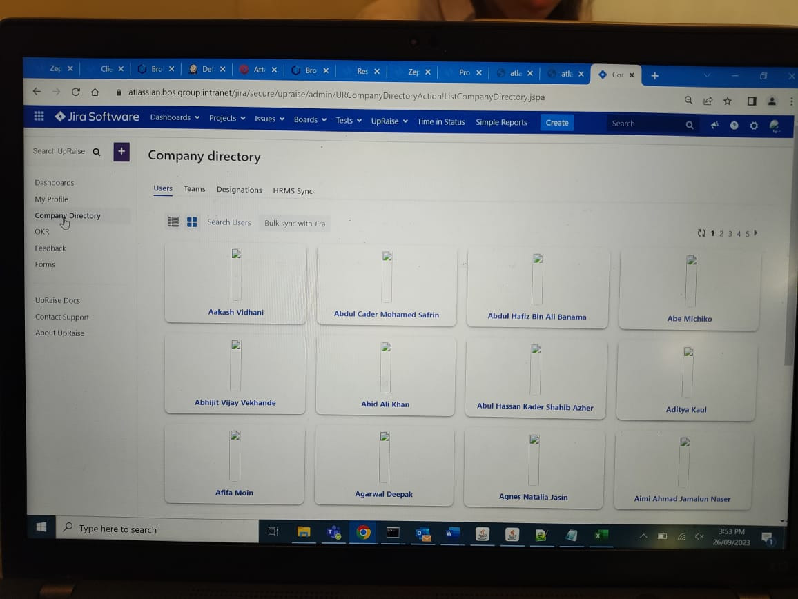

## 5.4 Rollback procedure

To do the rollback because the project is merging there will be no significant changes in the target so we just delete the project that we migrate in the production.

If need the clean instance without any data from BOS migrated, OCBC need to take database backup and VM Snapshot

1. Shutdown the OCBC Jira Service
2. Restore the OCBC Database backup
3. Restore the OCBC Virtual Machine Snapshot
4. Turn on the OCBC Jira Service Up

# 

# 6. Nexus Migration Process

Objective is to migrate Nexus repositories from the BOS environment into the OCBC environment. Doing so enables:

* Optimisation of data management, and cleanup of old repositories, unused artifacts.
* High level visibility and traceability of data repositories across the Bank environment.

## 6.1 Prerequisites

To get started, the following prerequisites need to be met:

* BOS to be on Nexus instance with Pro license
* Stable network connection between BOS Nexus server and OCBC Nexus server.
* Sufficient available disk space between BOS Nexus server and OCBC Nexus server

## 6.2 Migration Procedure

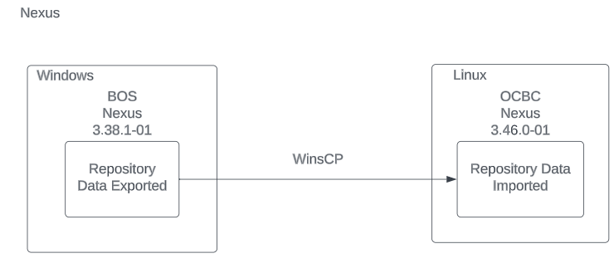

### 6.2.1 Pre-Migration Procedure

* List repositories information in BOS Nexus using python script in Section 10.1 , including the configuration for each repository. This list will provide the following information about each repository: name, size, assets, checksum, and last modified.
* List the repositories name in OCBC Nexus.
* Check for conflicts in the repository name and asset name between BOS instance and OCBC instance.
* List the assets in OCBC Nexus using python script in Section 10.1, from the repository that are the same as BOS Nexus.
  + If the asset has the same repository, name and path, BOS and OCBC team will need to resolve the asset name.
* Based on the repository size information, the BOS and OCBC teams will provide a sufficient disk size for the exported repository.

### 6.2.2 Migration Procedure

1. Create export repositories task in BOS Nexus

You will need to

* Log into BOS Nexus as **Administrator.**
* Click the **Server Admin** button**.**

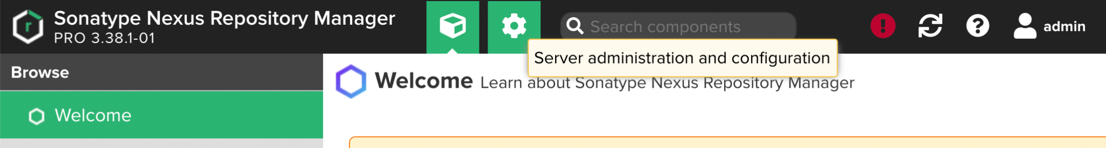

* On the left panel, click on **Tasks** under **System** section.

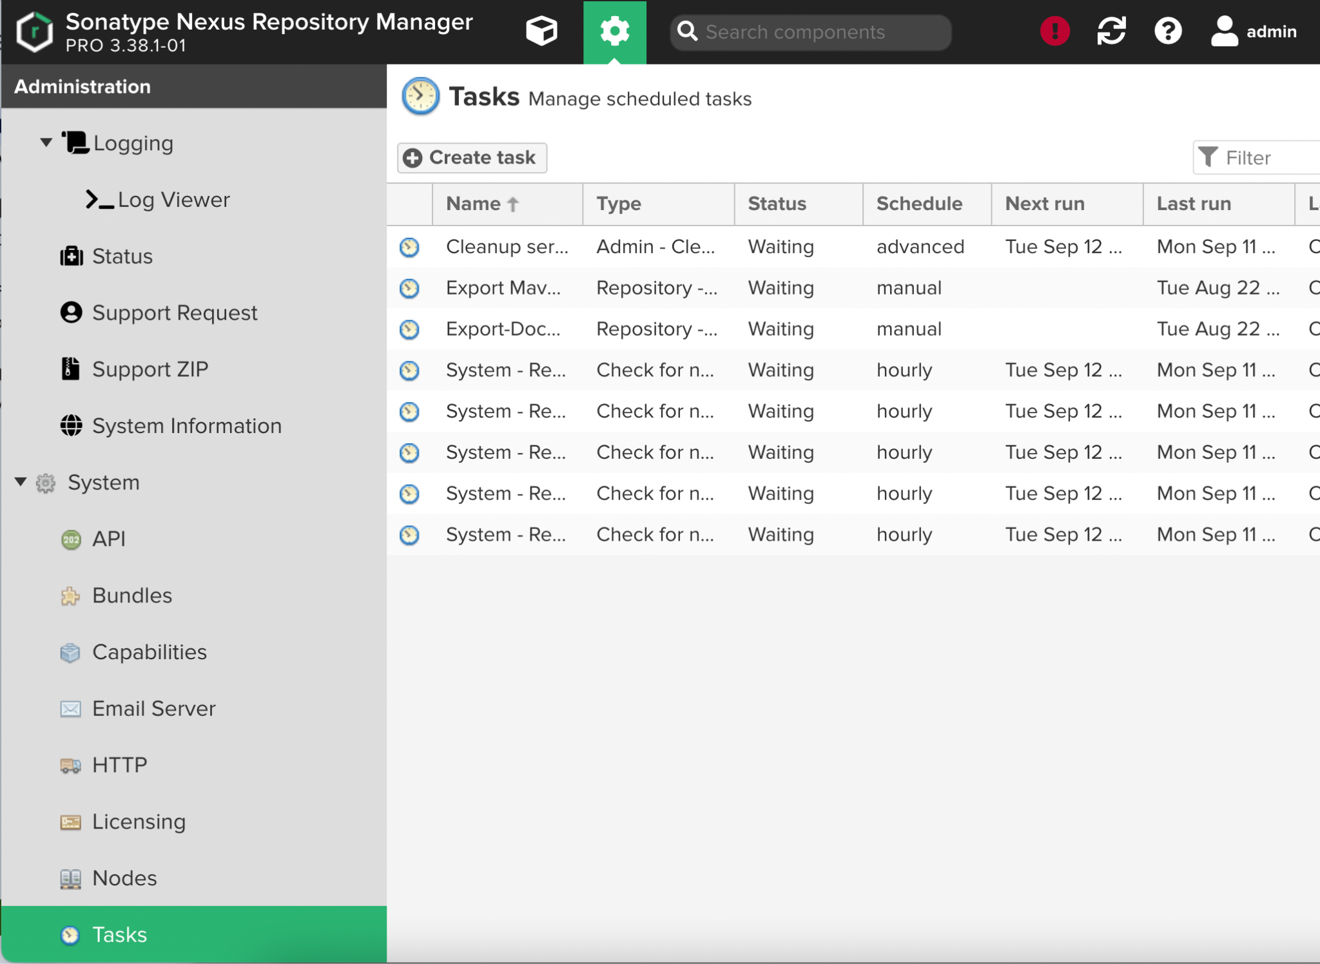

* Create a new task of type **Repository - Export assets.**

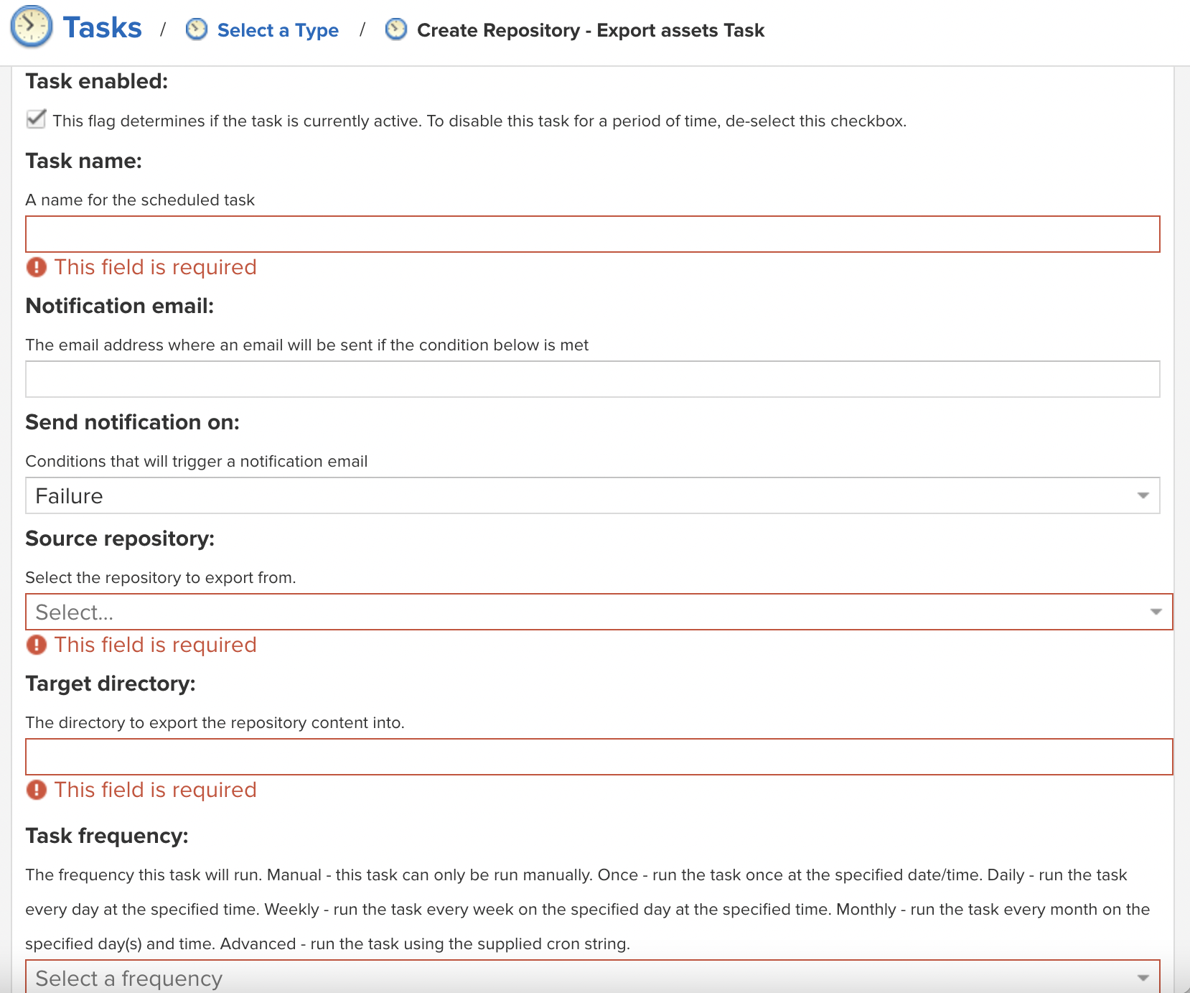

* Input a **Task name** to identify the task in user interface and log files.
* Configure a **Notification email** for the task execution. If the notification condition is met, a notification email will be sent to the configured email recipient.
* Notification can be sent on *Failure* or on *Success or Failure.*
* **Source repository** refers to the repository to export data from.
* **Target directory** refers to the directory in your server to export repositories into. The target directory must be writable by the user running the export task.
* Selecting the **Task frequency** allows you to configure the schedule for the task execution. Apart from *Manual* option, other options will trigger display of a custom user interface for scheduling the specific recurrence.
* Click **Create task** once done.
* On the Tasks interface, you can view the *status* and *last result* of the tasks.

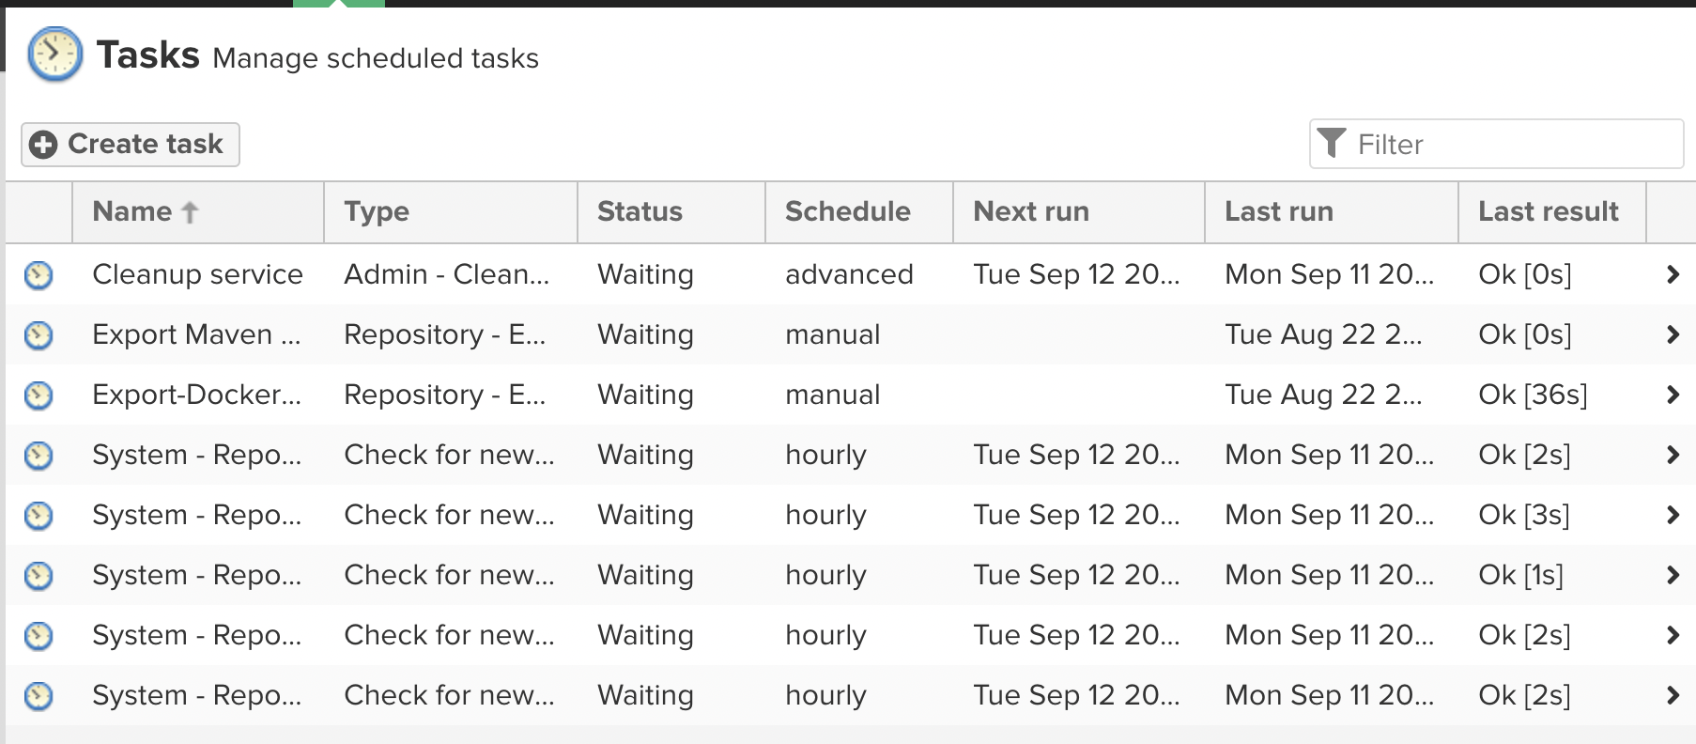

1. Run export task in BOS Nexus

Only one export task can run at a time. When the task runs, it generates a *.nexus* directory inside of the target directory, that contains some metadata you can use for future exports. This enables you to keep exporting content into this directory, and each time only the newer content will be exported.

As the export is running, every single exported file will be logged to a *task log,* along with any errors that may have occurred. If an error occurs with any particular asset, this will be logged and the export process will continue.

1. Transfer the exported BOS Nexus data to OCBC Nexus

To transfer all the exported data files to OCBC server, you can use WinSCP.

* Ensure you use a local computer that has **system administration access** to BOS server and OCBC server.
* Ensure you have WinSCP installed on your local computer.
* Have the following information ready:
  + **Host name/IP address** of the OCBC server
  + **Protocol** supported by the OCBC server
  + **Username and password** of the service account to use
* Start WinSCP and the Login Dialog will appear.



* Choose the protocol supported by OCBC server in the **File protocol** field.
* Enter **IP address or DNS name** of the target OCBC server in the **Host name** field.
* Enter **22** in the **Port number** field.
* Enter **user name and password t**o authenticate access to OCBC server.
* Click **Login** button
* Verify that you are authenticated to the OCBC server. Upon success, the IP address or DNS name of the OCBC server will appear at the top of the window.



* On the left window pane, select the files you want to migrate.
* You can drag and drop the files from the left window pane to the target OCBC server pane on the right. The files will start transfer.



* Once complete, you will be able to see the files on the right panel.

1. Create new repositories in OCBC Nexus if no repository shares the same name as those in BOS Nexus

You will need to

* Log into OCBC Nexus as **Administrator**.
* Navigate to the **Repositories** page**.**
* Click **create repository.**
* Select the **Recipe** for the new repository. The Recipe combines the format and the type of repository.

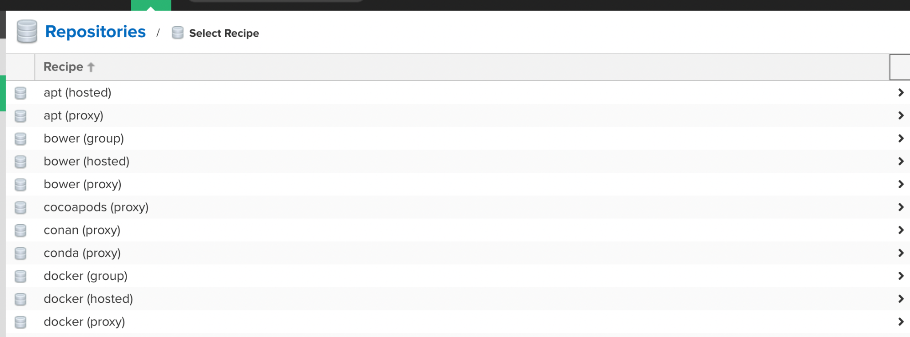

* The next page will show the configuration view that allows you to fill in the required parameters and further configuration. The exact view depends on the selected repository provider.

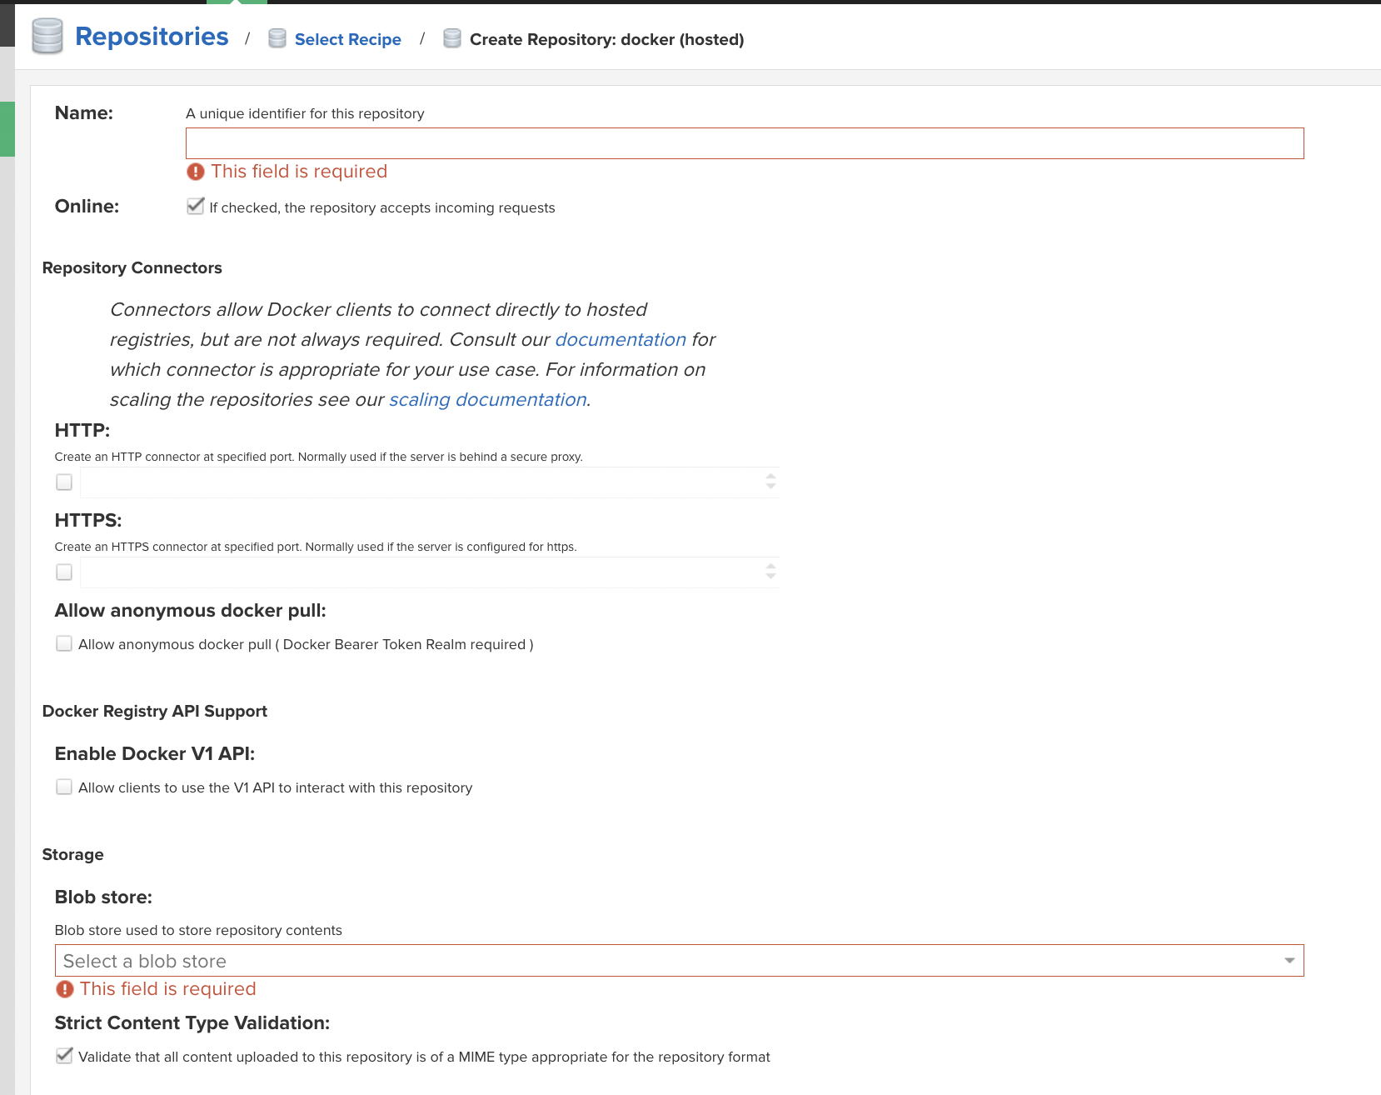

* Click **create** once done.

1. Create import repositories task in OCBC Nexus

You will need to

* Log into OCBC Nexus as **Administrator.**
* Click the **Server Admin** button**.**
* On the left panel, click on **Tasks** under **System** section.
* Create a new task of type **Repository - Import external files.**

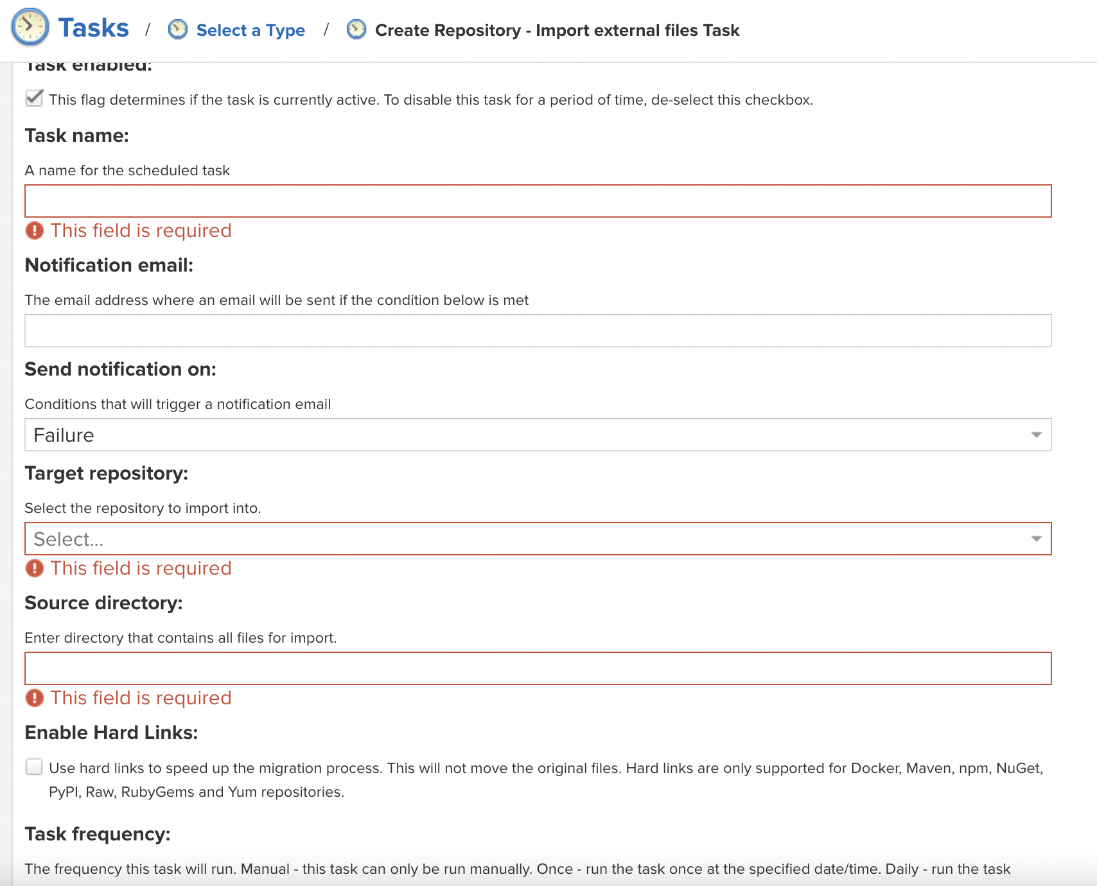

* Input a **Task name** to identify the task in user interface and log files.
* Configure a **Notification email** for the task execution. If the notification condition is met, a notification email will be sent to the configured email recipient.
* Notification can be sent on *Failure* or on *Success or Failure.*
* **Target repository** refers to the repository into which to import data.
* **Source directory** refers to the directory from which to import data.
* The **Enable Hard Links** option will create hard links for the blobs in the source directory to be used in the target directory. A physical copy of the blobs will not be created in the target directory.
* Selecting the **Task frequency** allows you to configure the schedule for the task execution. Apart from *Manual* option, other options will trigger display of a custom user interface for scheduling the specific recurrence.
* Click **Create task** once done.
* On the Tasks interface, you can view the *status* and *last result* of the tasks.

1. Run import task in OCBC Nexus

Only one import task can run at a time. When the task runs, it generates a *.nexus/nxrm-export-import-task/* directory inside the source directory that contains metadata you can use for future imports. This enables you to keep placing content into this directory and each time only importing newer content.

As the import is running, every single imported file will be logged to a *task log,* along with any errors that may have occurred. If an error occurs with any particular file, this will be logged and the import process will continue.

**Error Handling - Conflicting Repository Name** -

If the repository name is the same, the new item will be appended. If the repository name and asset name are the same, the item in the target repository will be replaced with the item from the source repository. To resolve conflicts with items, the workaround is to either rename the source asset or change the tagging.

### 6.2.3 Post-migration Procedure

* List all the new Nexus repository information in OCBC using python script in Section 10.1, including the configuration for each repository. This list will provide the following information about each repository: name, size, assets, checksum, and last modified.
* List the new assets in OCBC Nexus from the repository that are the same as Nexus BOS, as well as the new repository that has been created in the migration process.
* Compare the list before and after the migration.

# 7. Bitbucket Reconfiguration

Objective is to reconfigure Nexus URL in BOS Bitbucket repositories to use OCBC Nexus URL. Doing so enables :

* Integration of BOS Bitbucket with Nexus instance in OCBC.
* An integrated CI/CD solution that will allow continuous delivery.

Bitbucket Reconfiguration will be done as part of Nexus Post Migration.

## 7.1 Prerequisites

To get started, the following prerequisites need to be met:

* Local machines have to have Administrator access to BOS Bitbucket and BOS Jenkins.
* Require the following software installed in local machine or the jenkins agent:
  + Python 3

## 7.2 Configuration Steps

1. Create new repository in BOS Bitbucket

You will need to

* Log into BOS Bitbucket as **Administrator.**
* Click the **Create** button and select **Repository** from the dropdown list.

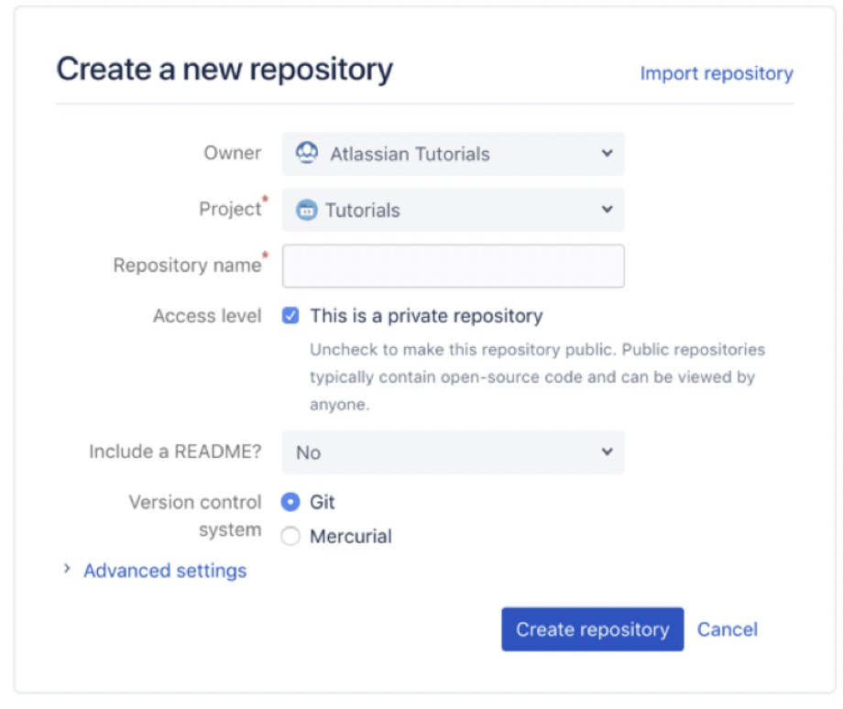

* In the Owner option, choose a repository **Workspace.**
* Select a project from the **Project** dropdown list.
* Input a **Repository name** to describe your repository. The repository name will be included in its URL.
* Keep access to your repository set to **Private,** unless you wish to make your repository public to others.
* Select **No** from **Include a README** option if you already have files you wish to add to your repository. Otherwise, go with the default option or select an option from the dropdown list.
* Select the **Version control system**, or keep **Git** as the default.
* Click **Create repository**.

1. Clone this new repository to your local machine

You will need to

* From the repository, select the **Clone** button on the left menu.

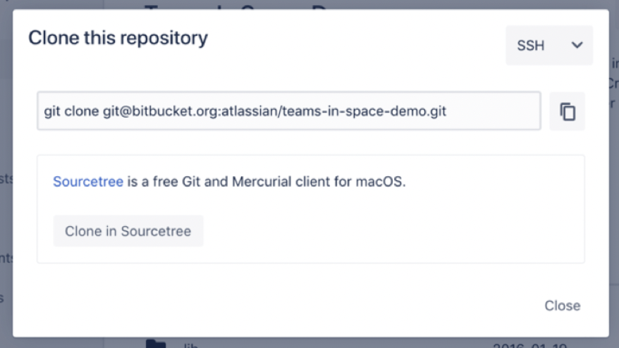

* From the drop-down on the top right, select either **SSH** or **HTTPS**. If you are using the SSH protocol, ensure your public key is in Bitbucket and available on the local machine to which you are cloning.
* **Copy** the clone command
* On your local machine, open the **Command Prompt** application.
* From the terminal window, change to the local directory where you wish to clone the repository, using the ***cd* command**.
* Paste the command you copied from Bitbucket.

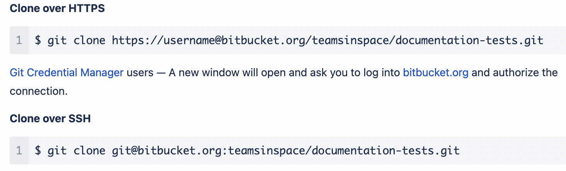

* Upon successful clone, a new sub-directory will appear in your local drive in the directory where you cloned the repository. This directory has the same name as the Bitbucket repository that you cloned. The clone contains the files and metadata that Git requires to maintain the changes you make to the source files.

1. Add the Python scripts to your local repository

You will need to

* Move the script files into the local directory that was created when you cloned the repository. Refer to Section 10.3.
  + *BitbucketMigrationScipt.py*
* From the command terminal window, change to your local repository, using the ***cd* command**.
* **Stage** the script files for commit to your local repository. You can use *“git add --all”* command to add all the files.

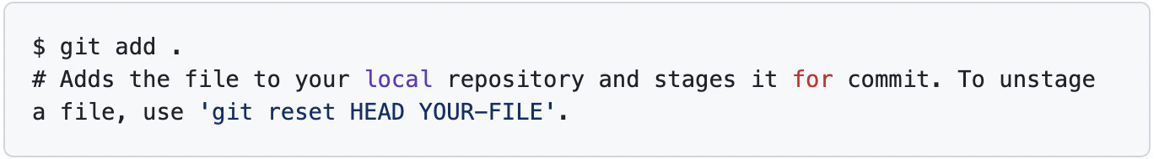

* **Commit** the script files

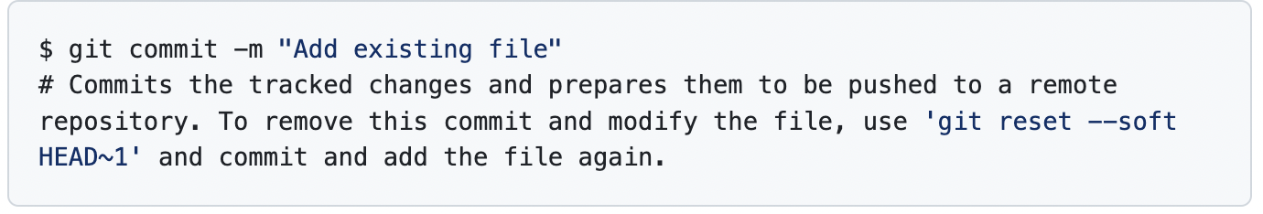

1. Add the Jenkins File to your local repository

You will need to

* Move the Jenkin File into the local directory that was created when you cloned the repository.
  + *Jenkinsfile*
* From the command terminal window, change to your local repository, using the ***cd* command**.
* **Stage** the Jenkin File for commit to your local repository.



* **Commit** the Jenkin File.



1. Push changes made on local repository to BOS Bitbucket

You will need to

* Have **write access** to the particular repository in BOS Bitbucket.
* From the command terminal window, change to the particular repository directory you wish to push changes to.
* Use **git push** command to push commits from your local repository to BOS Bitbucket

*git push <remote_server> <branch_name>*

where

* *remote_server* is the name of the remote server. *origin* indicates you are pushing to Bitbucket.
* *branch_name* is the repository branch where you made your changes and wish to push them.
* If prompted for authentication, enter your Bitbucket username and password.
* Once complete, open the BOS Bitbucket repository in your browser. The Commit tab shows your most recent commits.

1. Trigger the job via BOS Jenkins

You will need to:

* Log into BOS Jenkins as **administrator**.
* At the Dashboard page, on the top left click **New Item**.

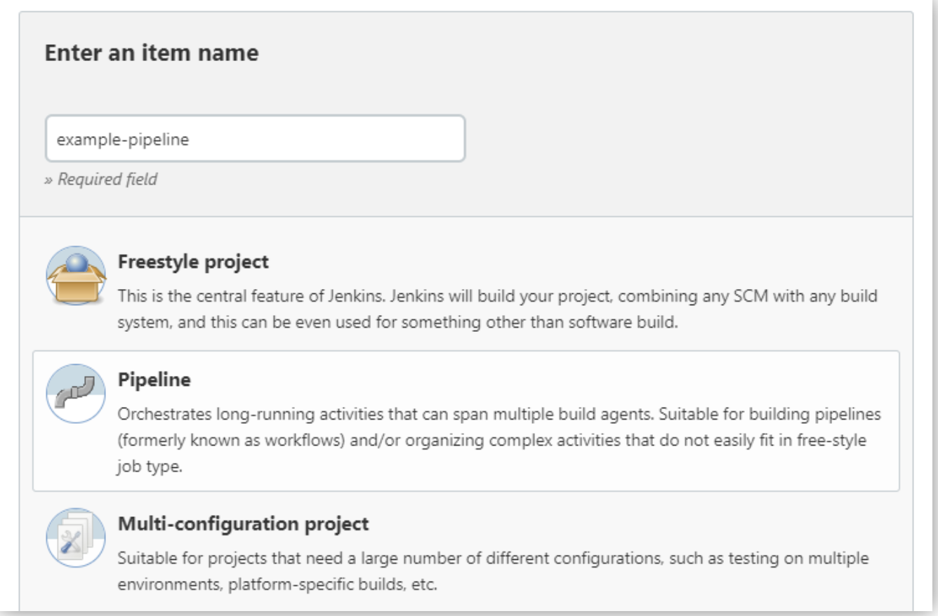

* Specify the name for your Pipeline. Note Jenkins uses this item name to create directories on disk, hence recommended to avoid using spaces in name.
* Select **Pipeline,** then click **OK** at the end of the window to trigger the opening of the Pipeline configuration page.

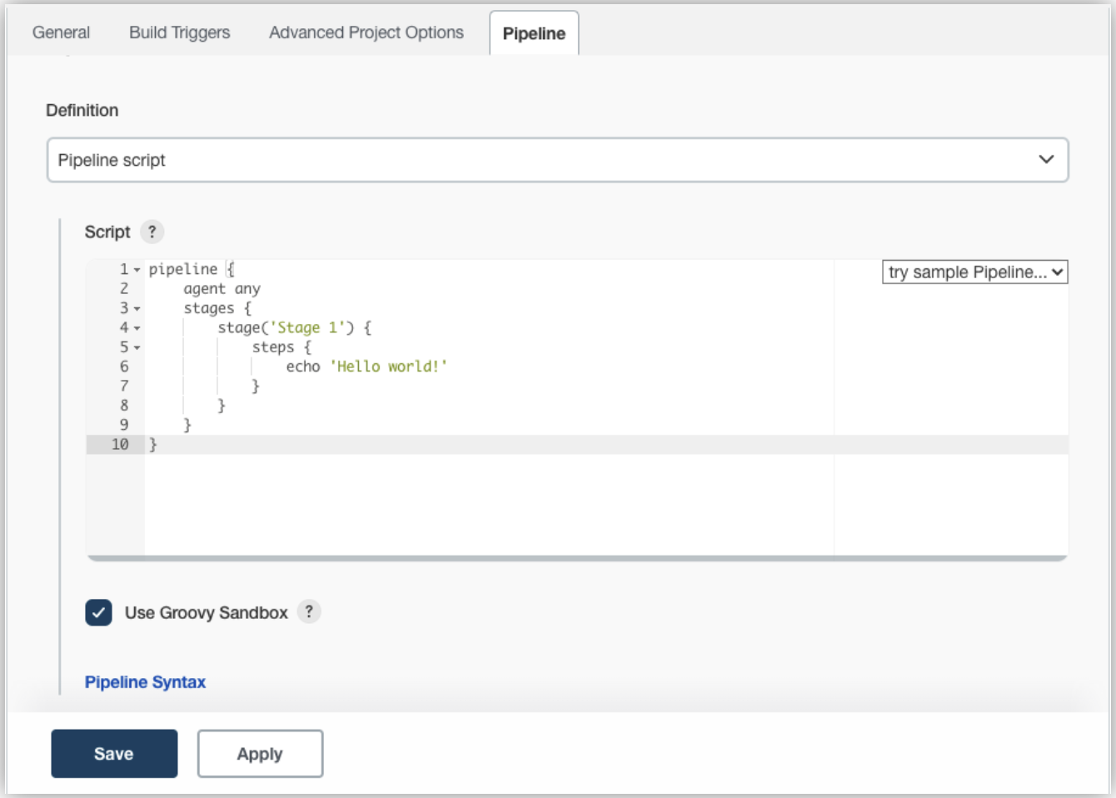

* Click the **Pipeline** tab.
* In the **Definition** field, choose the **Pipeline script from the SCM** option.
* In the **SCM** field, choose the type of source control system of the repository containing your Jenkins File.
* Complete the fields specific to your repository’s source control system.
* In the **Script Path** field, specify the location and name of your Jenkins File. This location is where Jenkins will check out/clone the repository containing your Jenkins File.
* Click **Save** to open the Pipeline item view page.
* On this page, click **Build Now** on the left to run the Pipeline.
* Under **Build History** on the left, click **#1** to access the details of the Pipeline run.
* Click **Console Output** to see the full output from the Pipeline run.

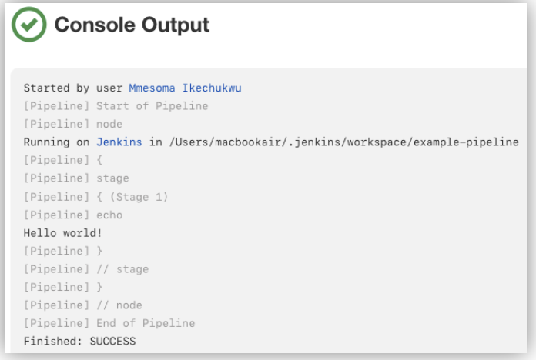

1. Validate the changes in BOS Bitbucket

You will need to:

* Log into BOS Bitbucket as **Administrator.**
* Navigate to the Repositories page to see the latest status of the repositories.
* Open your Repository and click on the Commitstab to see the latest changes made.

# 8. Jenkins Reconfiguration

Objective is to reconfigure Nexus URL in BOS Jenkins instance to use OCBC Nexus URL. Doing so enables:

* Integration of BOS Jenkins with Nexus instance in OCBC.
* An integrated CI/CD solution that will allow continuous delivery.

Jenkins Reconfiguration will be done as part of Nexus Post Migration.

## 8.1 Prerequisites

To get started, the following prerequisites need to be met:

* Local machines have to have Administrator access to BOS Jenkins and BOS Bitbucket.
* Require the following software installed in local machine and BOS Jenkins server:
  + Python 3

## 8.2 Configuration Steps

1. Add the Python scripts to your local repository

In Section 7.2 above, you have created and cloned a repository from BOS Bitbucket instance to your local directory, refer to Step 1 and 2. You may use the same local directory to store the python scripts for this section.

You will need to:

* Move the script files into the local directory that was created when you cloned the repository. Refer to Section 10.2.1
  + *file-list.py*
* From the command terminal window, change to your local repository, using the ***cd* command**.
* **Stage** the script files for commit to your local repository. You can use the *“git add --all”* command to add all the files.



* **Commit** the script files



1. Add the Jenkinsfile to the pipeline configuration

You will need to

* Move the Jenkinsfile into the local directory that was created when you cloned the repository. Refer to Section 10.2.2
  + *Jenkinsfile*
* From the command terminal window, change to your local repository, using the ***cd* command**.
* **Stage** the Jenkin File for commit to your local repository.



* **Commit** the Jenkin File.



1. Push changes made on local repository to BOS Bitbucket

You will need to

* Have **write access** to the particular repository in BOS Bitbucket.
* From the command terminal window, change to the particular repository directory you wish to push changes to.
* Use **git push** command to push commits from your local repository to BOS Bitbucket

*git push <remote_server> <branch_name>*

where

* *remote_server* is the name of the remote server. *origin* indicates you are pushing to Bitbucket.
* *branch_name* is the repository branch where you made your changes and wish to push them.
* If prompted for authentication, enter your Bitbucket username and password.
* Once complete, open the BOS Bitbucket repository in your browser. The Commit tab shows your most recent commits.

1. Trigger the job via BOS Jenkins

You will need to:

* Log into BOS Jenkins as **administrator**.
* At the Dashboard page, on the top left click **New Item**.



* Specify the name for your Pipeline. Note Jenkins uses this item name to create directories on disk, hence recommended to avoid using spaces in name.
* Select **Pipeline,** then click **OK** at the end of the window to trigger the open of Pipeline configuration page.
* Click the **Pipeline** tab.
* In the **Definition** field, choose the **Pipeline script from SCM** option.
* In the **SCM** field, choose git.
* Complete the fields specific to your repository’s source control system.

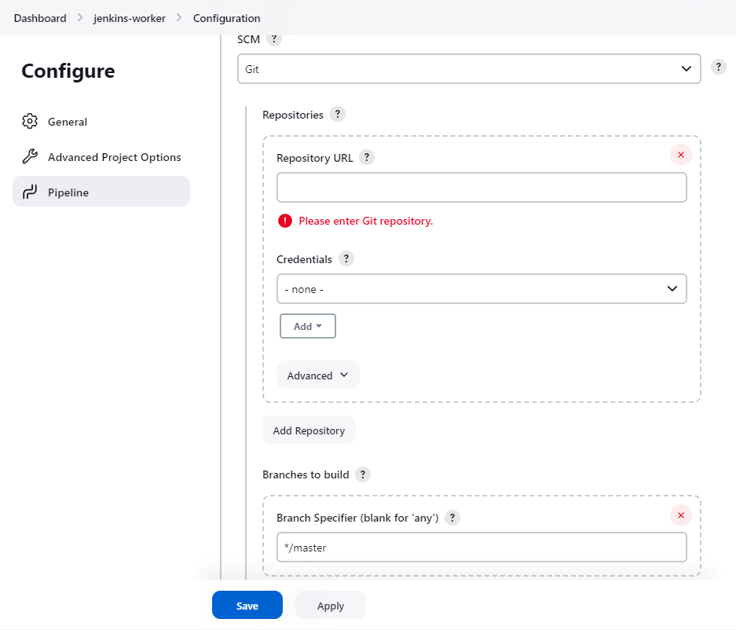

* In the **Script Path** field, specify the location and name of your Jenkinsfile..
* Click **Save** to open the Pipeline item view page.
* On this page, click **Build Now** on the left to run the Pipeline.
* Under **Build History** on the left, click **#1** to access the details of the Pipeline run.
* Click **Console Output** to see the full output from the Pipeline run.

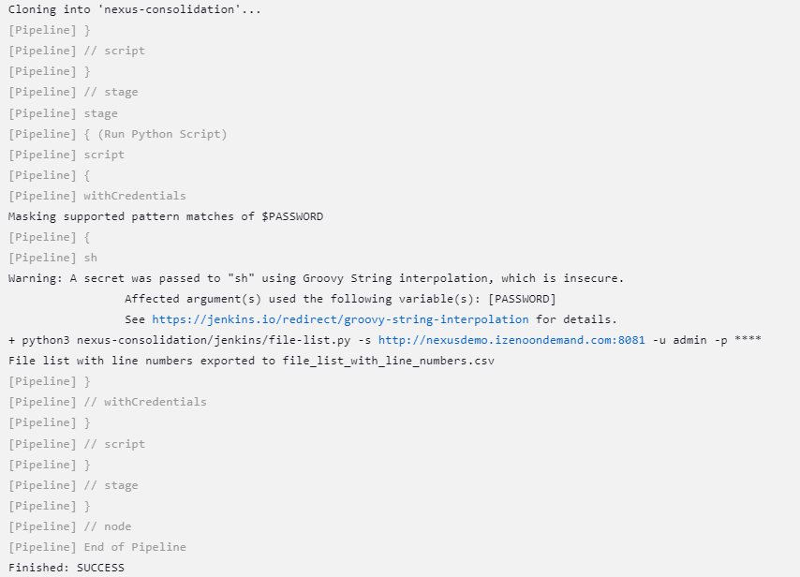

1. Validate the changes in BOS Jenkins

You will need to:

* Log into BOS Jenkins as **Administrator.**
* Navigate to the Dashboard page.
* Click on **Build History** to see past builds and status of each build.
* Select **Console Output** to see details of the build output.

1. Get the csv file from Jenkins

* Log into BOS Jenkins as **Administrator.**
* Navigate to the Dashboard page.
* Click on the latest build from **Build History**
* Go to **Workspaces** and select the path

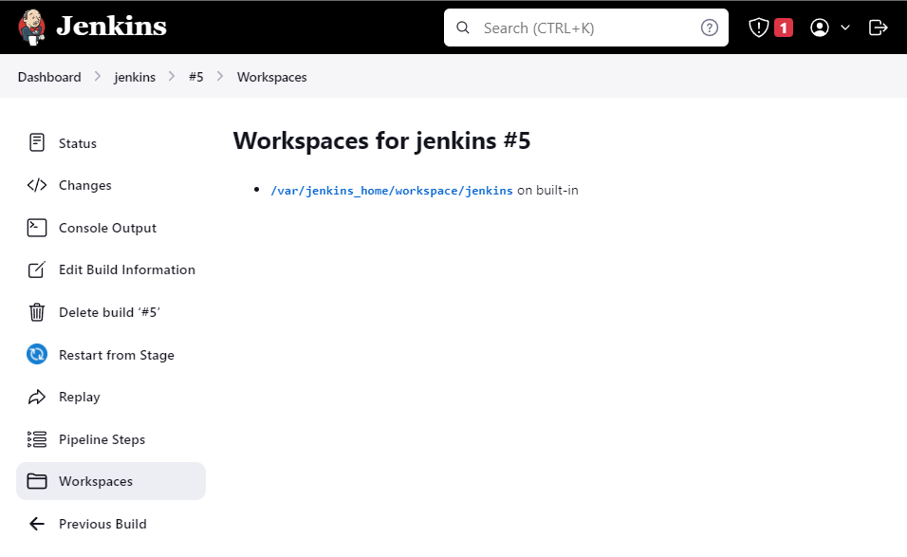

* Download the csv file

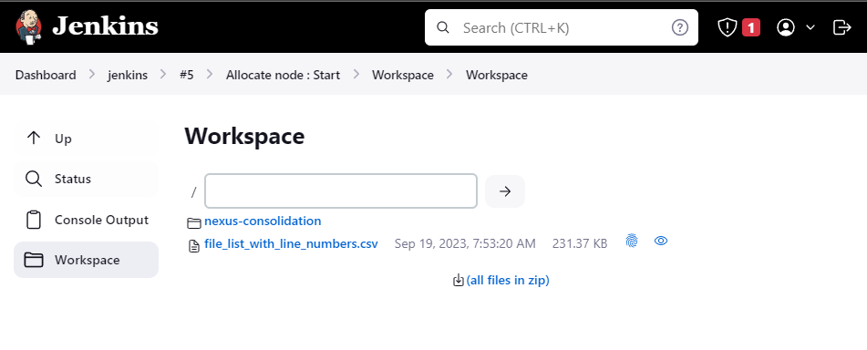

1. Change the Nexus URL in files based on the provided csv from the BOS to OCBC

# 

# 9. Migration Runbook Schedule

The below table shows the rough downtime required for executing the migration for each of the task items in our scope of work.

|  |  |  |
| --- | --- | --- |
| DevOps Tool | Task | Rough Downtime required |
| Jira | Migration of BOS Jira project data and Add-on data to OCBC Jira | 2 - 3 days |
| Nexus | Migration of BOS Nexus repository data to OCBC Nexus | 4 - 5 days |
| Bitbucket | Reconfigure Nexus URL in BOS Bitbucket to use OCBC Nexus URL | 3 - 4 days |
| Jenkins | Reconfigure Nexus URL in BOS Jenkins to use OCBC Nexus URL | 2 - 3 days |

# 10. Appendix

## 10.1 Nexus Python Script

### 10.1.1 List all the current Nexus Repository

This script will list all the Nexus repositories format, type, and the url (get_repos_list.py).



Below shows the sample csv result:

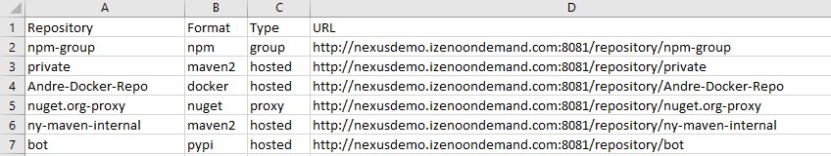

### 10.1.2 List Nexus Asset for Maven Repository (get_maven_asset.py)

This script will list all the asset from Maven Repository file size, download url, last modified and checksum.



Below shows the sample csv result:

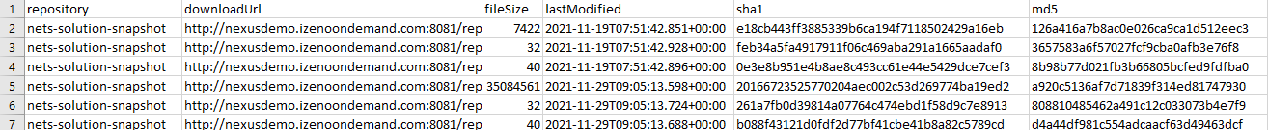

### 10.1.3 List Nexus Asset for Docker Repository (get_docker_assets.py)

This script will list all the asset from the Docker repository.

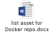

Below shows the sample csv result:

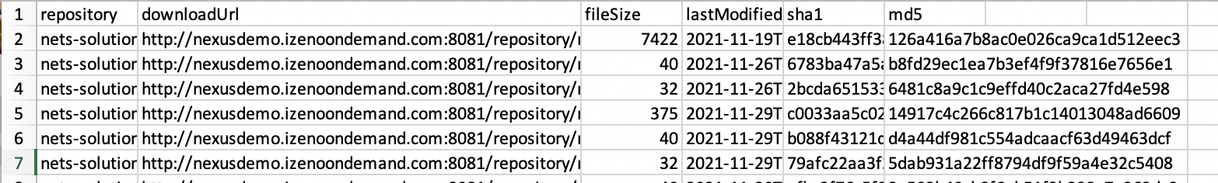

### 10.1.4 List Nexus Asset for NPM Repository (get_npm_asset.py)

This script will list the npm assets file size, download url, last modified and checksum



Below is the sample csv result:



### 10.1.5 List Nexus Asset for Python Repository (get_python_asset.py)



Below is the sample csv result:



### 10.1.6 List Nexus Asset for Raw Repository (get_raw_asset.py)



Below is the sample csv result:

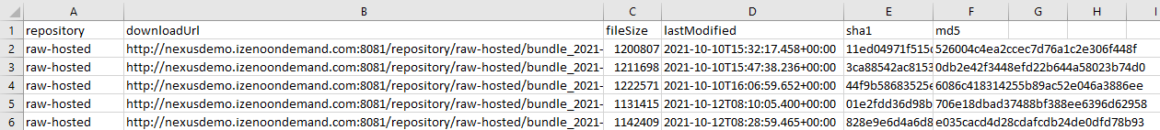

## 10.2 Jenkins Python Script

### 10.2.1 List files containing nexus url (file-list.py)

This script will list files containing nexus url in the jenkins home directory and the result will be in csv



### 10.2.2 Jenkins file to run file-list.py

This script will run on Jenkins pipeline.



Below is the sample Jenkins file-list.py result in csv:



## 10.3 Bitbucket Python Script

### 10.3.1 List all the current repository

This script will list all the BOS repositories and create a file called input.csv. The data in here will further be used when changing the nexus url inside the bitbucket source code. Inside the input.csv we will get the repository name, project link, Git Link, status, default branch and project key.

Run in Command Prompt

|  |
| --- |
| python BitbucketServerMigration.py listrepo |

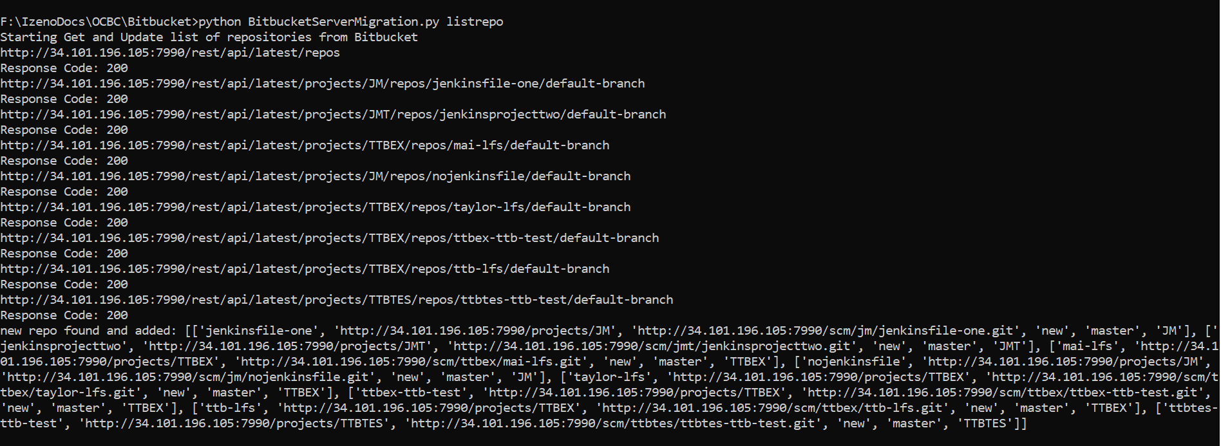

Result

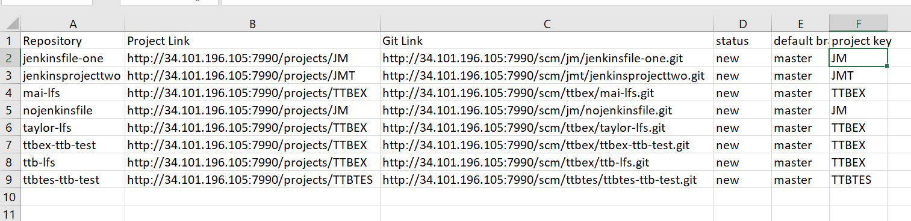

### 10.3.2 Clone All Repository

After we get the list of all repositories, we clone all of that source code to the local.

Run the script in Command Prompt

python BitbucketServerMigration.py CloneAllRepo

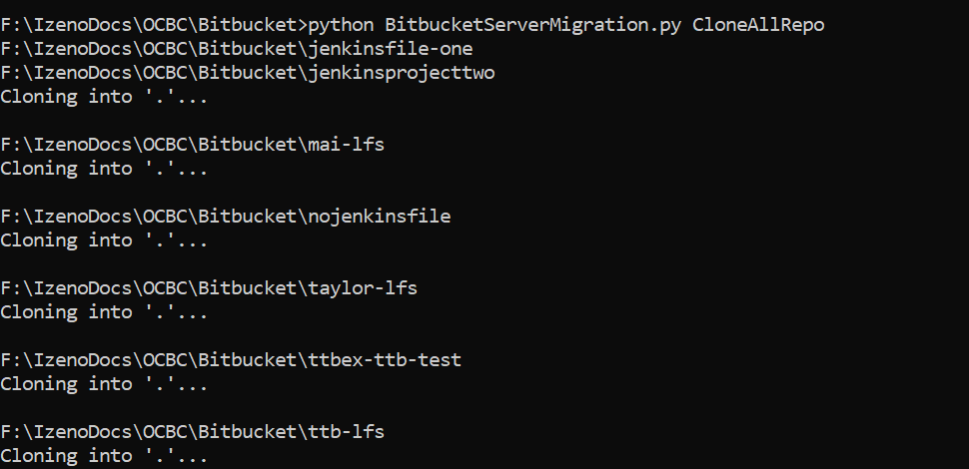

Result. Create All the folders of the source code.

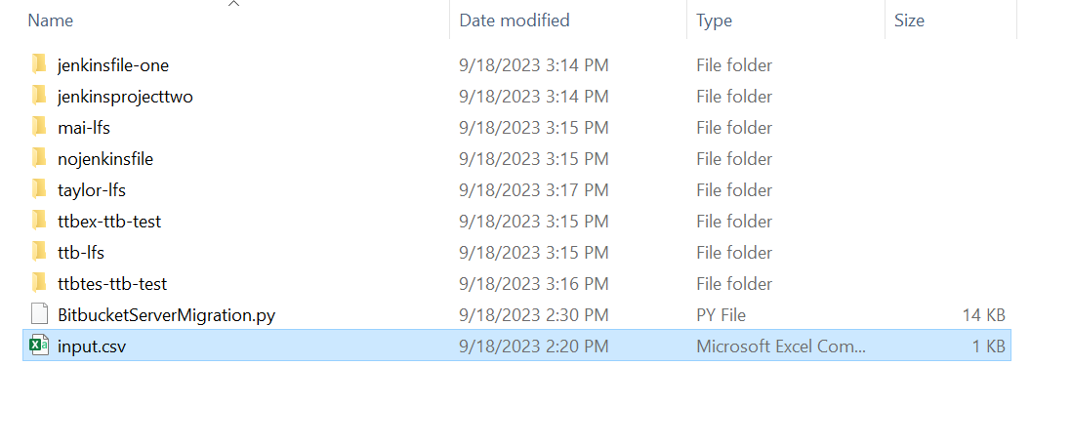

### 10.3.3 Check Nexus Url

After we get all the source code we can check each of the files using the python script. Then we will get the list of the file that uses the BOS Nexus URL.

python BitbucketServerMigration.py checknexusurl

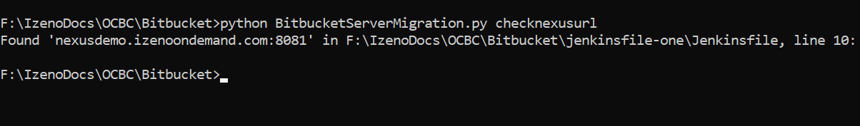

Result

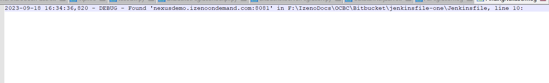

### 10.3.4 Change Nexus Url and Create Pull Request

After we have the list and approve of the change we will create a new branch to the repository, checkout the branch, make change to nexus url and create a pull request.

Run in Command Prompt

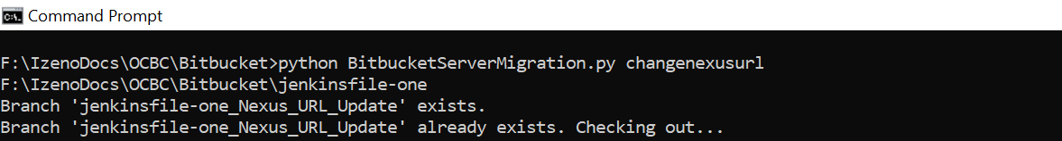

Changing the Nexus URL



Push to the created branch and create pull request

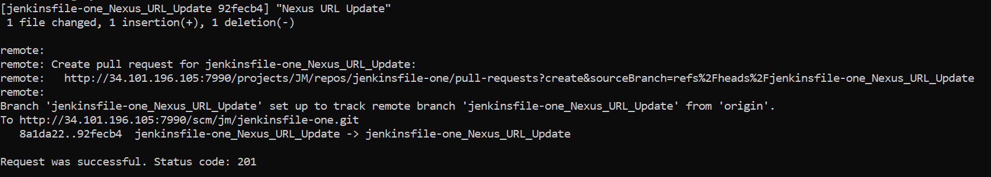

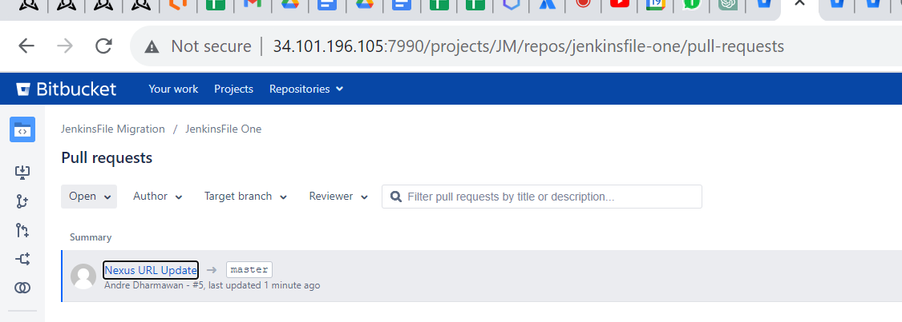

### 10.3.5 Complete Script Code



## 10.4 Jira Version Upgrade